# Conflict blocks

|  |  |
| --- | --- |
| Conflict Location | The cases regarding downstream modifications |
| 1. Method block | Downstream development modifies native method blocks: a)modify/add condition branch(45); b)modify/add call site(43); c)modify/add variable(24); d) update log(10); e)others(10). |
| 1. Class Field | Downstream development modifies or adds class fields: a) class static constants with non-SDK restriction(8); b) class variable members to aggregate upstream or downstream class object(25). |
| 1. Import | Downstream development imports: a) actively native entity(8); b) intrusively native entity(3); c)static constant(5); d)others(15). |
| 1. Parameters | Downstream development changes the parameters of intrusively native methods and calls them:a) add a new parameter(13); b) modify parameter type(5). |
| 1. Accessibility | Downstream development changes the accessibility (private, protected, and public) of a native entity. These entities can be: a) classes(2); b) methods(2); c) class fields(5). |
| 1. Extensive method | Downstream development adds extensive methods for native classes. The methods can be: a)overriding a method due to interface implementation(3);b) adding a method in native interface or parent class(1); c) extracting native code(1); d) others(3). |
| 1. Final | Downstream development removes the final keyword of an entity: a)remove the final of a native class field to re-assign its value(2). |
| 1. Annotation | Downstream development removes the annotation: a) remove `@Deprecated` annotation(1), b)remove non-SDK restriction level annotation(1). |
| 1. Inner-classes | Downstream development defines an extensive inner-class inside a intrusively native class(1). |
| 1. Upstream Update | These conflict blocks only contain modifications made by upstream development. |
| 1. Others | These conflict blocks were reported near the downstream modifications. |

## LineageOS-19.1

### Merge: 8acf7b3981a55a3da70fd03d38b3645437b84d46

1. Services/core/java/com/android/server/audio/AudioDeviceBroker.java
2. 2-b

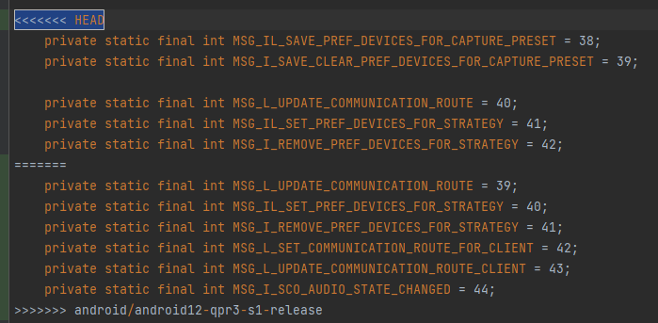

1. packages/SystemUI/src/com/android/systemui/statusbar/phone/fragment/CollapsedStatusBarFragment.java
2. 3-b

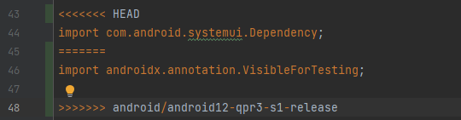

1. 3-a

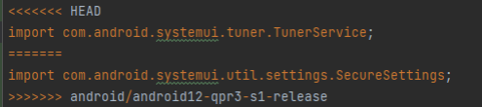

1. 2-b

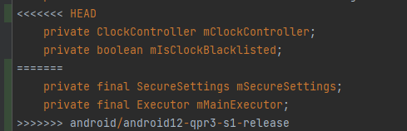

1. 1-b

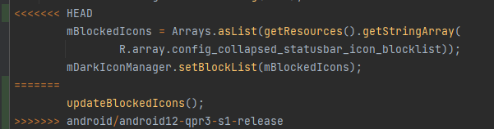

## LineageOS-18.1

### Merge: d045f50ed2f0e1f00aefc591f9f104f2bee3a546

1. services/core/java/com/android/server/wm/RootWindowContainer.java
2. 10

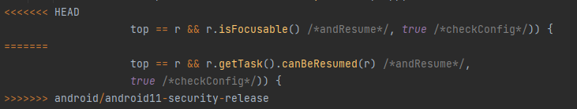

### Merge: ce87f77e2ac9edfb8cce11ea072c53401f7018d8

1. services/core/java/com/android/server/pm/PackageInstallerService.java
2. 10

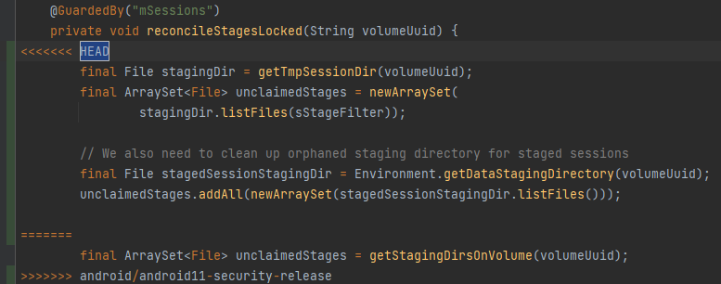

1. core/java/android/app/admin/DevicePolicyManagerInternal.java
2. 10

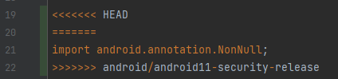

### Merge: 617f1aaaa25fabf89a392460136fbe1031d963cd

1. services/core/java/com/android/server/am/ActiveServices.java
2. AOSP modifies method block

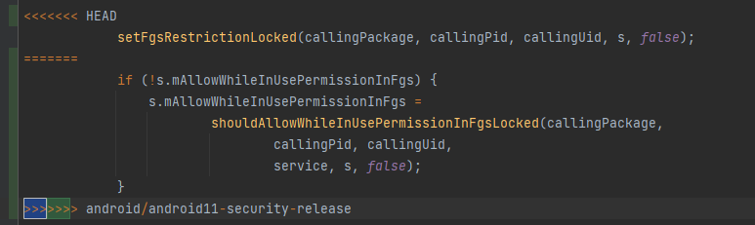

1. services/core/java/com/android/server/notification/NotificationManagerService.java
2. Drownstream modifies a class field

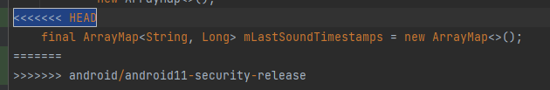

1. Drownstream adds a class field

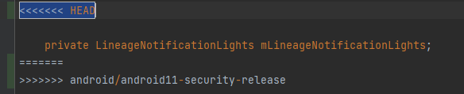

1. core/java/com/android/internal/util/ScreenshotHelper.java
2. AOSP modifies method block

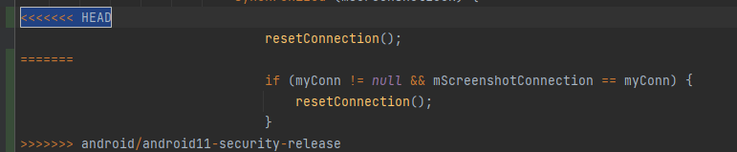

1. services/core/java/com/android/server/pm/PackageManagerService.java
2. Drownstream modifies method block

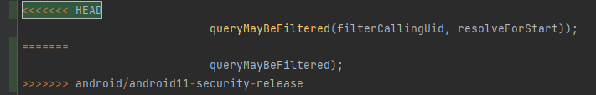

1. packages/SystemUI/src/com/android/systemui/SlicePermissionActivity.java
2. AOSP modifies method block

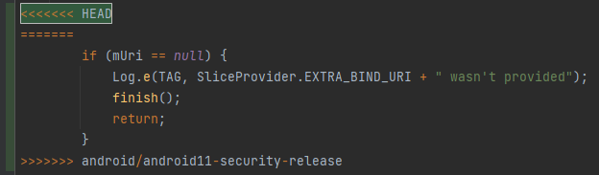

1. Drownstream modifies a class field

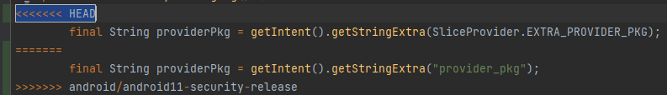

1. services/core/java/com/android/server/policy/PhoneWindowManager.java
2. Downstream adds class field

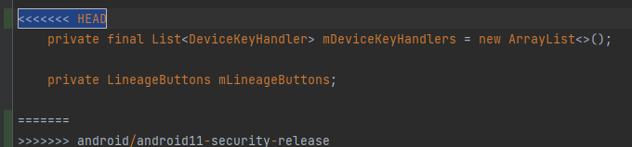

1. services/core/java/com/android/server/pm/CrossProfileAppsServiceImpl.java
2. AOSP modifies method block

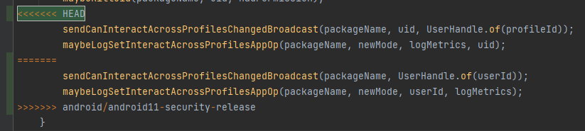

1. AOSP modifies method block

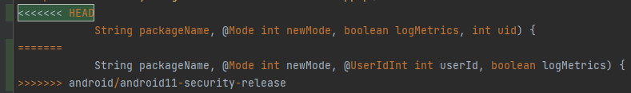

1. packages/CompanionDeviceManager/src/com/android/companiondevicemanager/DeviceCh

ooserActivity.java

1. Drownstream modifies import

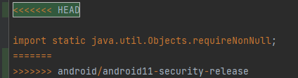

1. services/core/java/com/android/server/biometrics/Utils.java
2. Drownstream modifies import

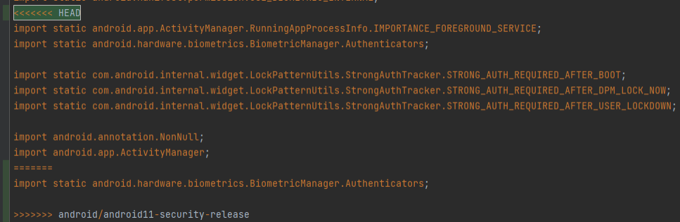

1. Drownstream modifies import

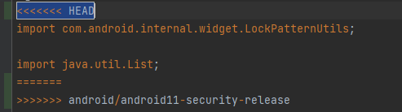

1. Drownstream modifies method block

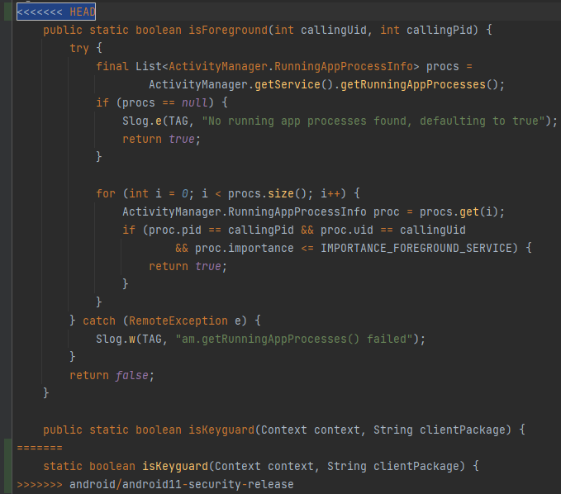

1. Drownstream modifies method block

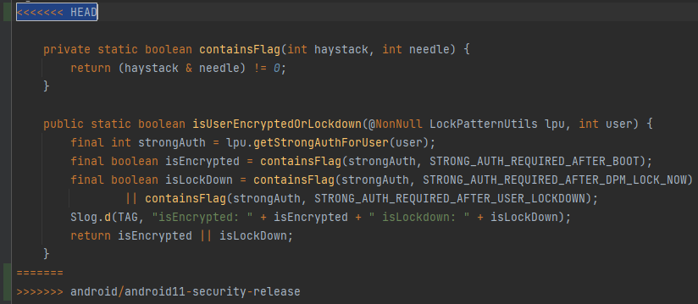

### Merge: 74544b9e39b174025fcb91cc194ca920b12e8683

1. services/core/java/com/android/server/policy/PhoneWindowManager.java
2. Drownstream modifies method block

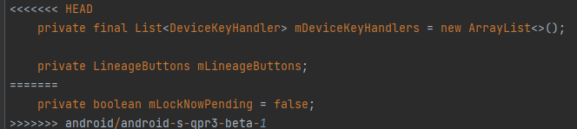

### Merge: 0d56322831621c44d8d3f30d777f0893216ad09c

1. packages/SystemUI/src/com/android/systemui/doze/DozeSensors.java
2. Drownstream modifies imports

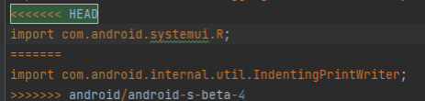

1. packages/SystemUI/src/com/android/systemui/statusbar/KeyguardIndicationController.java
2. Drownstream modifies method block

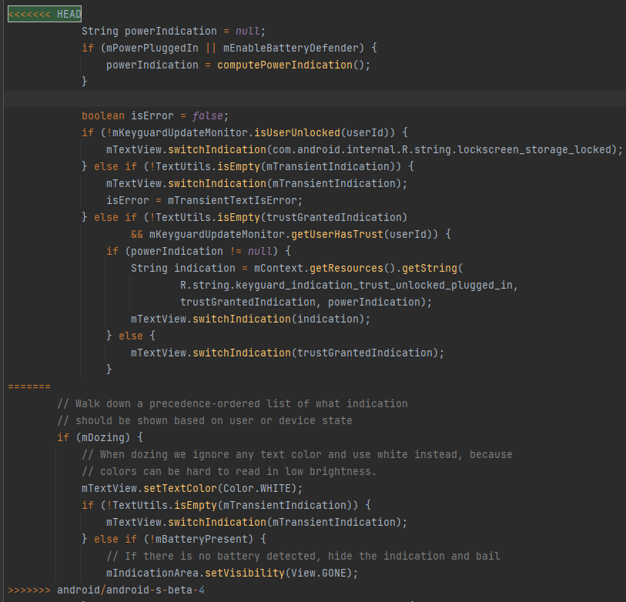

1. packages/SystemUI/src/com/android/systemui/BatteryMeterView.java
2. AOSP add global fields

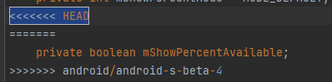

1. Drownstream modifies method block

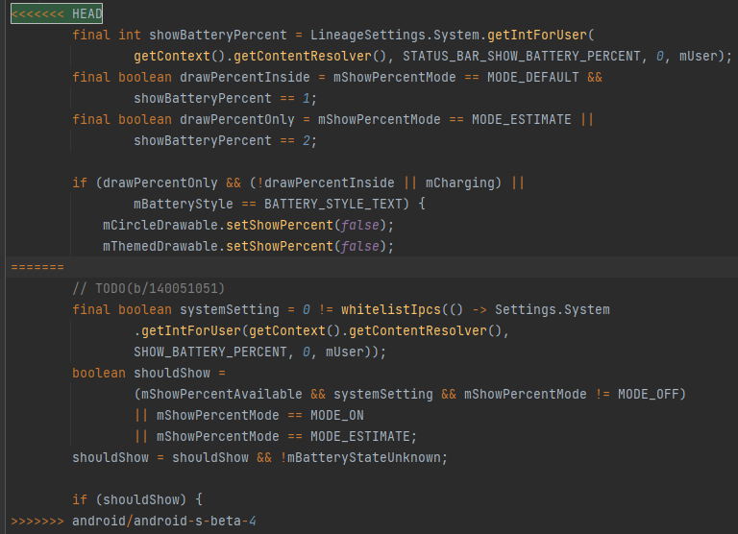

### Merge: d274c33a679b96f638f6b6d14abb2472dd3fc2ac

1. packages/SystemUI/src/com/android/systemui/statusbar/phone/EdgeBackGestureHandler.java
2. AOSP modifies method block

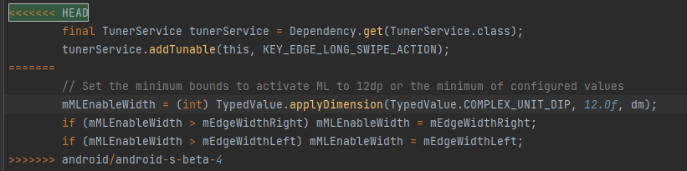

1. core/java/com/android/internal/app/ChooserActivity.java
2. Drownstream modifies method block

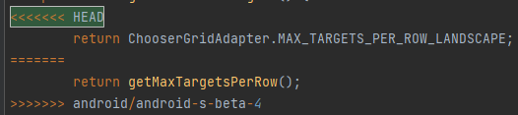

1. services/core/java/com/android/server/notification/NotificationManagerService.java
2. AOSP add annotation

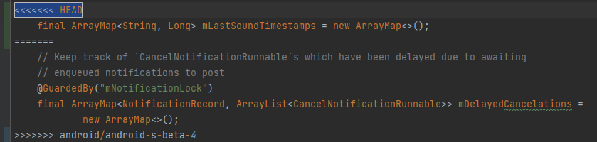

## LineageOS-17.1

### Merge: 9d930f996e6d31820e201f4eb7dd7bf11127f932

1. services/tests/uiservicestests/src/com/android/server/notification/NotificationManagerServiceTest.java
2. 侵入式修改其他方法导致间接冲突

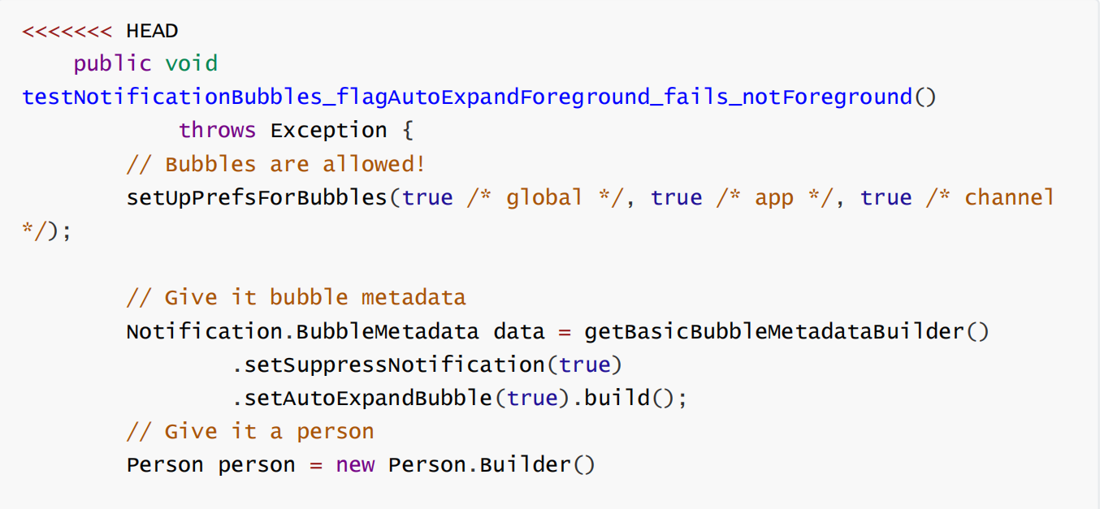

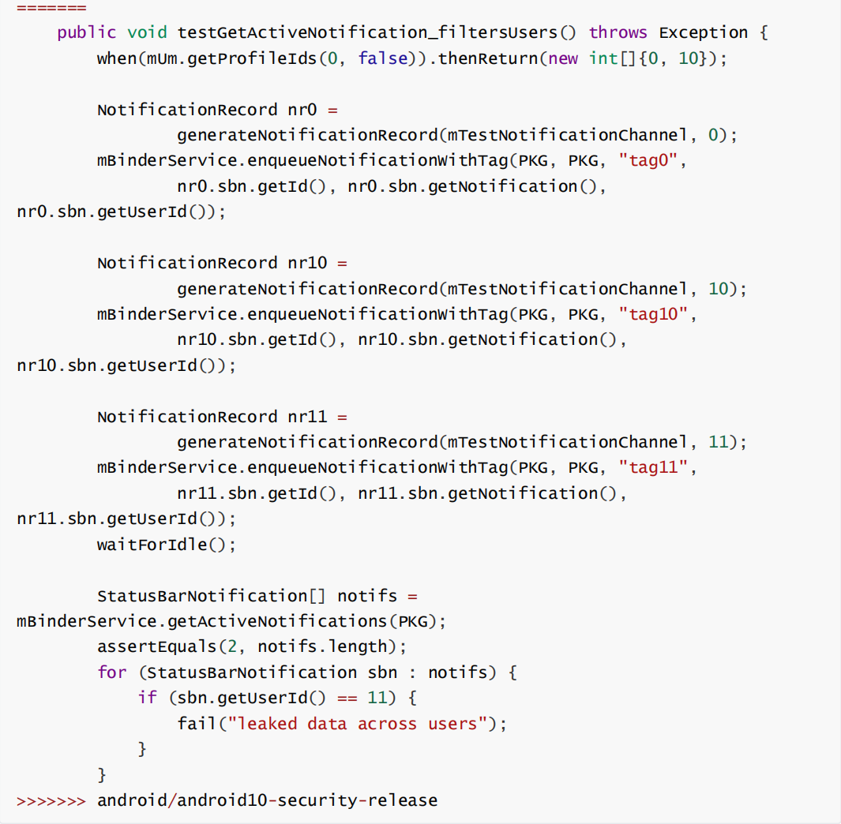

### Merge: a5464e4c3f2a28630d99d1d7996bd3c41ec2877f

1. packages/SystemUI/src/com/android/systemui/statusbar/phone/StatusBar.java
2. 扩展删除modifier并增加重写方法

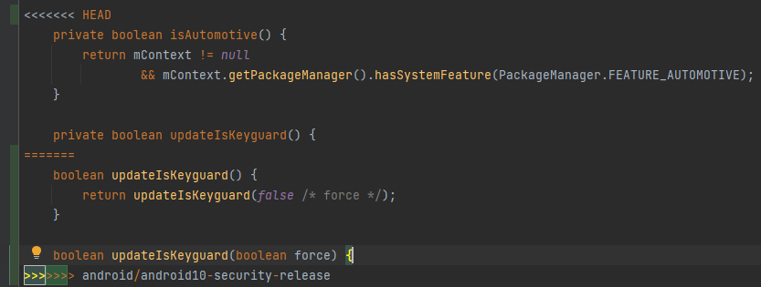

### Merge: 10e300d48682ac576ead42e0f216976fa8847033

1. packages/SystemUI/src/com/android/systemui/statusbar/phone/NavigationModeController.java
2. AOSP修改

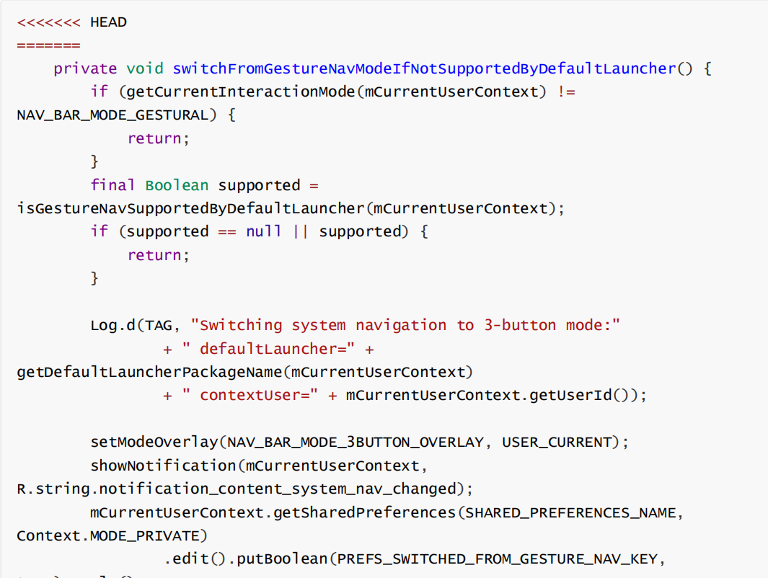

### Merge: 05fa7e2c3e169e955e815187e15fd141fe9aa95b

1. services/core/java/com/android/server/policy/PhoneWindowManager.java
2. 扩展新增属性

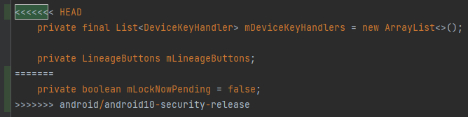

### Merge: 09f6943068695f12f8f624668cbff7572dfa6053

1. core/java/com/android/internal/util/ScreenshotHelper.java
2. 扩展新增属性

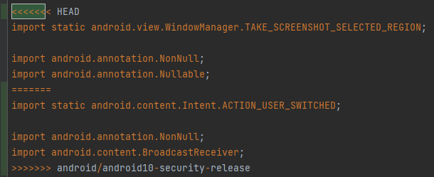

1. Downstream modifies method block

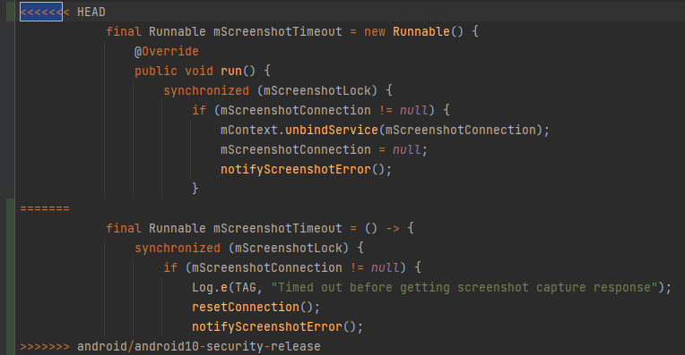

### Merge: 3a6c4af35c60db2b635f8f4c414b6c921a80a293

1. packages/SystemUI/src/com/android/systemui/screenshot/GlobalScreenshot.java
2. Downstream modifies method block

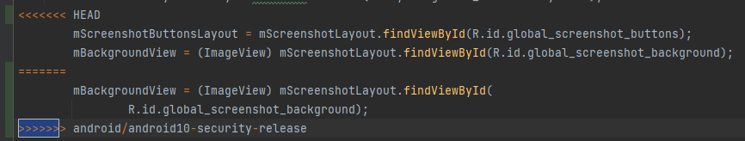

### Merge: 96e5fca97c43ea282d5ad4b7c6fad40acd91586d

1. services/core/java/com/android/server/policy/keyguard/KeyguardStateMonitor.java
2. Downstream modifies method block

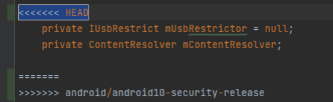

1. Downstream modifies method block

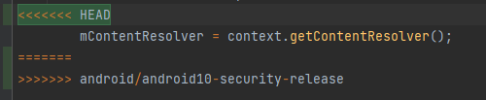

1. Downstream modifies method block

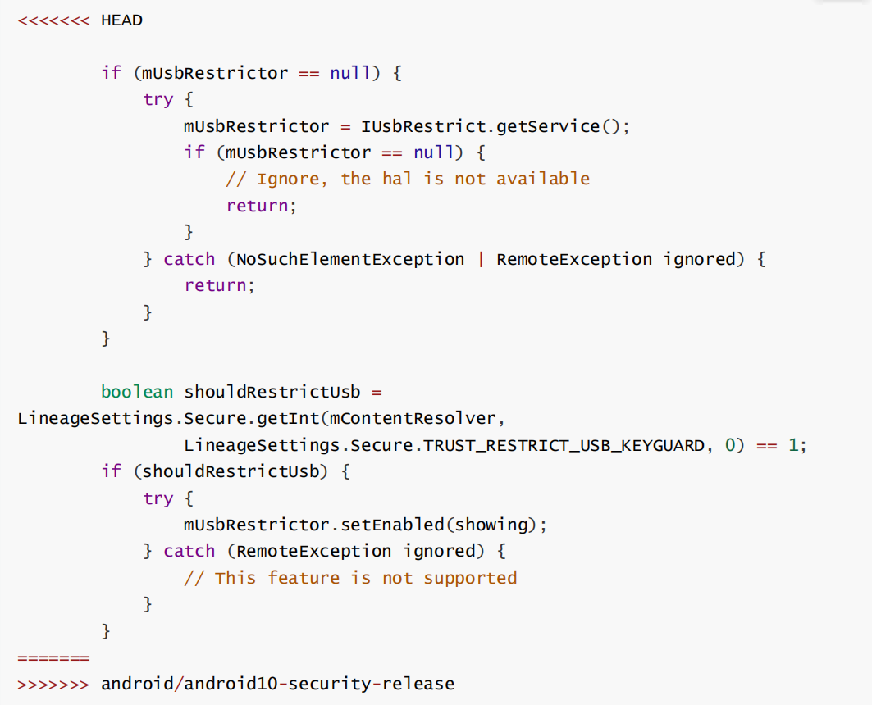

1. packages/SystemUI/src/com/android/systemui/appops/AppOpsControllerImpl.java
2. Downstream modifies method block

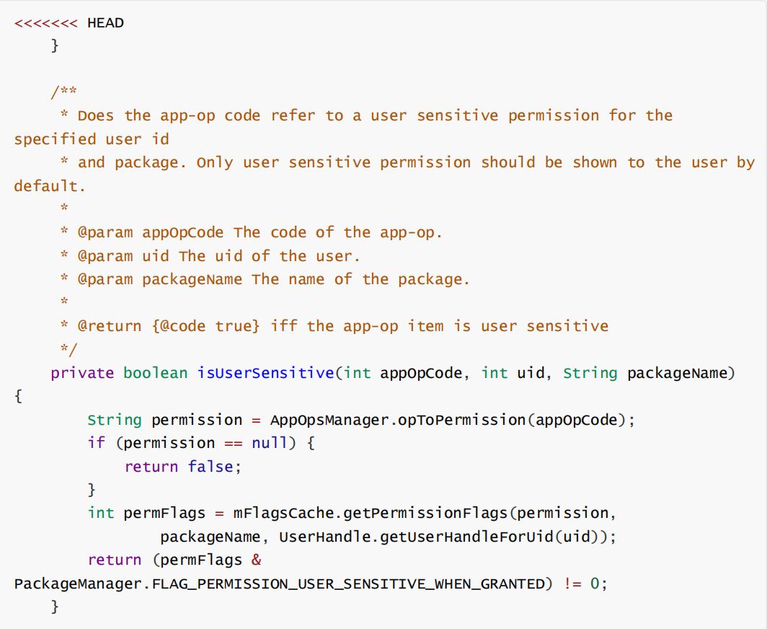

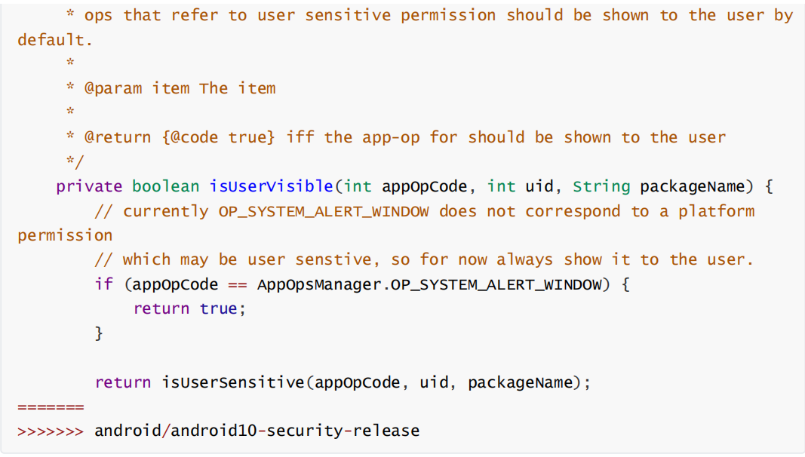

1. Downstream modifies method block

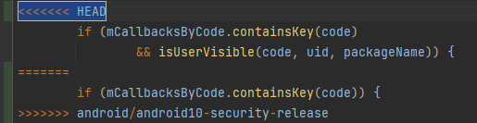

1. packages/SystemUI/src/com/android/systemui/statusbar/NotificationShelf.java
2. Downstream modifies method block

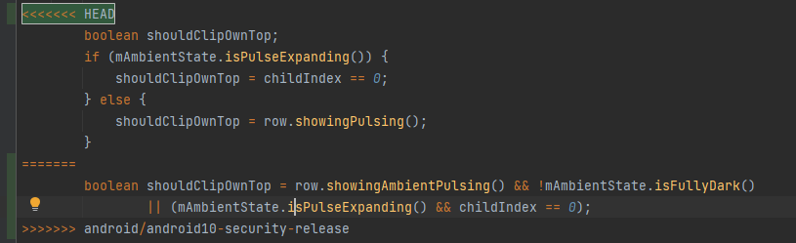

1. Downstream modifies method block

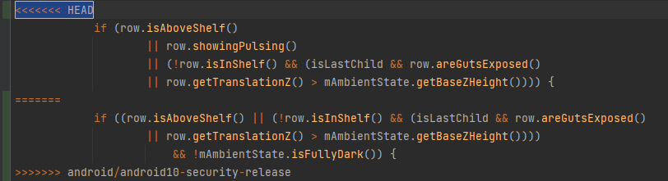

1. packages/SystemUI/src/com/android/systemui/classifier/FalsingManagerProxy.java
2. Downstream modifies method block

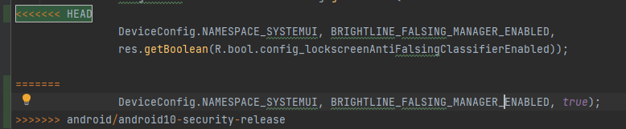

1. packages/SystemUI/src/com/android/systemui/doze/DozeSensors.java
2. Downstream modifies method block

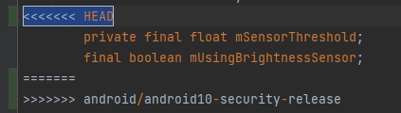

1. Downstream modifies method block

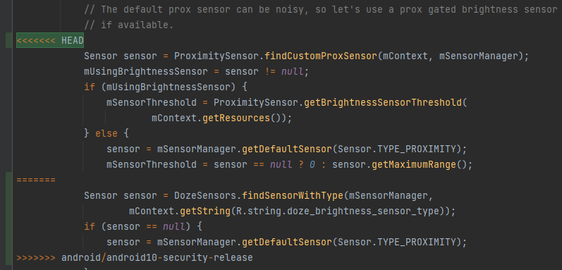

1. services/core/java/com/android/server/pm/Settings.java
2. Downstream modifies method block

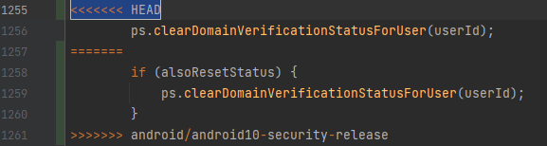

1. services/core/java/com/android/server/UiModeManagerService.java
2. Downstream modifies method block

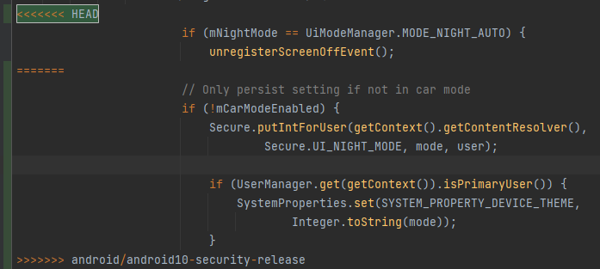

1. packages/SystemUI/src/com/android/systemui/statusbar/notification/collection/NotificationEntry.java
2. Downstream modifies method block

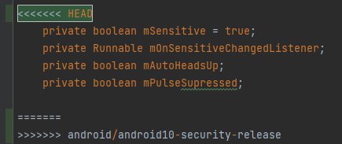

1. services/core/java/com/android/server/pm/PackageManagerService.java
2. Downstream modifies method block

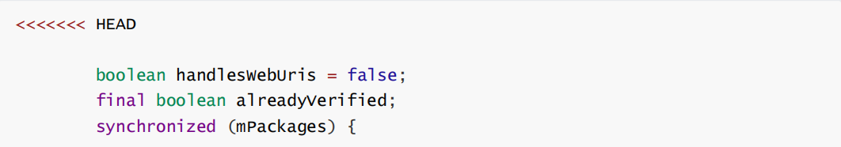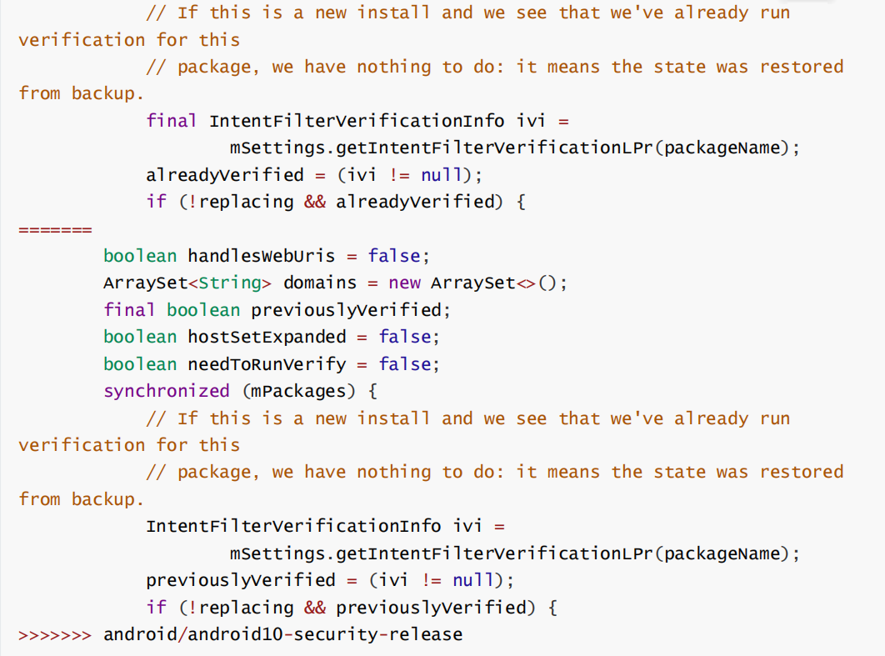

1. Downstream modifies method block

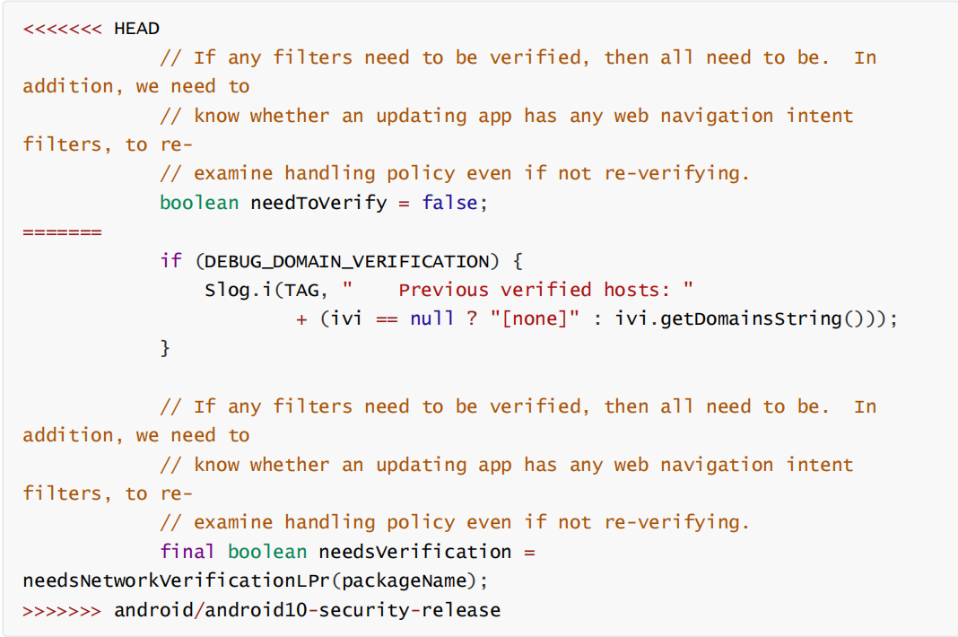

1. Downstream modifies method block

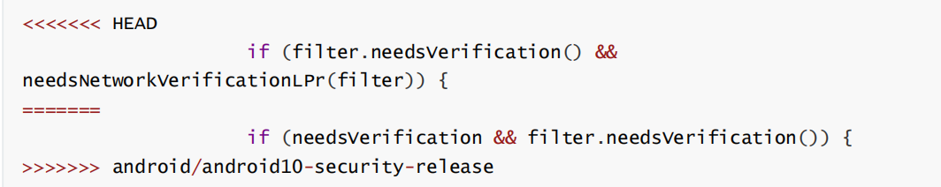

1. Downstream modifies method block

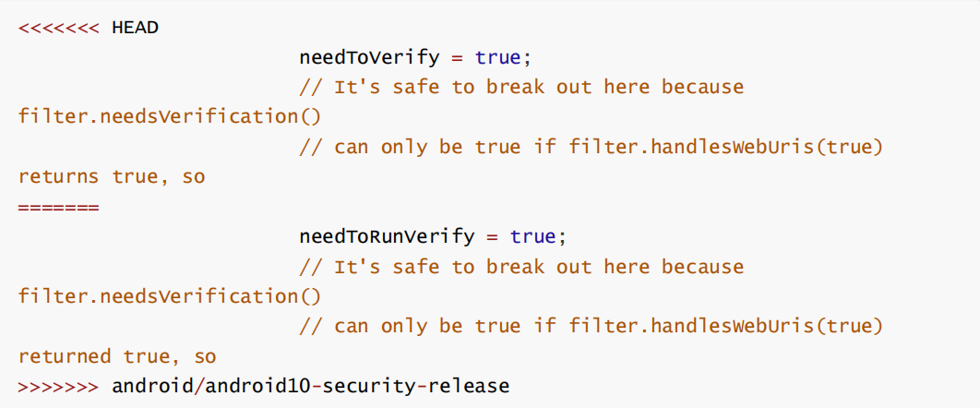

1. Downstream modifies method block

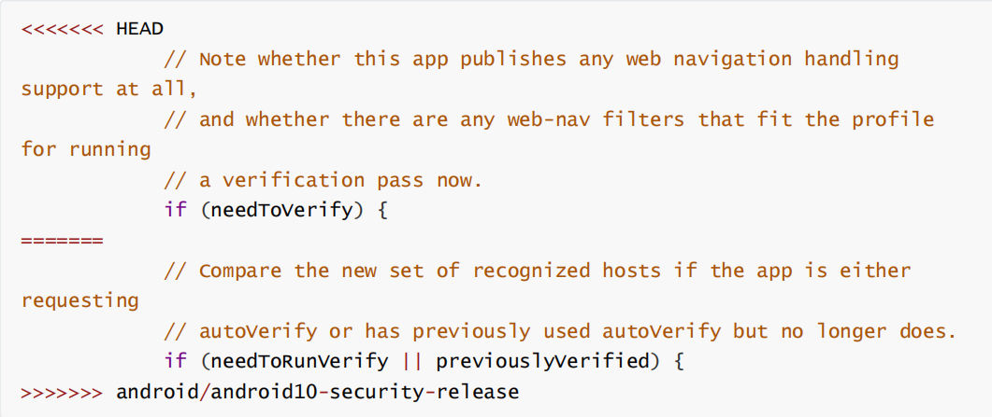

1. Downstream modifies method block

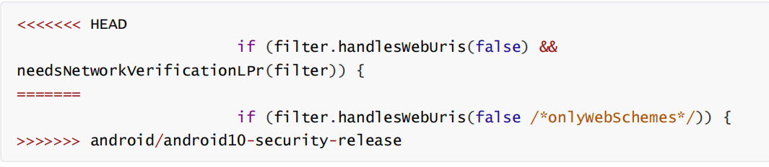

1. Downstream modifies method block

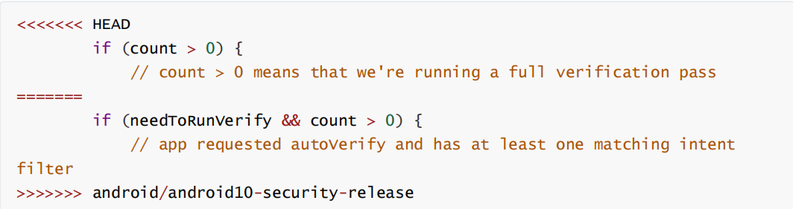

1. Downstream modifies method block

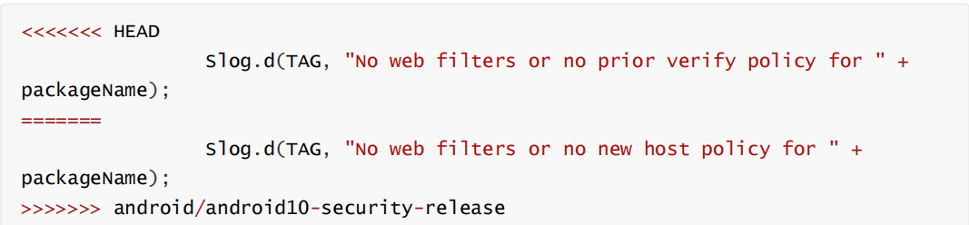

1. packages/SystemUI/src/com/android/systemui/keyguard/KeyguardSliceProvider.java
2. Downstream modifies method block

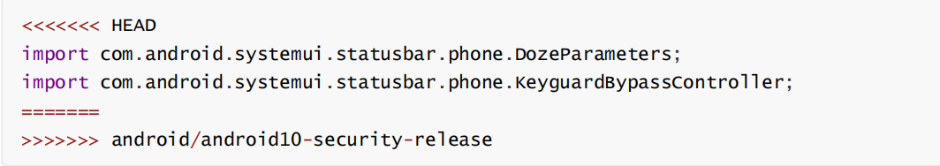

1. Downstream modifies method block

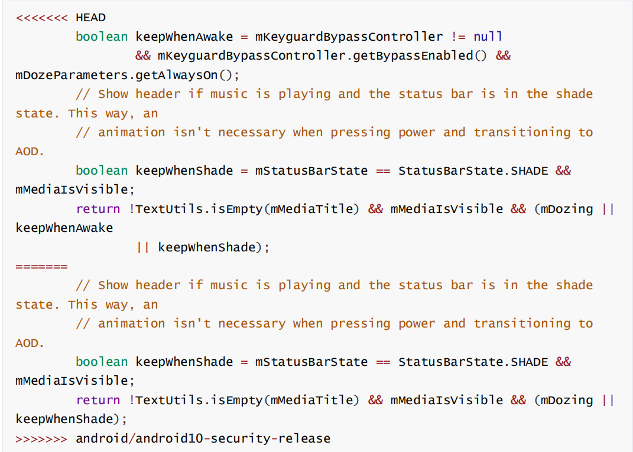

1. Downstream modifies method block

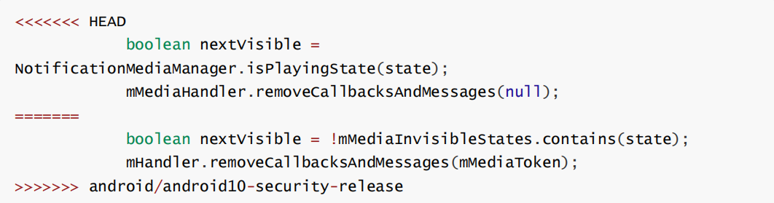

1. packages/SystemUI/src/com/android/systemui/doze/DozeFactory.java
2. Downstream modifies method block

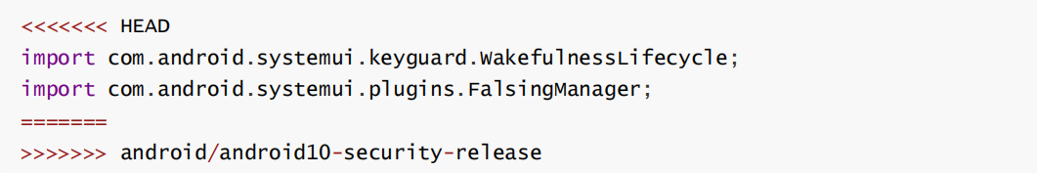

1. Downstream modifies method block

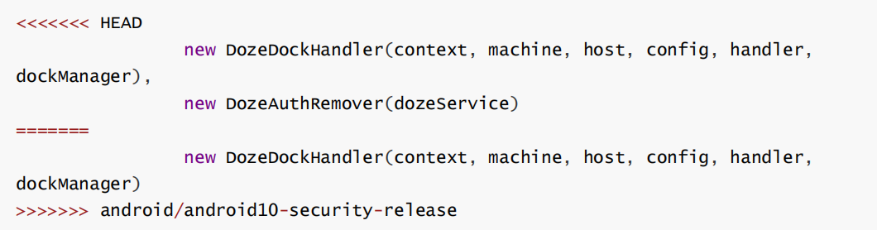

1. packages/SystemUI/src/com/android/systemui/glwallpaper/ImageRevealHelper.java
2. Downstream modifies method block

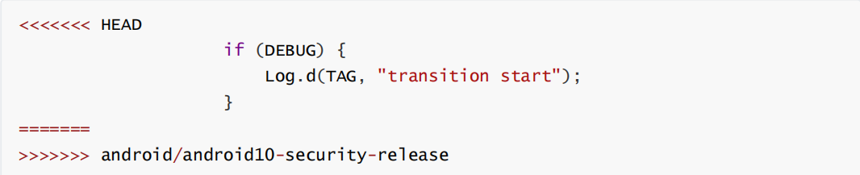

1. Downstream modifies method block

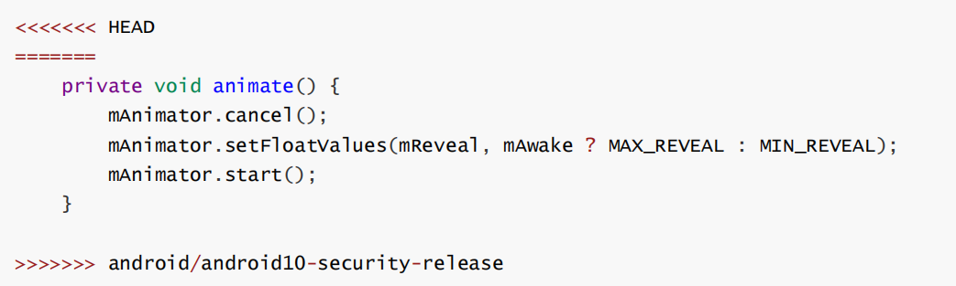

1. Downstream modifies method block

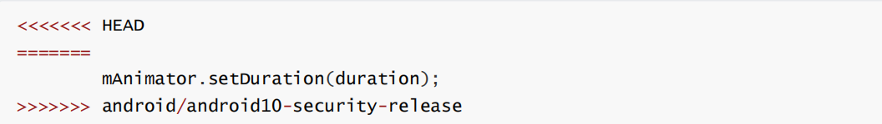

1. packages/SystemUI/src/com/android/systemui/classifier/brightline/ProximityClassifier.java
2. Downstream modifies method block

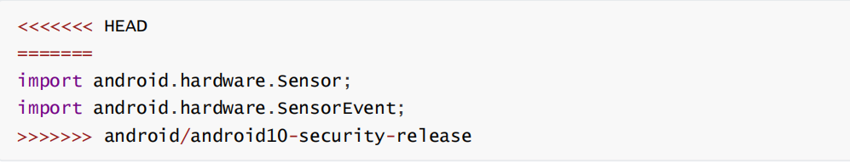

1. services/core/java/com/android/server/pm/PackageInstallerSession.java
2. Downstream modifies method block

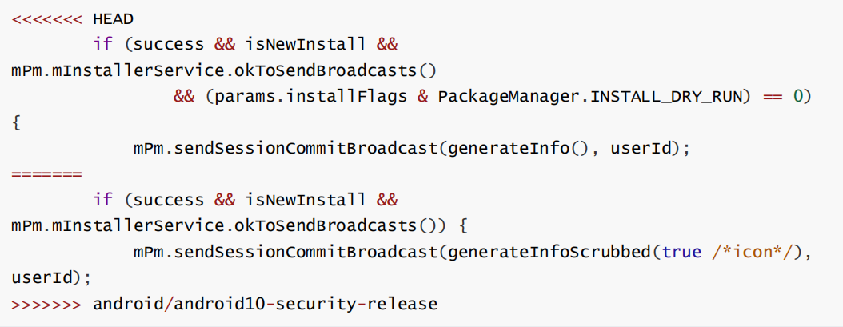

1. packages/SystemUI/tests/src/com/android/systemui/keyguard/KeyguardSliceProviderTest.java
2. Downstream modifies method block

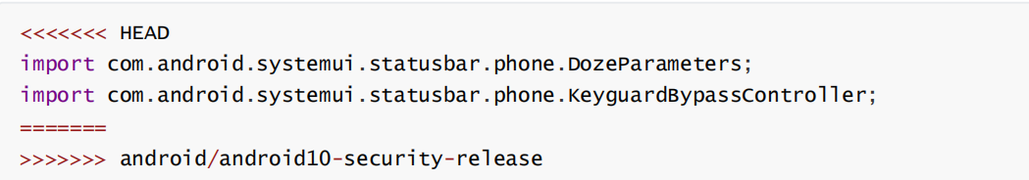

1. packages/SystemUI/src/com/android/systemui/statusbar/phone/NotificationPanelView.java
2. Downstream modifies method block

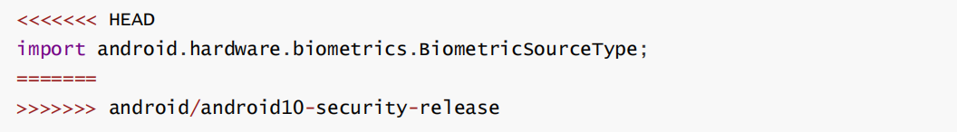

1. packages/SystemUI/src/com/android/systemui/statusbar/phone/StatusBar.java
2. Downstream modifies method block

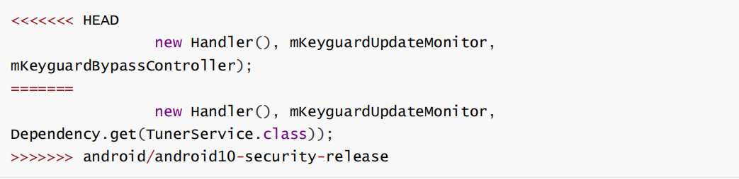

1. packages/SystemUI/src/com/android/systemui/ImageWallpaper.java
2. Downstream modifies method block

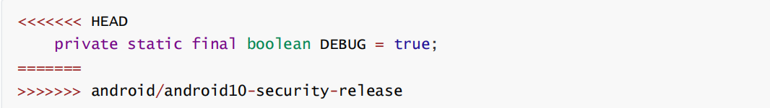

1. Downstream modifies method block

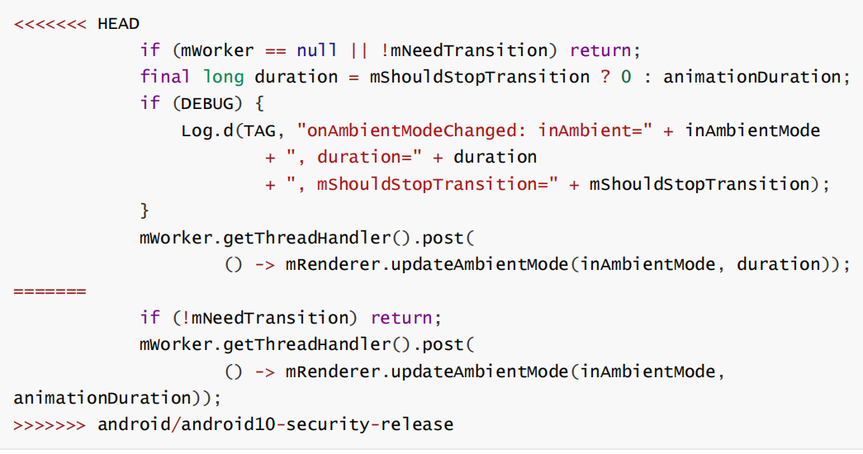

1. services/core/java/com/android/server/appop/AppOpsService.java
2. Downstream modifies method block

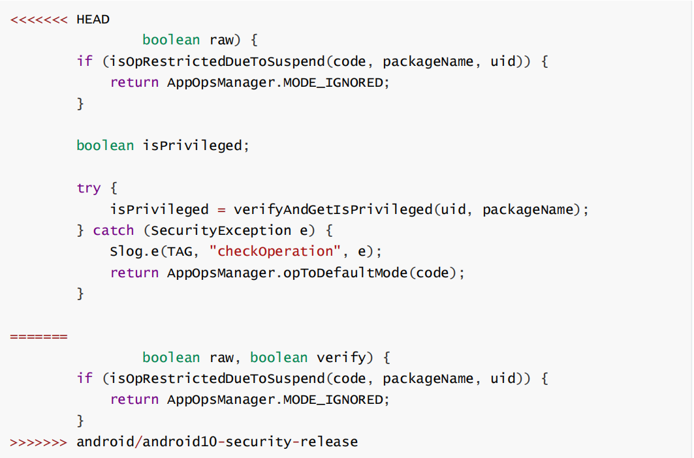

1. Downstream modifies method block

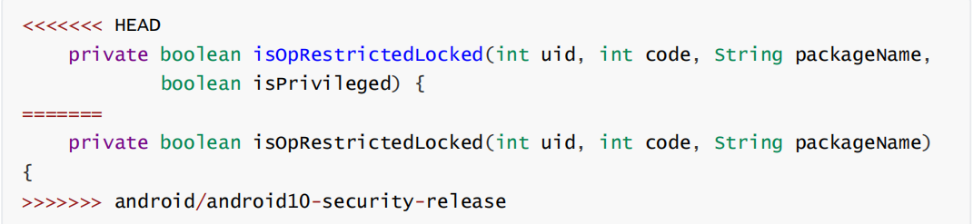

1. packages/SystemUI/tests/src/com/android/systemui/statusbar/notification/stack/NotificationStackScrollLayoutTest.java
2. Downstream modifies method block

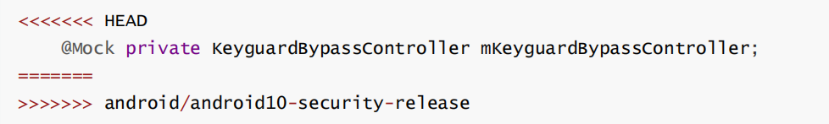

1. Downstream modifies method block

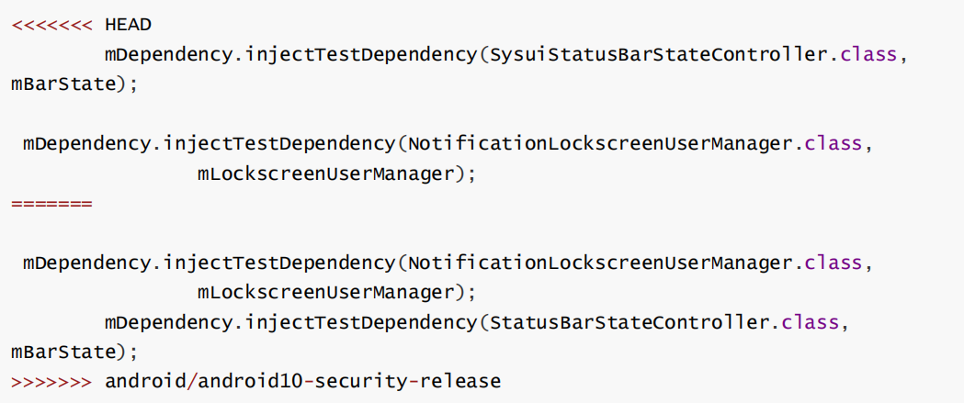

1. packages/SystemUI/tests/src/com/android/systemui/appops/AppOpsControllerTest.java
2. Downstream modifies method block

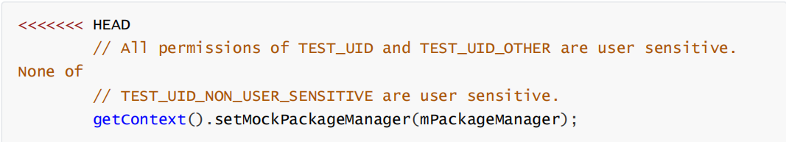

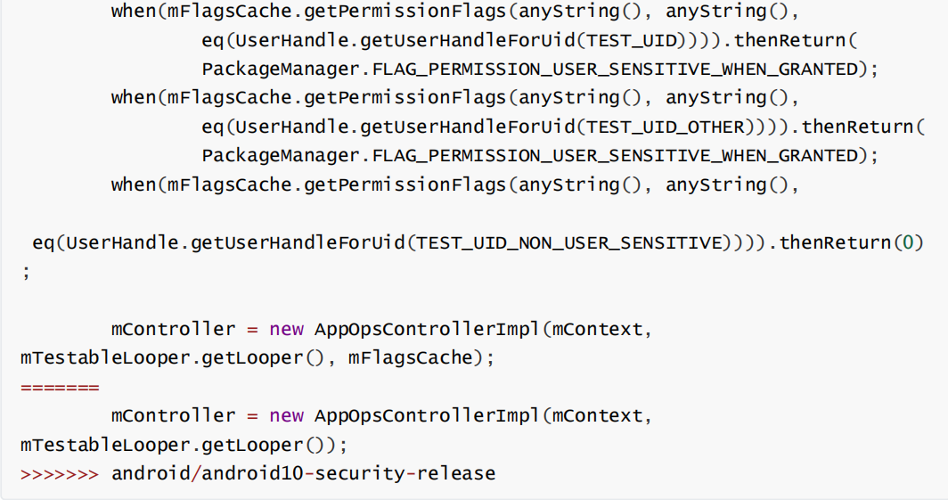

1. packages/SystemUI/src/com/android/systemui/statusbar/phone/BiometricUnlockController.java
2. Downstream modifies method block

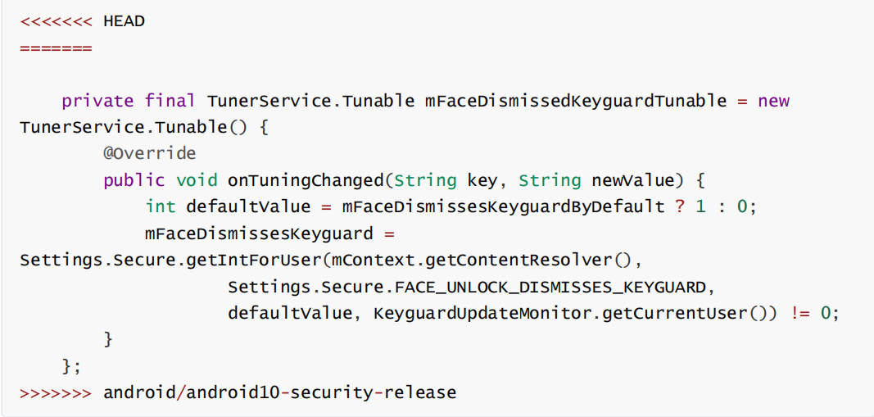

1. packages/SystemUI/src/com/android/systemui/glwallpaper/ImageWallpaperRenderer.java
2. Downstream modifies method block

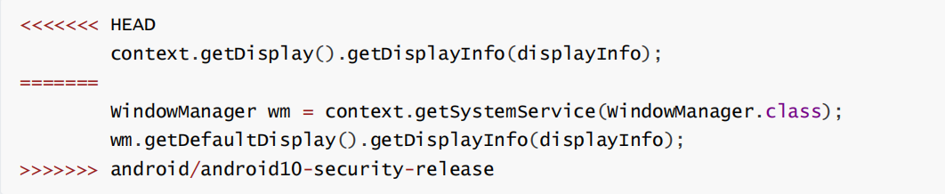

1. Downstream modifies method block

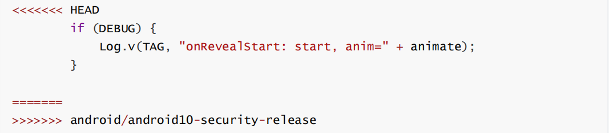

1. Downstream modifies method block

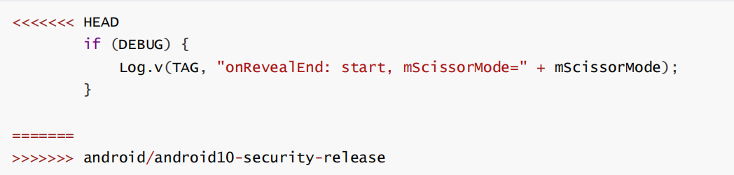

1. packages/SystemUI/src/com/android/systemui/classifier/brightline/BrightLineFalsingManager.java
2. Downstream modifies method block

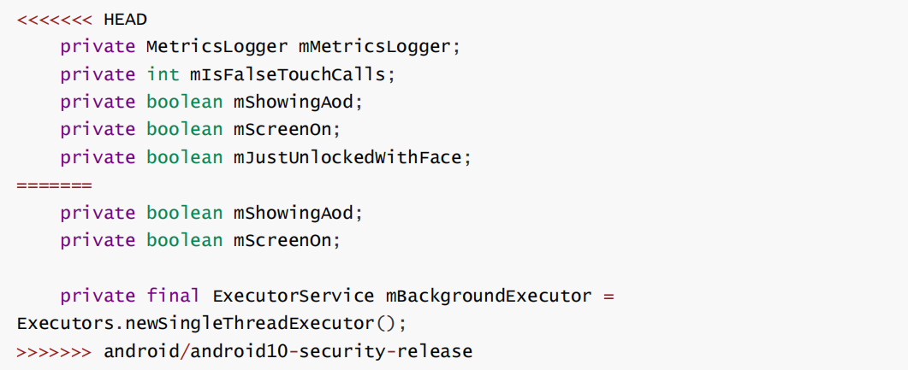

1. Downstream modifies method block

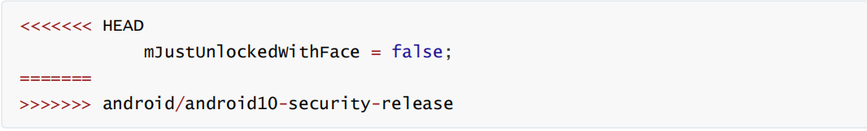

1. Downstream modifies method block

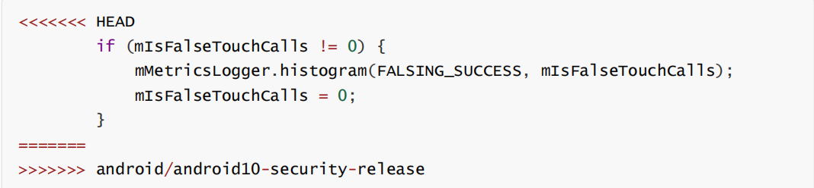

1. Downstream modifies method block

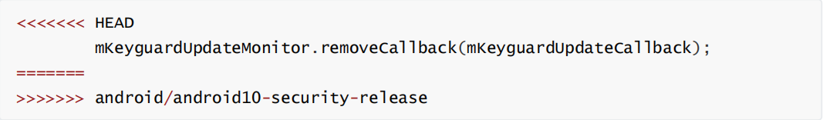

1. packages/SystemUI/src/com/android/systemui/statusbar/notification/stack/StackScrollAlgorithm.java
2. Downstream modifies method block

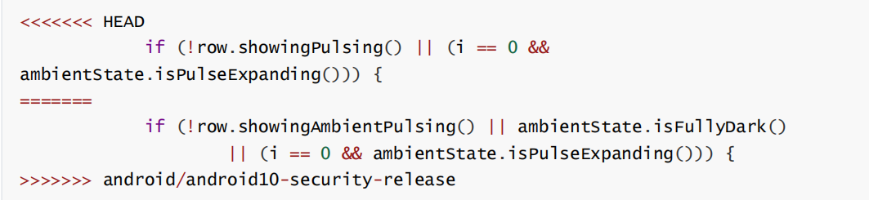

### Merge: f67897bc05520f743974fc397aa96e4049a057b3

1. services/core/java/com/android/server/policy/keyguard/KeyguardStateMonitor.java
2. Downstream modifies method block

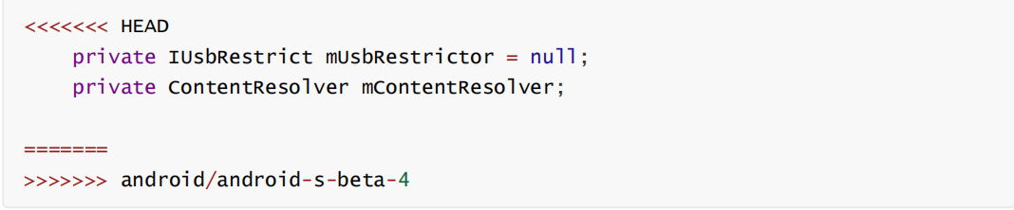

1. Downstream modifies method block

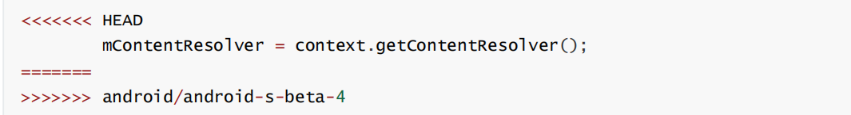

1. Downstream modifies method block

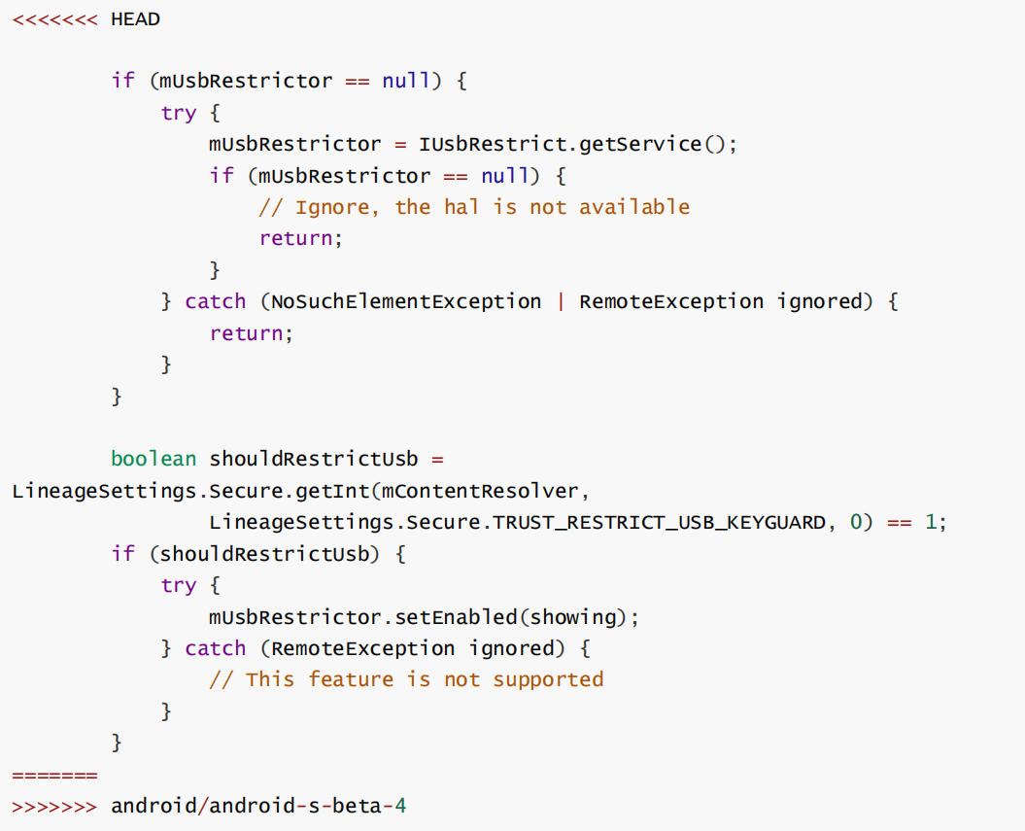

1. services/core/java/com/android/server/input/InputManagerService.java
2. Downstream modifies method block

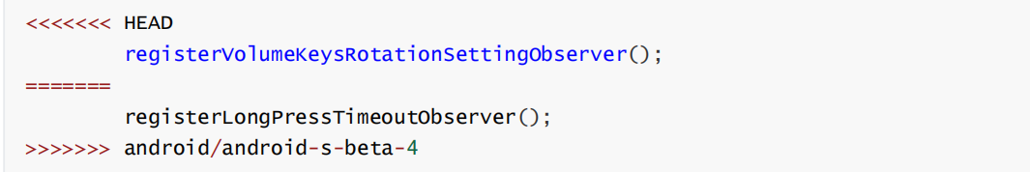

1. Downstream modifies method block

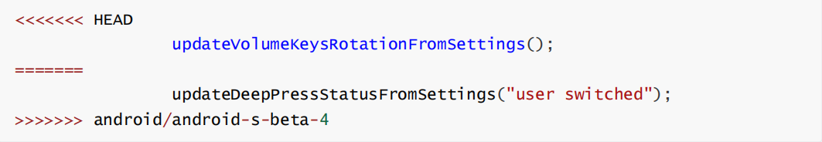

1. Downstream modifies method block

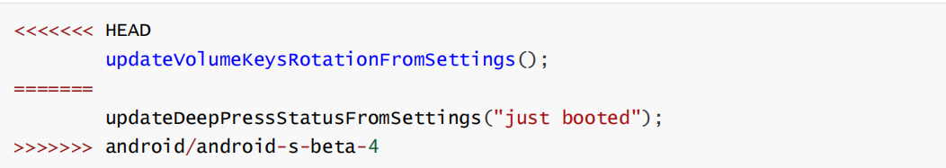

1. packages/SystemUI/src/com/android/systemui/statusbar/phone/PhoneStatusBarTransitions.java
2. Downstream modifies method block

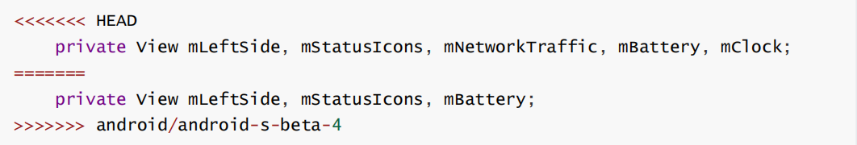

1. Downstream modifies method block

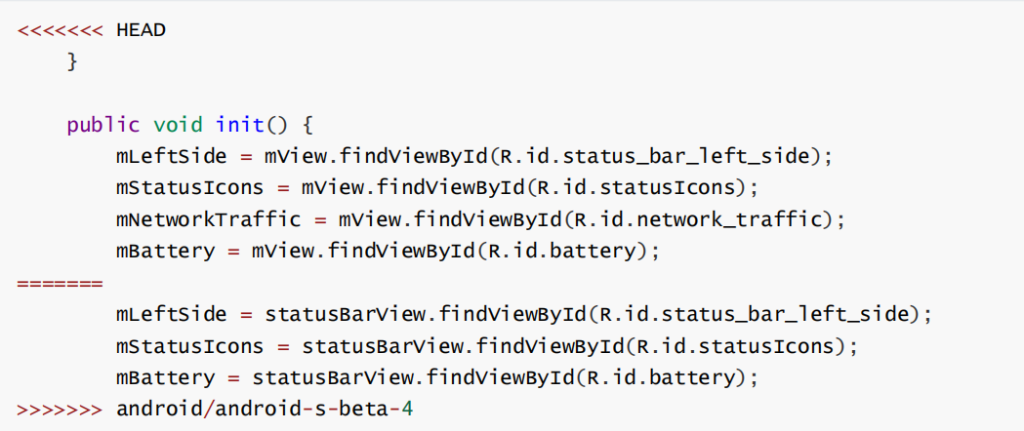

1. packages/SystemUI/src/com/android/systemui/appops/AppOpsControllerImpl.java
2. Downstream modifies method block

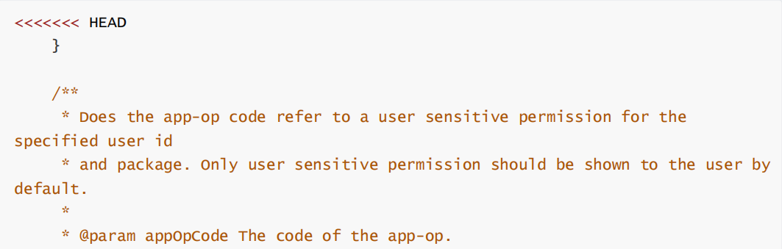

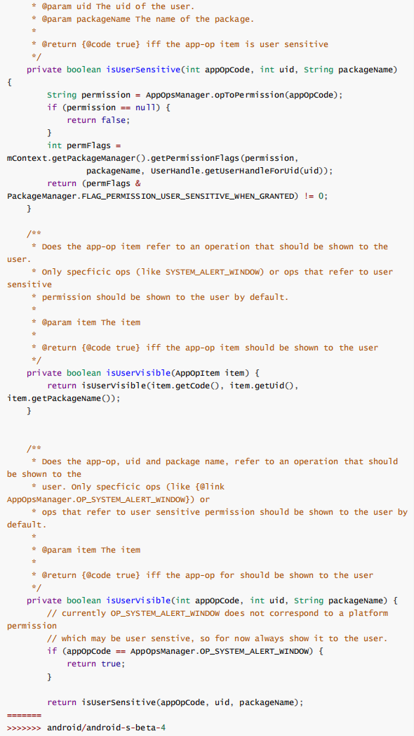

1. packages/SystemUI/src/com/android/systemui/statusbar/policy/Clock.java
2. Downstream modifies method block

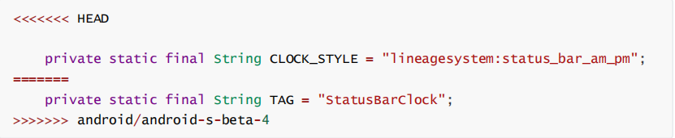

1. packages/SystemUI/src/com/android/systemui/doze/DozeScreenBrightness.java
2. Downstream modifies method block

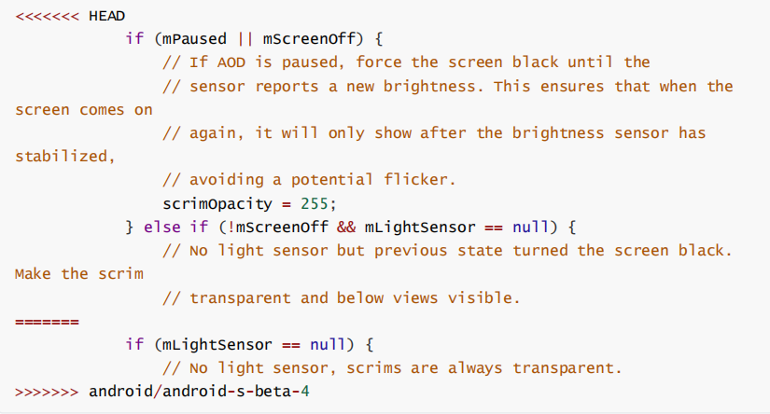

1. packages/SystemUI/tests/src/com/android/systemui/statusbar/notification/stack/NotificationStackScrollLayoutTest.java
2. Downstream modifies method block

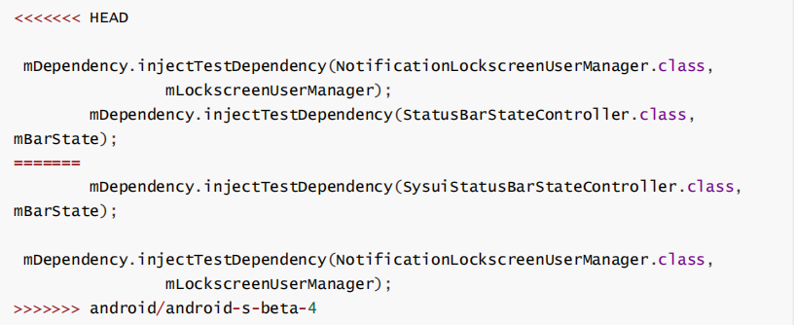

1. services/core/java/com/android/server/NetworkManagementService.java
2. Downstream modifies method block

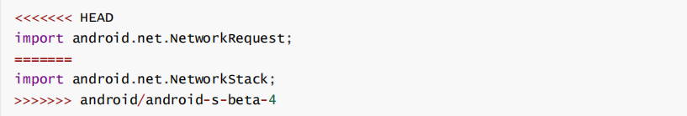

1. services/core/java/com/android/server/BluetoothManagerService.java
2. Downstream modifies method block

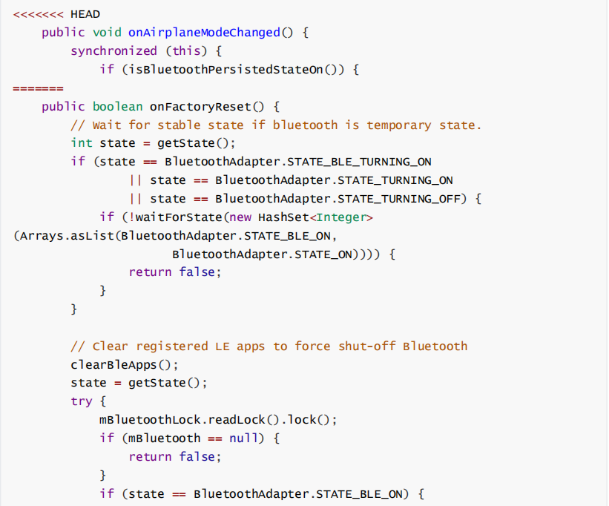

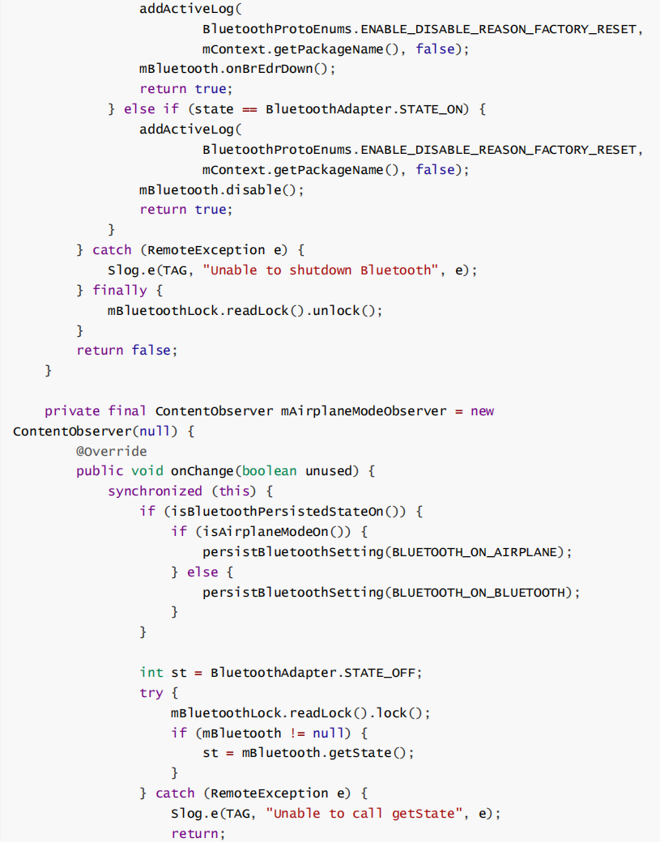

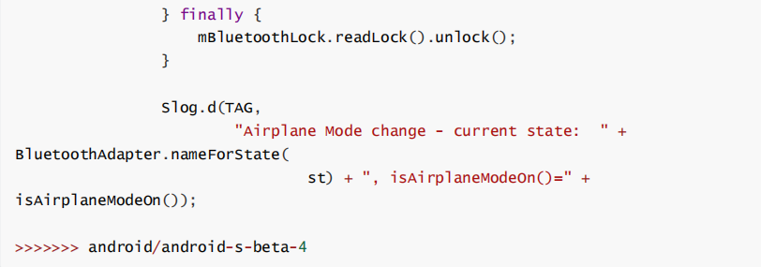

### Merge: 721f892272f7a01a7b3d4db7cefd8943acbb8a01

1. services/core/java/com/android/server/policy/keyguard/KeyguardStateMonitor.java
2. Downstream modifies method block

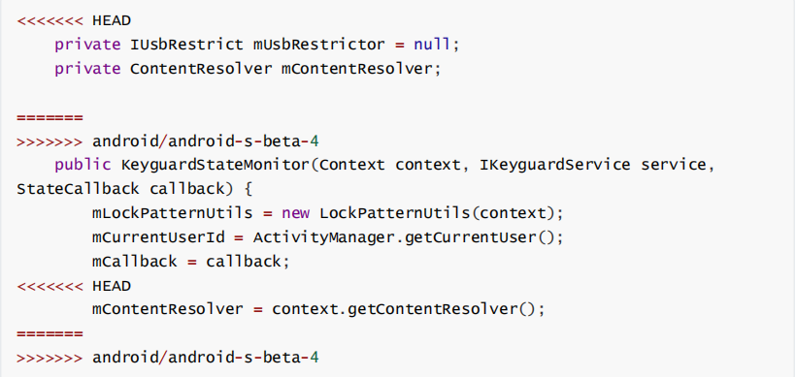

1. Downstream modifies method block

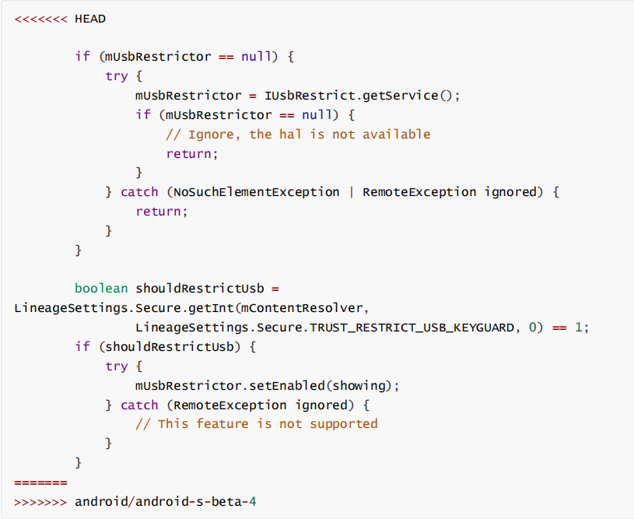

### Merge: 721f892272f7a01a7b3d4db7cefd8943acbb8a01

1. services/core/java/com/android/server/policy/keyguard/KeyguardStateMonitor.java
2. Downstream modifies method block

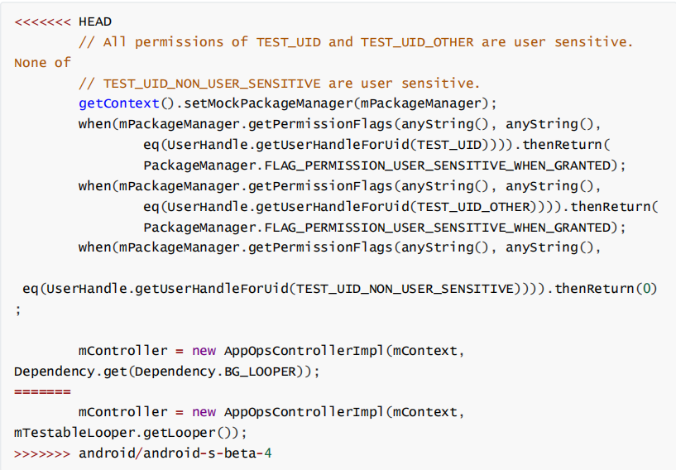

1. Downstream modifies method block

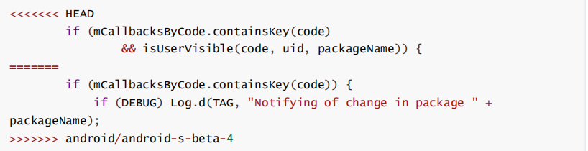

### Merge: 8943bbe92bfbc3ead44f63a6a3c145a135548b7c

1. packages/SystemUI/src/com/android/systemui/statusbar/phone/PhoneStatusBarPolicy.java
2. Downstream modifies method block

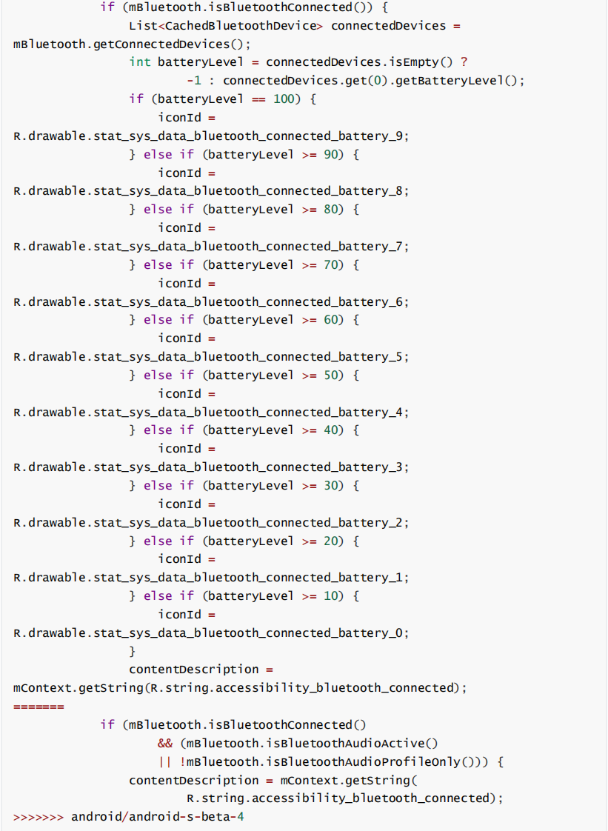

1. telephony/java/android/telephony/ServiceState.java
2. Downstream modifies method block

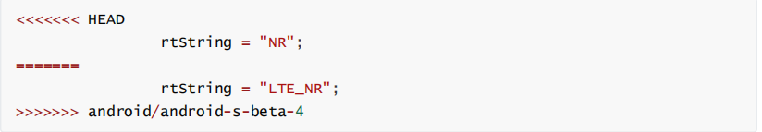

1. core/java/android/provider/Settings.java
2. Downstream modifies method block

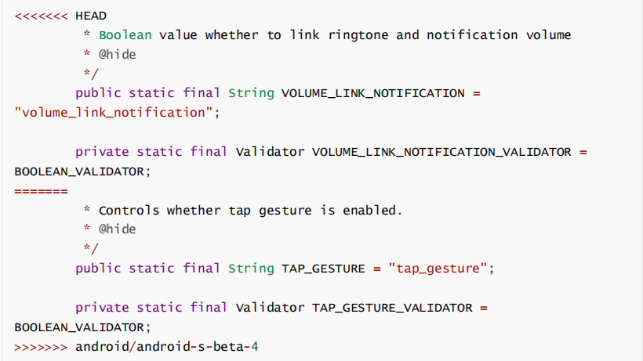

1. Downstream modifies method block

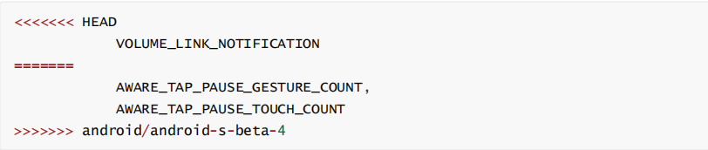

1. Downstream modifies method block

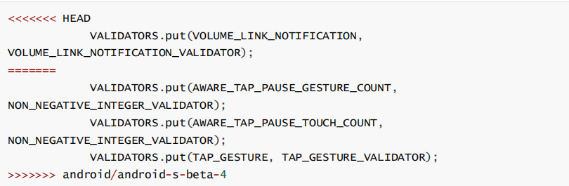

1. services/core/java/com/android/server/pm/UserManagerService.java
2. Downstream modifies method block

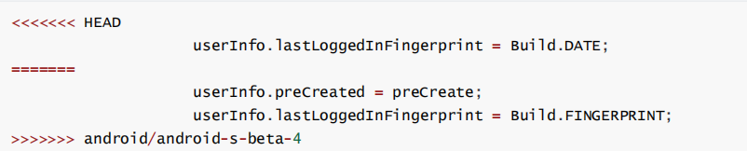

1. packages/SystemUI/src/com/android/systemui/statusbar/phone/StatusBar.java
2. Downstream modifies method block

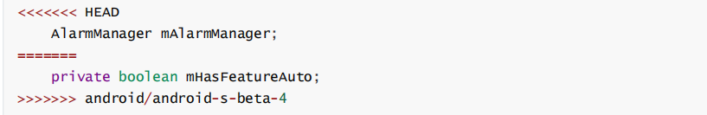

1. packages/SystemUI/src/com/android/systemui/screenshot/GlobalScreenshot.java
2. Downstream modifies method block

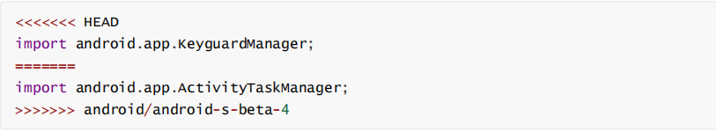

1. Downstream modifies method block

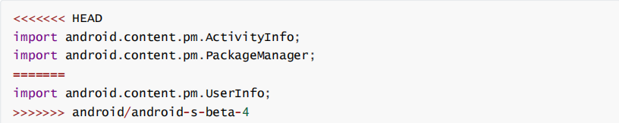

1. Downstream modifies method block

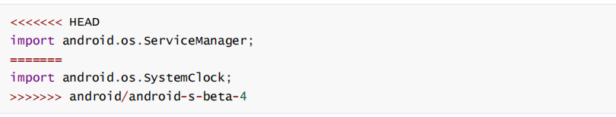

1. Downstream modifies method block

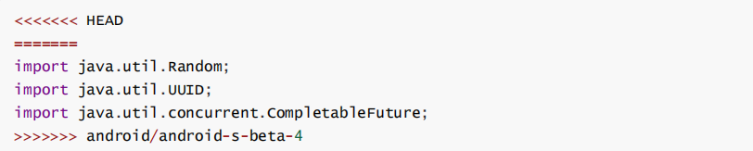

1. Downstream modifies method block

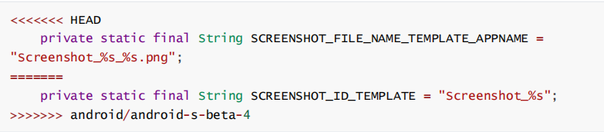

1. Downstream modifies method block

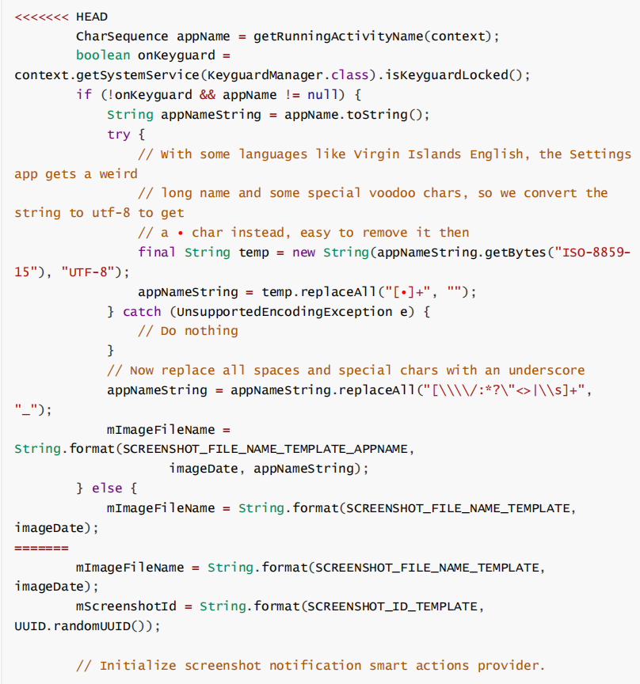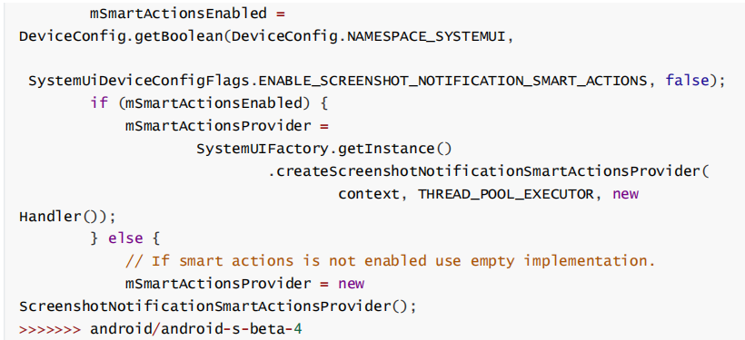

1. Downstream modifies method block

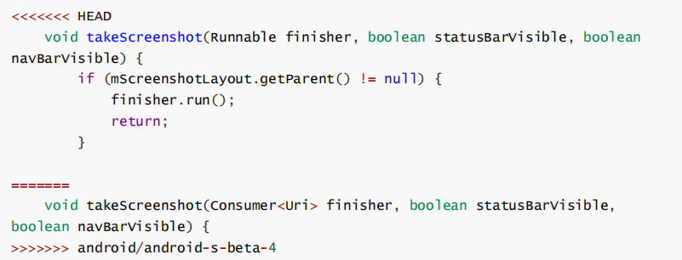

1. tests/net/java/android/net/netlink/InetDiagSocketTest.java
2. Downstream modifies method block

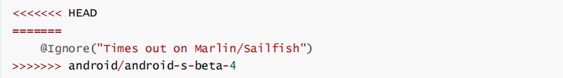

## OmniROM-12

### Merge: e15313dd5c01373f4e046366a36472a1913e3e39

1. services/core/java/com/android/server/pm/PackageManagerService.java
2. Downstream modifies method block

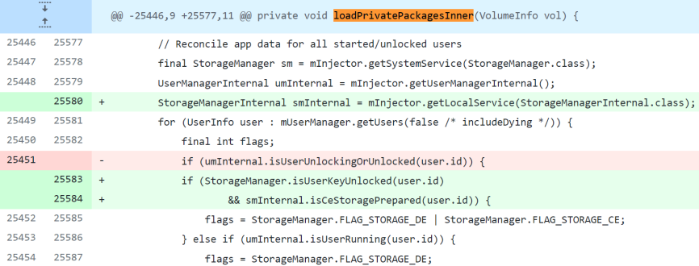

## OmniROM-11

### Merge: 8d21ad0d966c1e9f96e5a65144efad2582391957

1. services/core/java/com/android/server/wm/ActivityStack.java
2. Downstream modifies method block



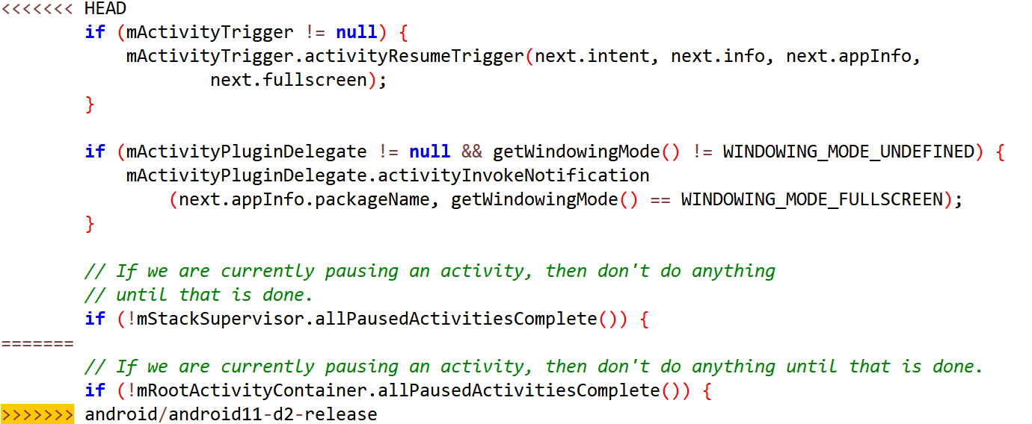

1. wifi/java/android/net/wifi/p2p/WifiP2pManager.java
2. Downstream modifies method block

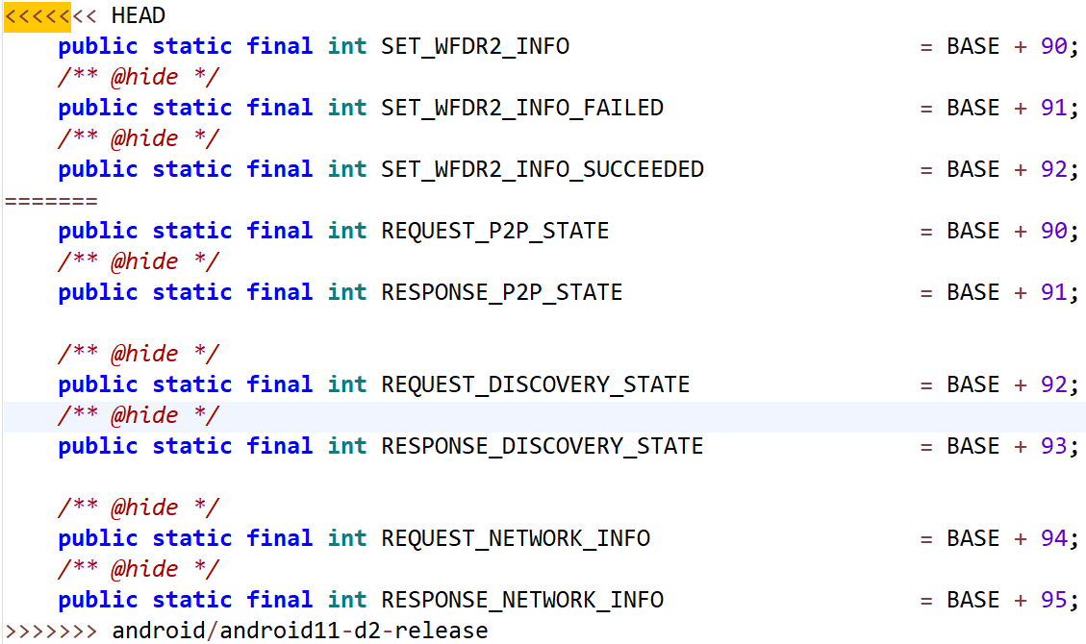

1. services/core/java/com/android/server/wm/ActivityStackSupervisor.java
2. Downstream modifies method block

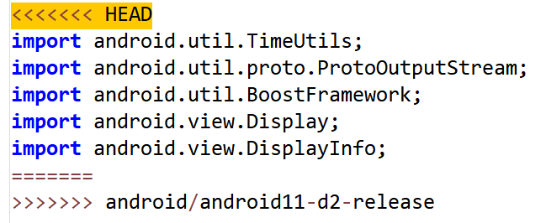

1. services/core/java/com/android/server/wm/ActivityRecord.java
2. Downstream modifies method block

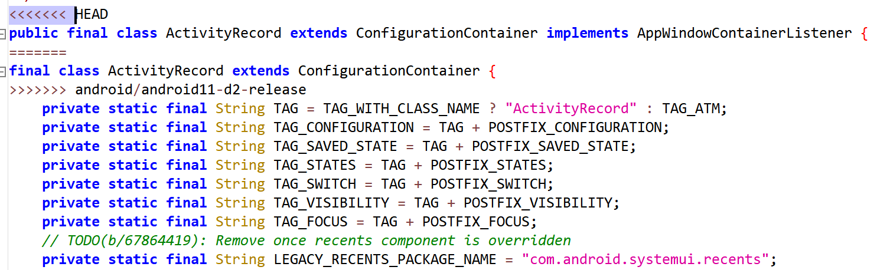

1. services/core/java/com/android/server/policy/PhoneWindowManager.java
2. Downstream modifies method block

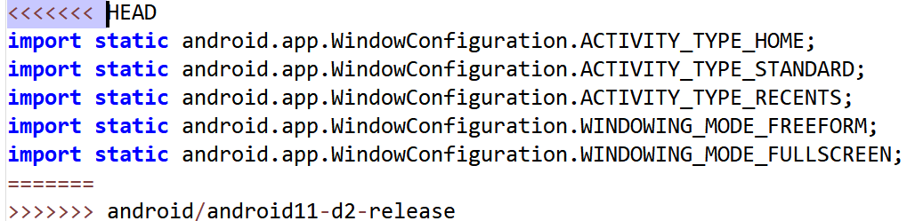

1. services/core/java/com/android/server/ConnectivityService.java
2. Downstream modifies method block

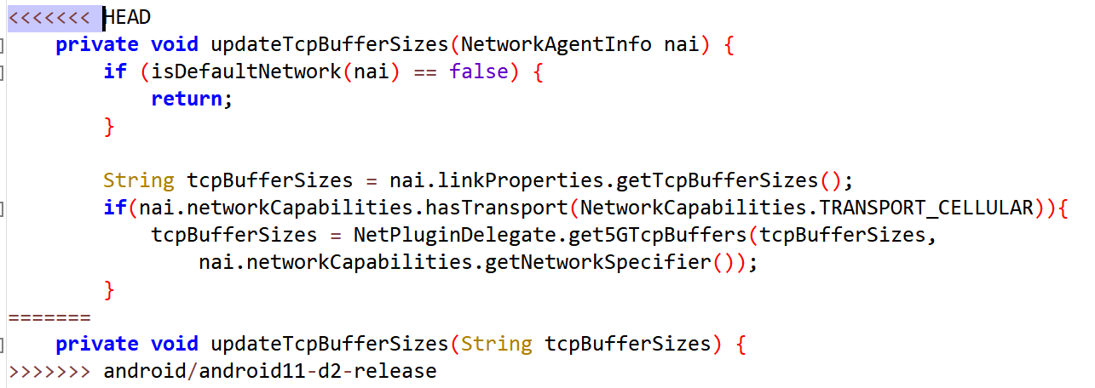

1. packages/SettingsLib/src/com/android/settingslib/wifi/AccessPoint.java
2. Downstream modifies method block

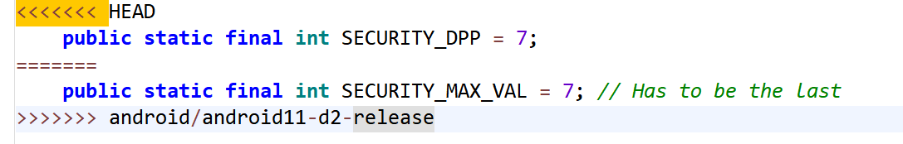

### Merge: ddc3dc79034f4570388245270b50ddad964c11f0

1. services/core/java/com/android/server/audio/AudioDeviceBroker.java
2. Downstream modifies method block

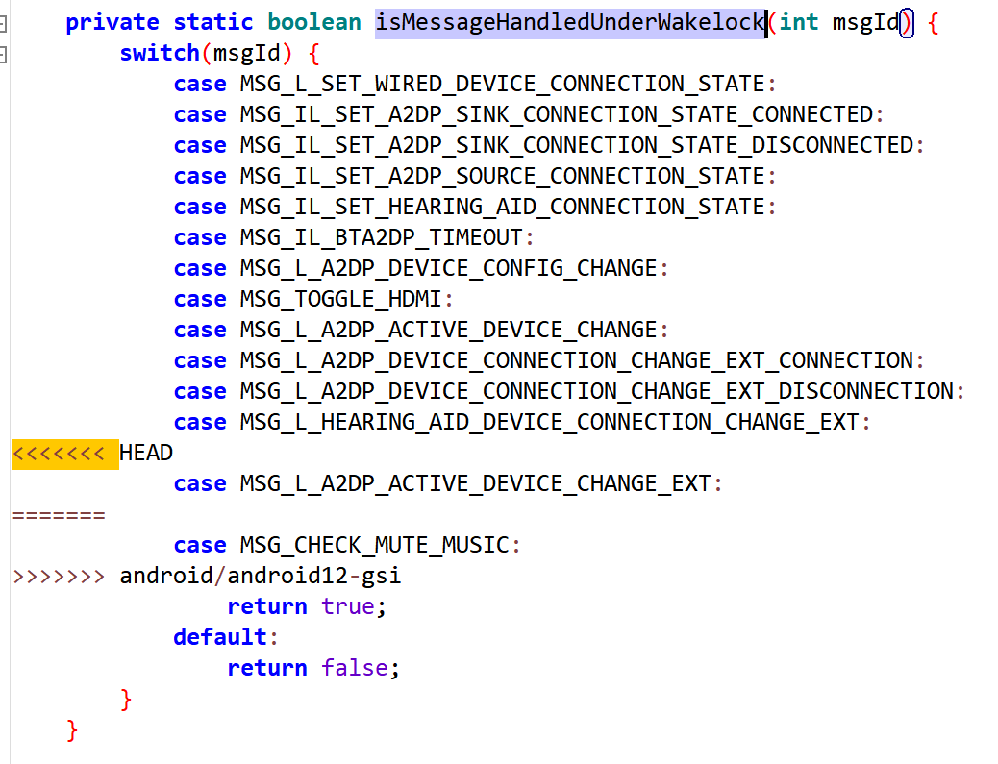

1. packages/SystemUI/src/com/android/systemui/statusbar/phone/PhoneStatusBarPolicy.java
2. Downstream modifies method block

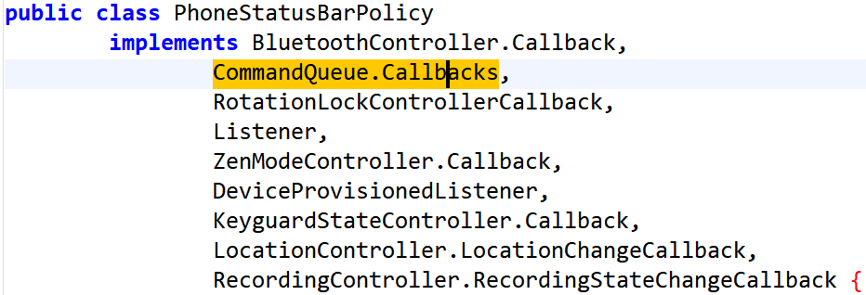

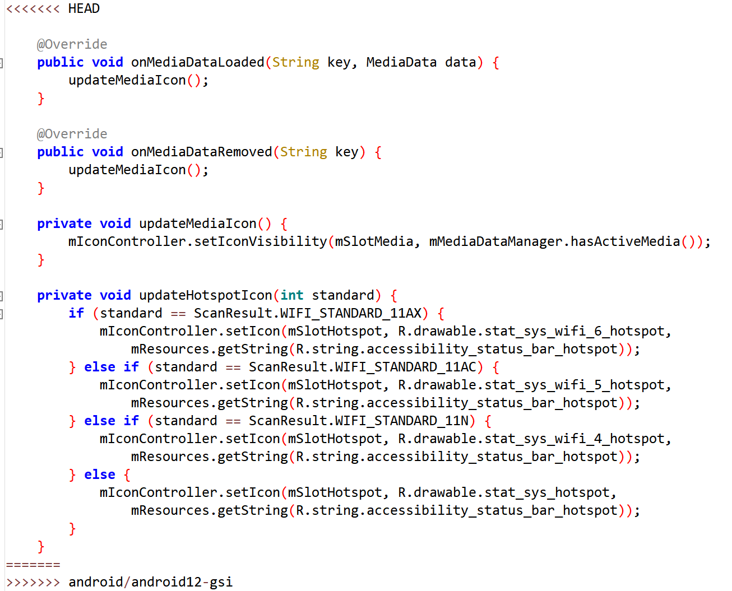

### Merge: 8faa0d981413f18b2468dde1b1fe71e248df0df1

1. packages/SystemUI/src/com/android/systemui/qs/QSPanel.java
2. Downstream modifies method block

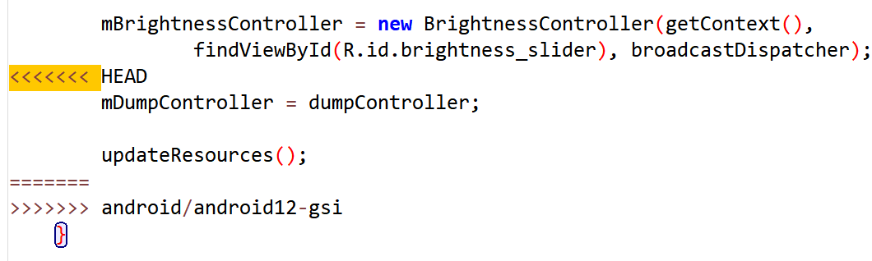

1. core/java/android/view/SurfaceControl.java
2. Downstream modifies method block

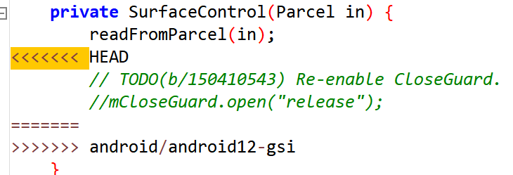

1. packages/SystemUI/src/com/android/systemui/keyguard/KeyguardViewMediator.java
2. Downstream modifies method block

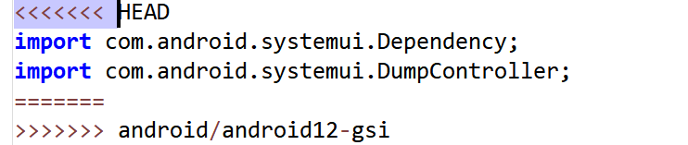

1. packages/SystemUI/src/com/android/systemui/statusbar/phone/PhoneStatusBarPolicy.java
2. Downstream modifies method block

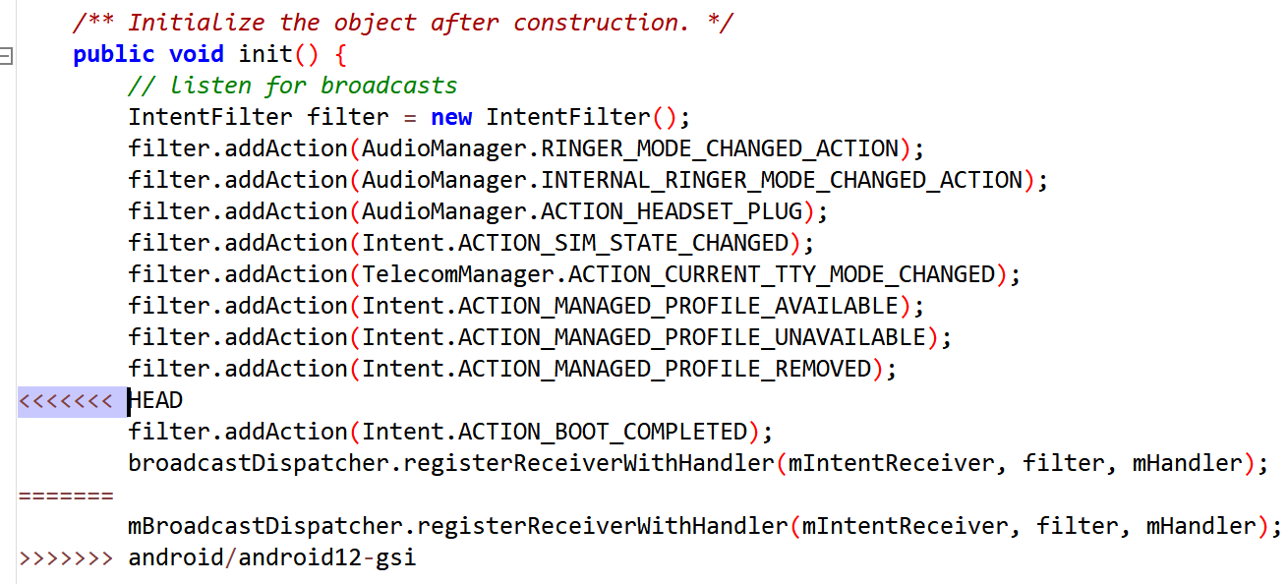

1. packages/SystemUI/src/com/android/systemui/statusbar/policy/WifiSignalController.java
2. Downstream modifies method block

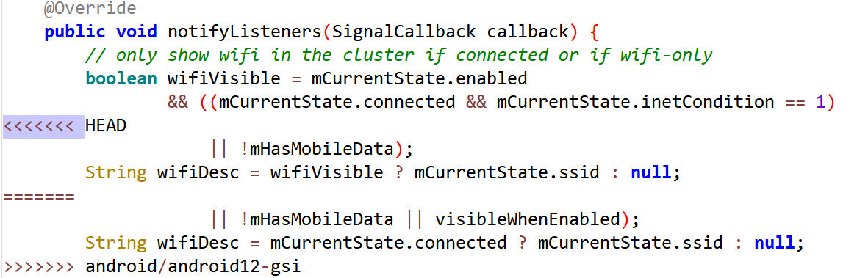

1. services/core/java/com/android/server/ConnectivityService.java
2. Downstream modifies method block

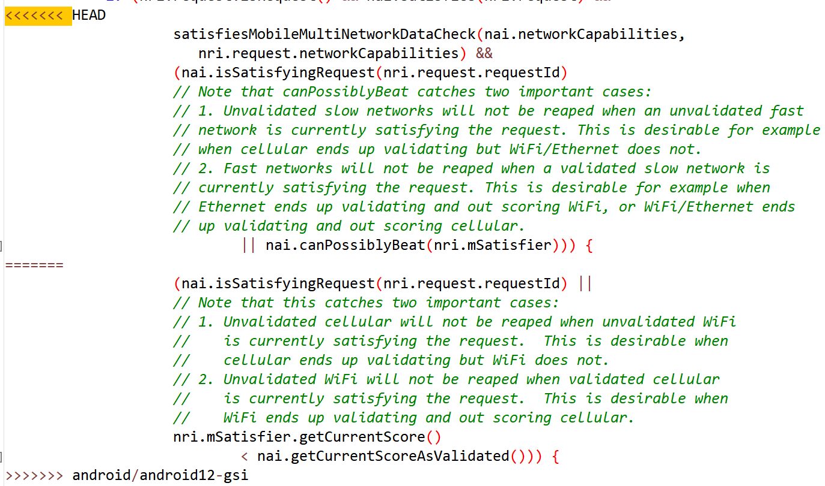

1. services/core/java/com/android/server/Watchdog.java
2. Downstream modifies method block

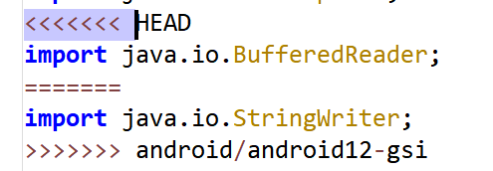

1. Downstream modifies method block

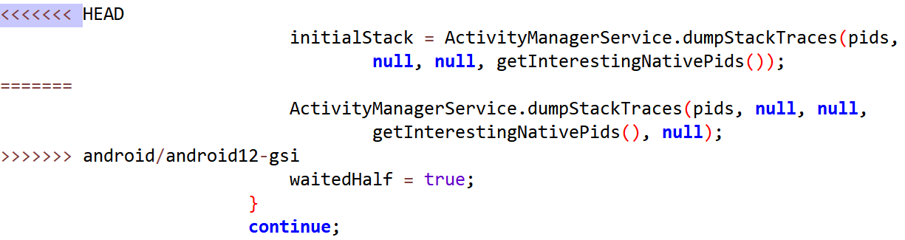

1. Downstream modifies method block

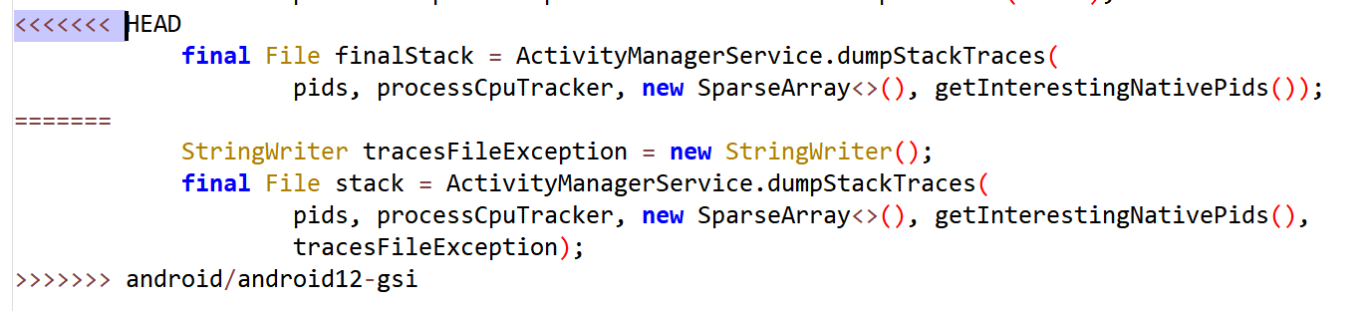

1. Downstream modifies method block

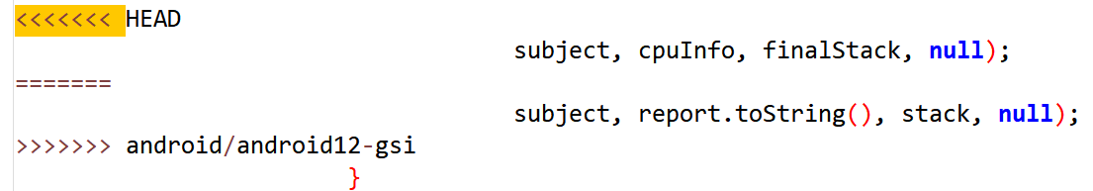

1. services/core/java/com/android/server/am/ProcessRecord.java
2. Downstream modifies method block

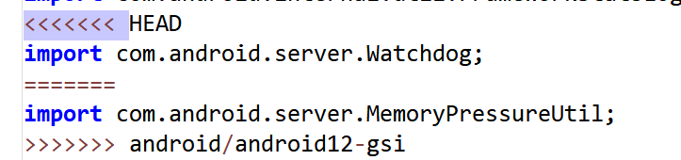

1. services/core/java/com/android/server/connectivity/NetworkAgentInfo.java
2. Downstream modifies method block

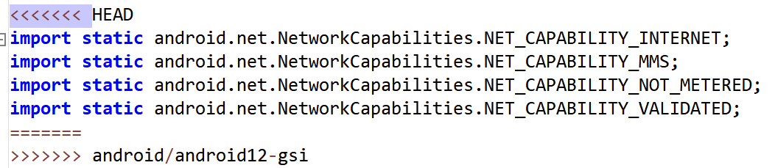

1. services/core/java/com/android/server/wm/ActivityRecord.java
2. Downstream modifies method block

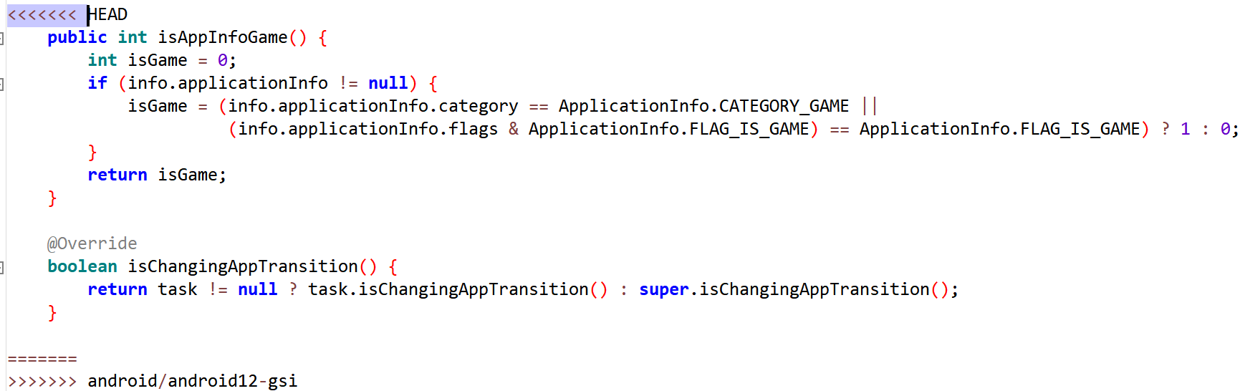

1. services/core/java/com/android/server/wm/ActivityStack.java
2. Downstream modifies method block

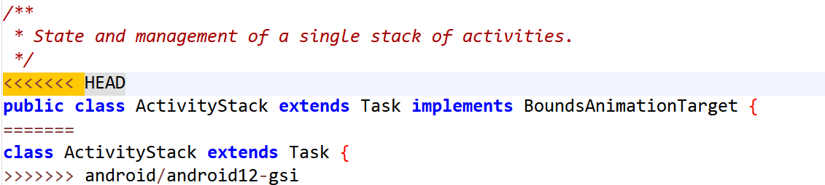

1. telephony/java/android/telephony/CarrierConfigManager.java
2. Downstream modifies method block

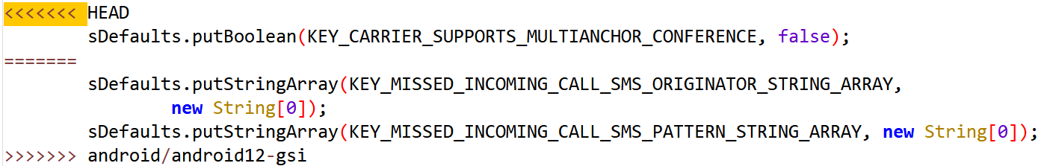

1. packages/SystemUI/src/com/android/systemui/statusbar/phone/PhoneStatusBarPolicy.java
2. Downstream modifies method block

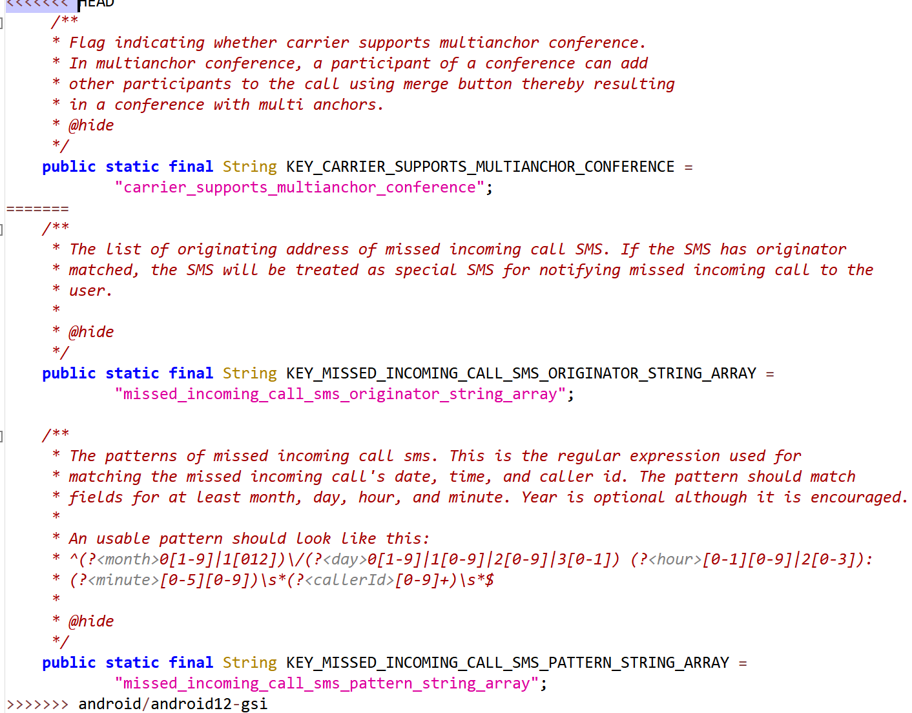

1. wifi/java/android/net/wifi/ScanResult.java
2. Downstream modifies method block

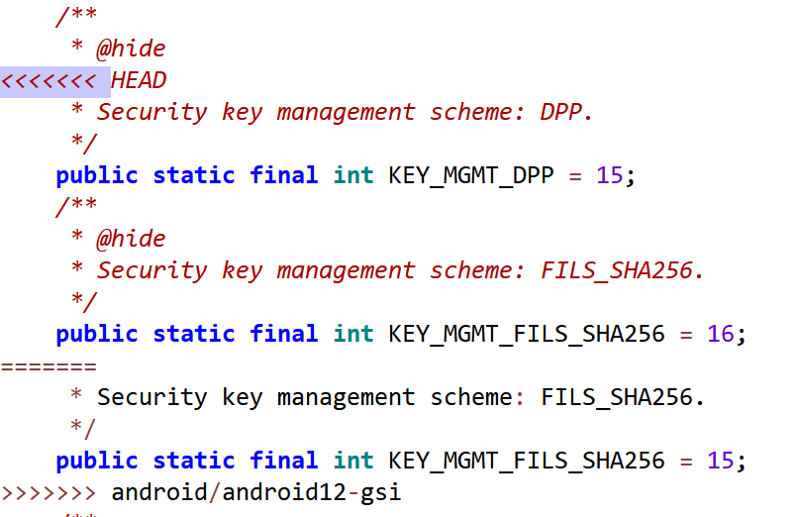

1. Downstream modifies method block

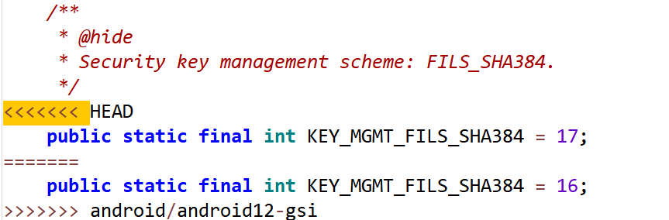

1. wifi/java/android/net/wifi/WifiConfiguration.java
2. Downstream modifies method block

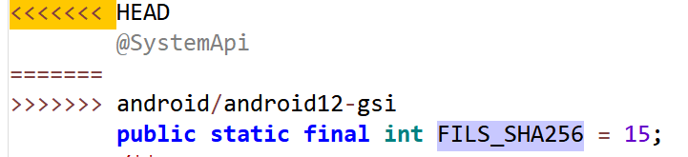

1. Downstream modifies method block

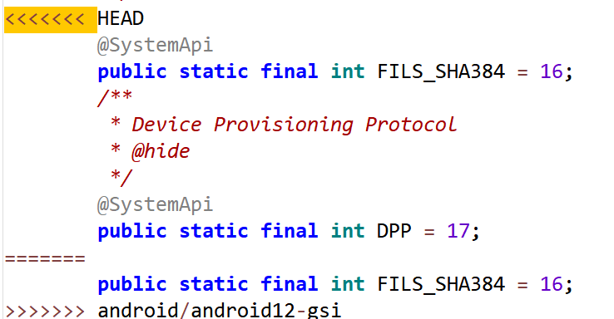

1. Downstream modifies method block

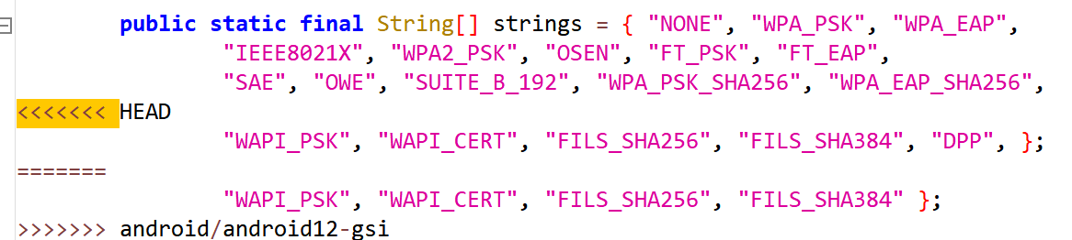

1. Downstream modifies method block

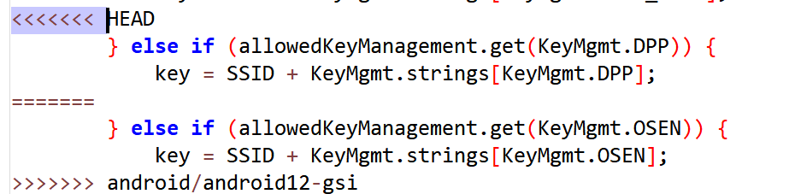

1. wifi/java/android/net/wifi/WifiEnterpriseConfig.java
2. Downstream modifies method block

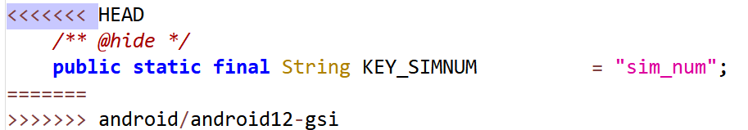

### Merge: 43ceded8caaffead0a2a1967f42a4ef4bb658ced

1. services/core/java/com/android/server/wm/ActivityStackSupervisor.java
2. Downstream modifies method block

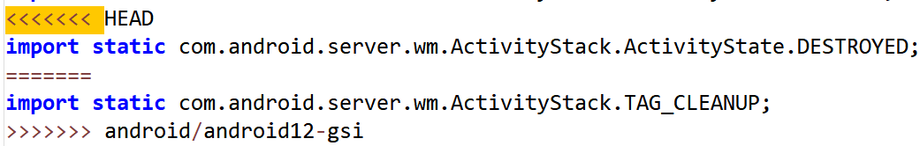

1. Downstream modifies method block

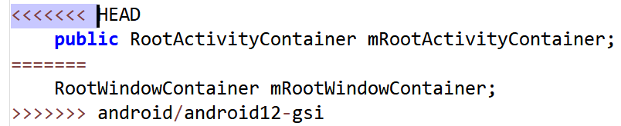

1. wifi/java/android/net/wifi/WifiManager.java
2. Downstream modifies method block

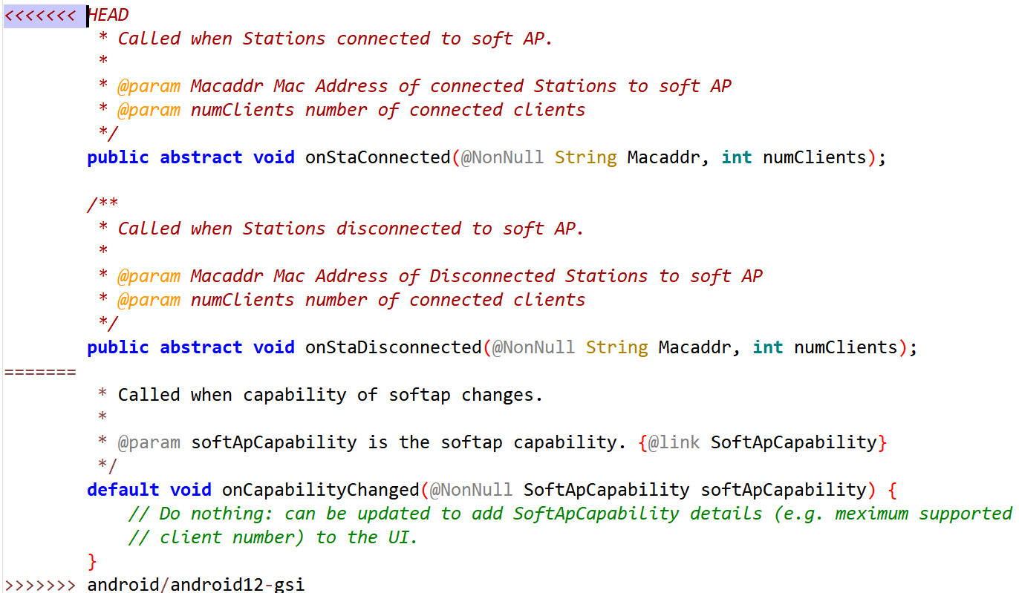

1. wifi/java/android/net/wifi/WifiManager.java
2. Downstream modifies method block

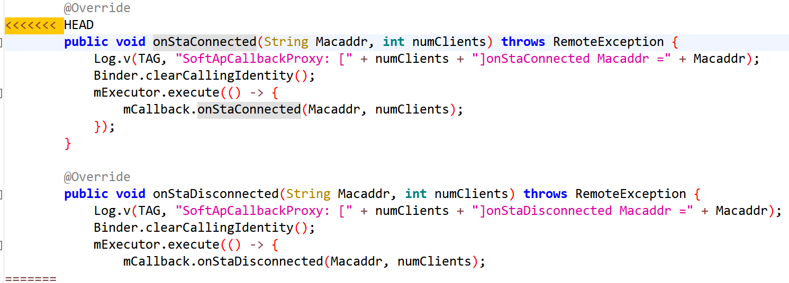

1. wifi/java/android/net/wifi/WifiEnterpriseConfig.java
2. Downstream modifies method block

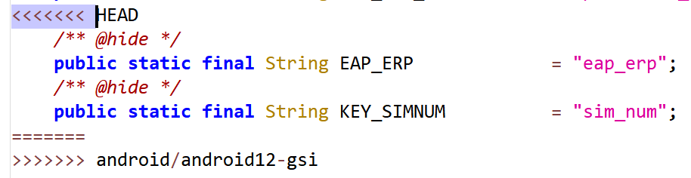

1. wifi/java/android/net/wifi/WifiConfiguration.java
2. Downstream modifies method block

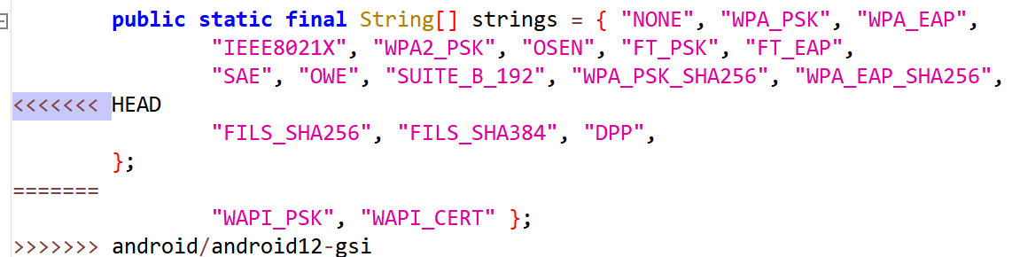

1. wifi/java/android/net/wifi/WifiConfiguration.java
2. Downstream modifies method block

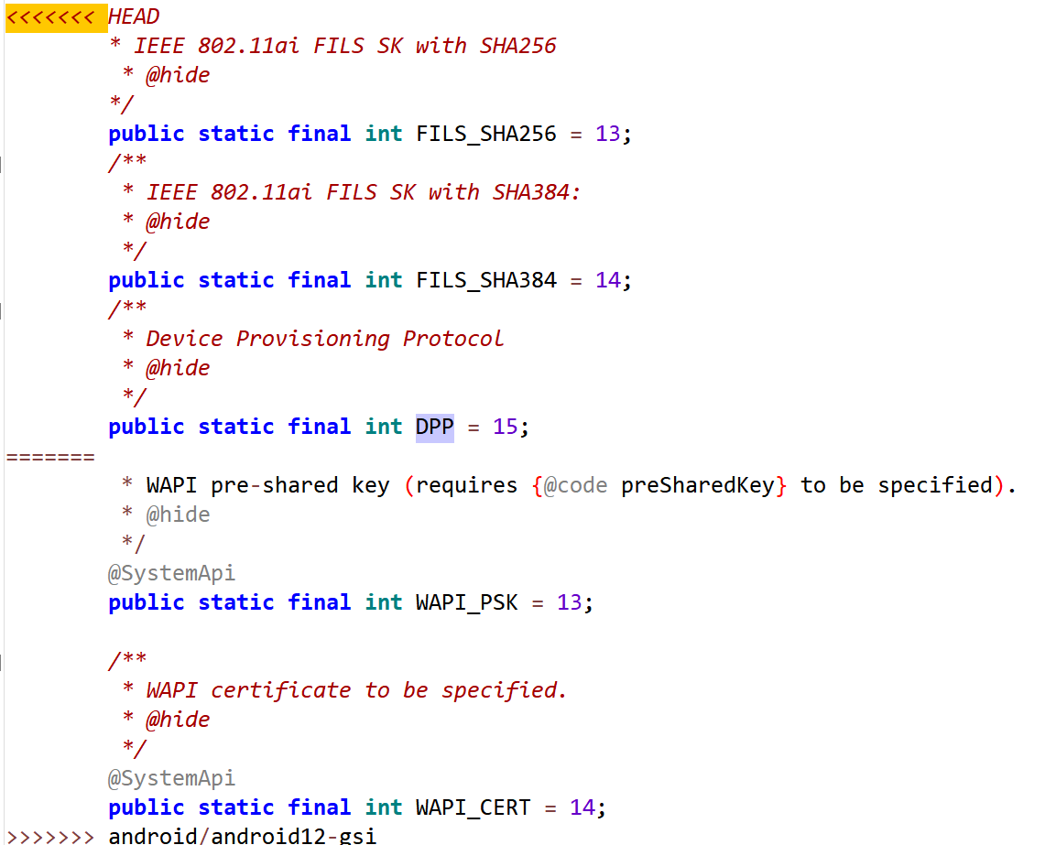

1. wifi/java/android/net/wifi/WifiConfiguration.java
2. Downstream modifies method block

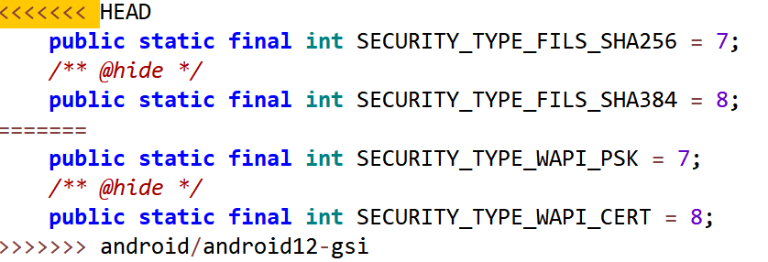

1. Downstream modifies method block

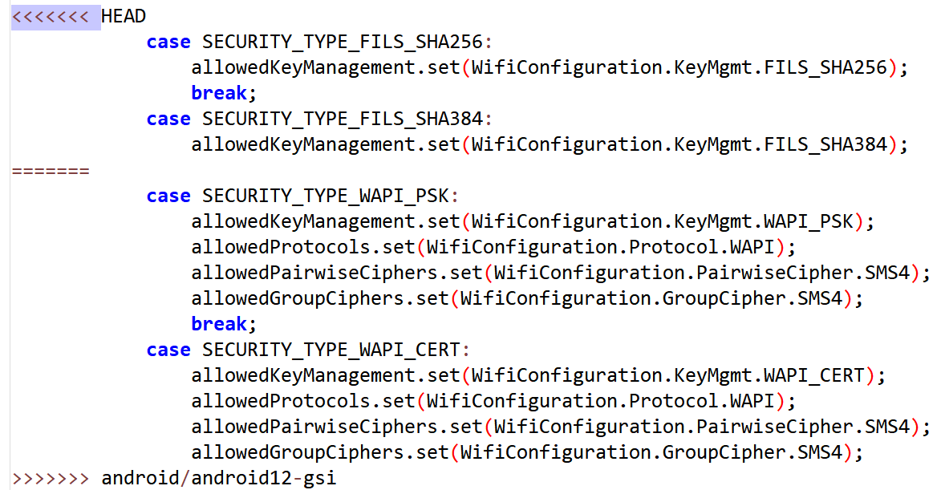

1. Downstream modifies method block

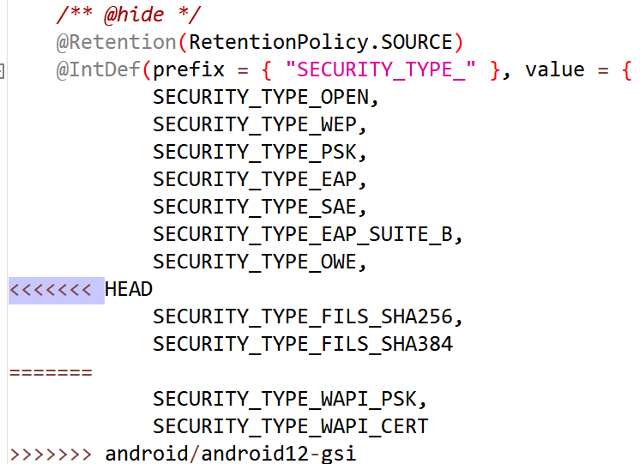

1. Downstream modifies method block

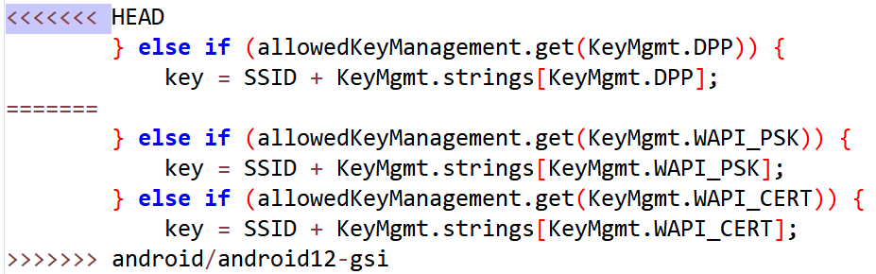

1. wifi/java/android/net/wifi/WifiConfiguration.java
2. Downstream modifies method block



1. wifi/java/android/net/wifi/ScanResult.java
2. Downstream modifies method block

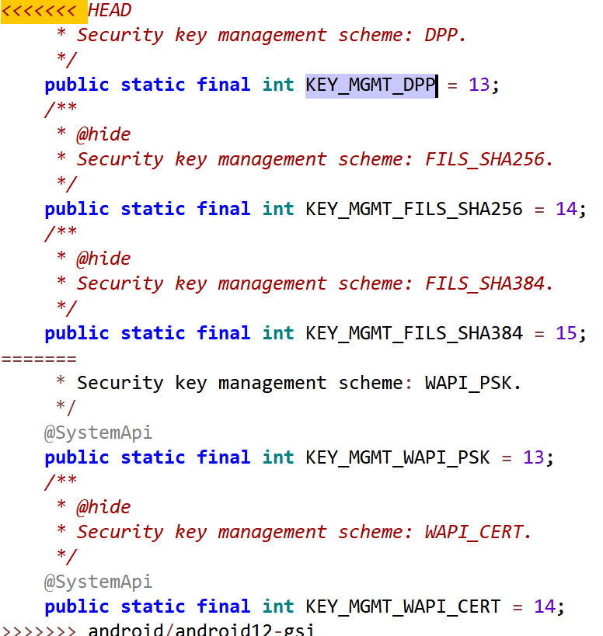

1. telephony/java/android/telephony/SmsManager.java
2. Downstream modifies method block

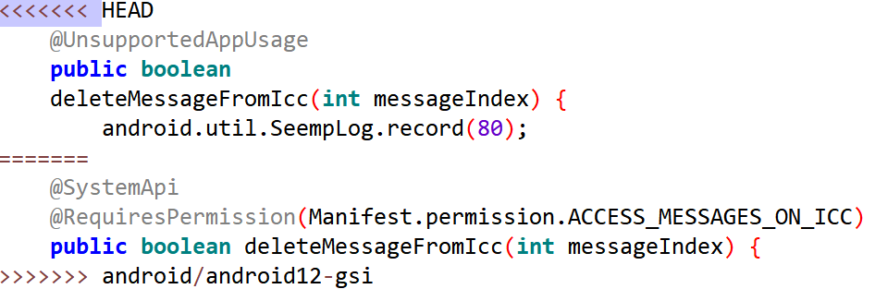

1. wifi/java/android/net/wifi/WifiConfiguration.java
2. Downstream modifies method block

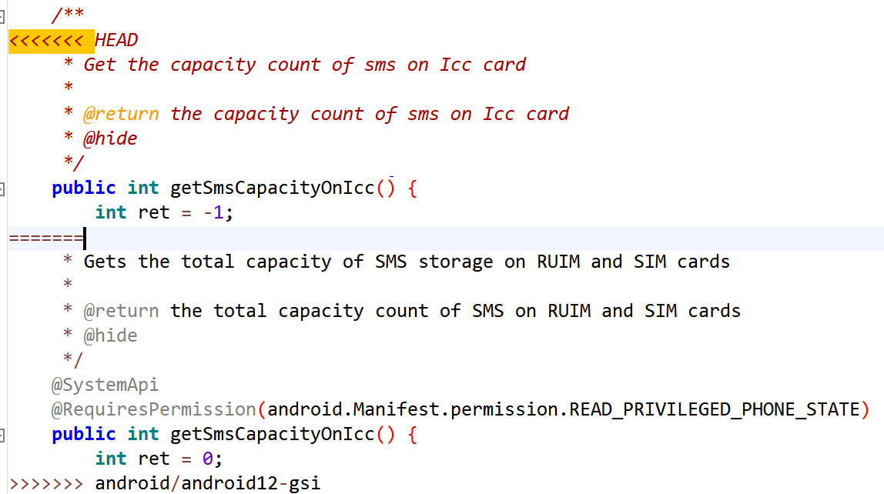

1. telephony/java/android/telephony/CarrierConfigManager.java
2. Downstream modifies method block

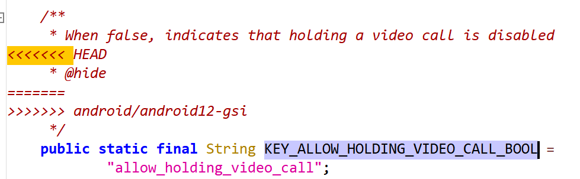

1. services/core/java/com/android/server/wm/ActivityTaskManagerService.java
2. Downstream modifies method block

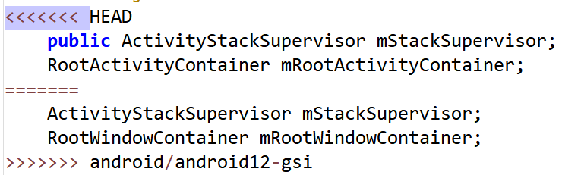

1. services/core/java/com/android/server/wm/ActivityStack.java
2. Downstream modifies method block

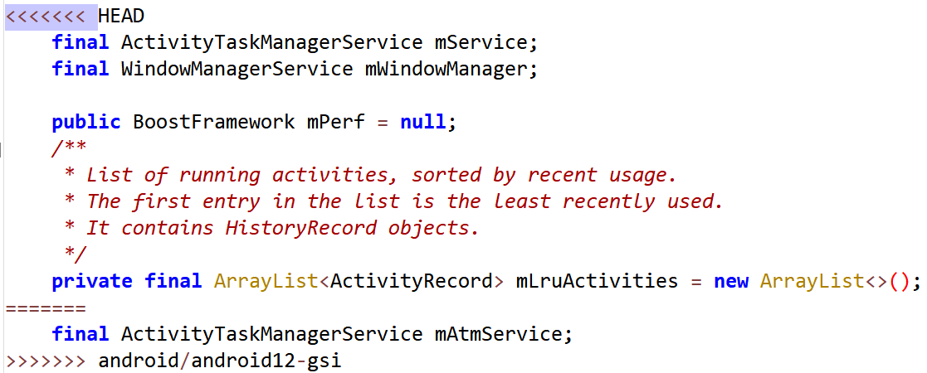

1. services/core/java/com/android/server/pm/PackageManagerService.java
2. Downstream modifies method block

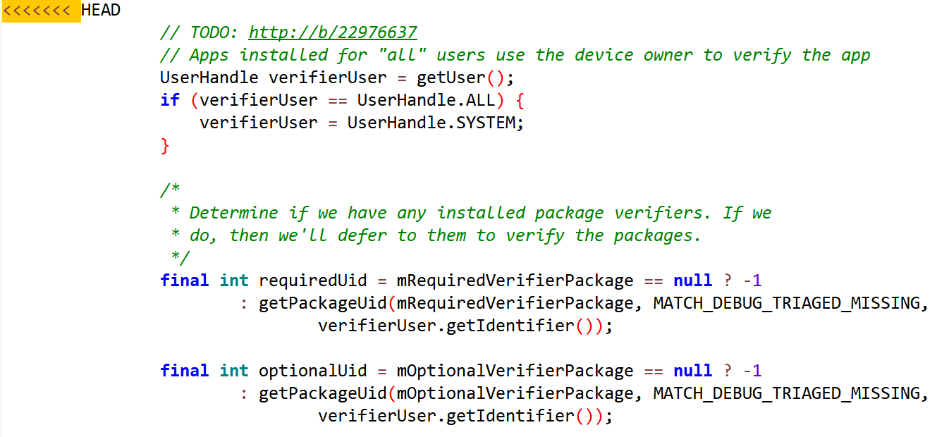

1. Downstream modifies method block

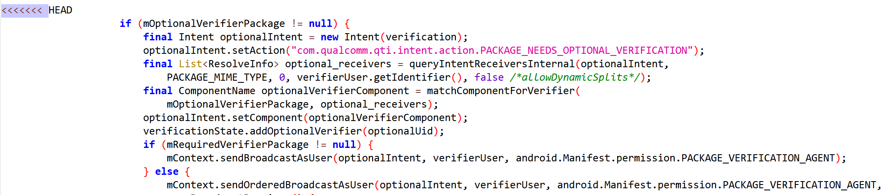

1. services/core/java/com/android/server/display/LocalDisplayAdapter.java
2. Downstream modifies method block

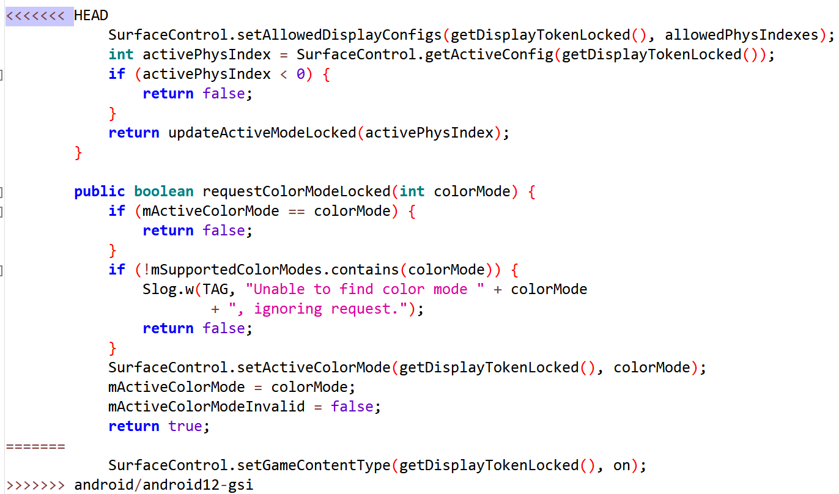

1. services/core/java/com/android/server/audio/AudioDeviceInventory.java
2. Downstream modifies method block

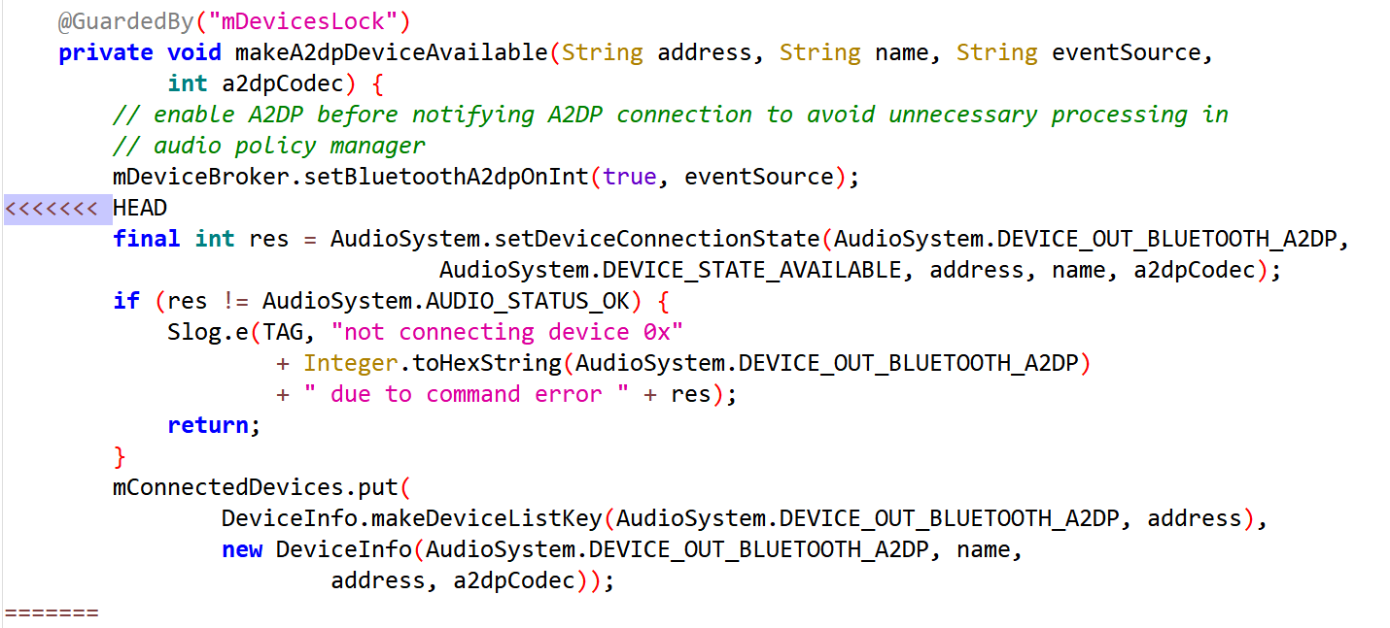

1. services/core/java/com/android/server/am/ProcessRecord.java
2. Downstream modifies method block

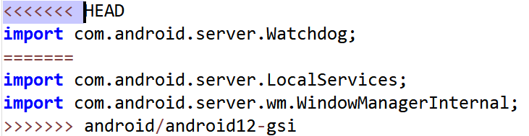

1. services/core/java/com/android/server/am/ProcessList.java
2. Downstream modifies method block

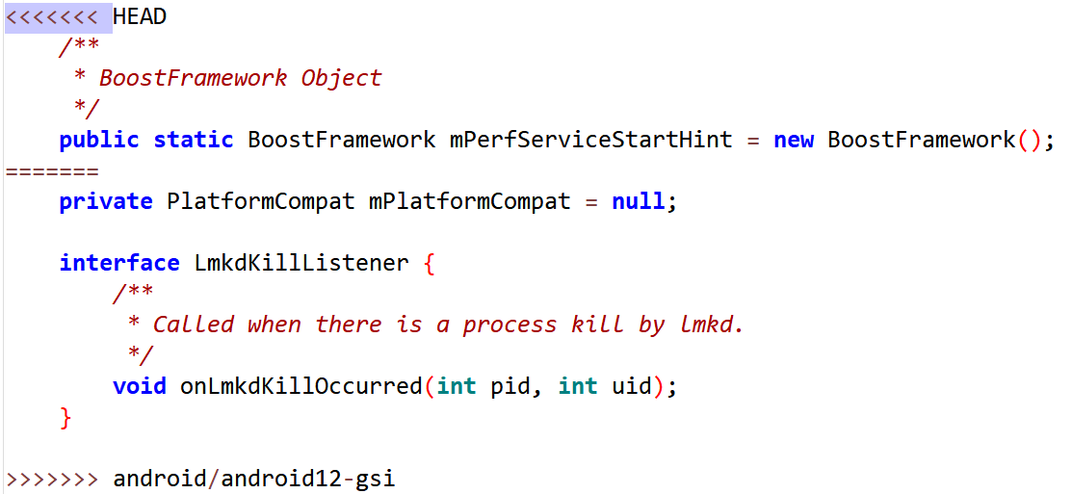

1. core/java/android/content/Intent.java
2. Downstream modifies method block

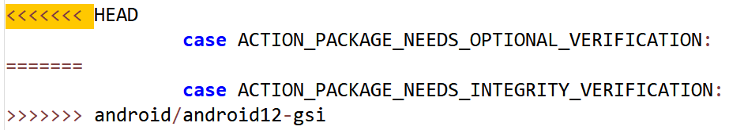

1. core/java/android/content/ContentResolver.java
2. Downstream modifies method block

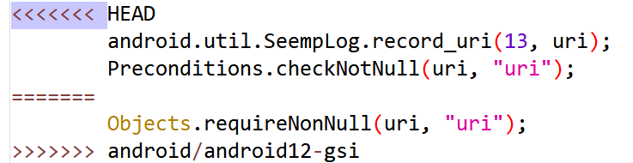

1. Downstream modifies method block

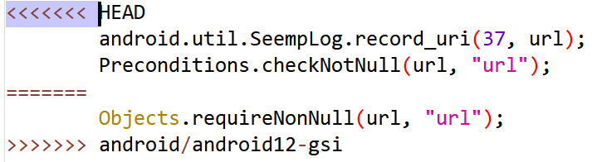

## OmniROM-10

### Merge: b7ff81acc796b2957f68c9412cef71b9b47e67de

1. services/core/java/com/android/server/display/AutomaticBrightnessController.java
2. Downstream modifies method block

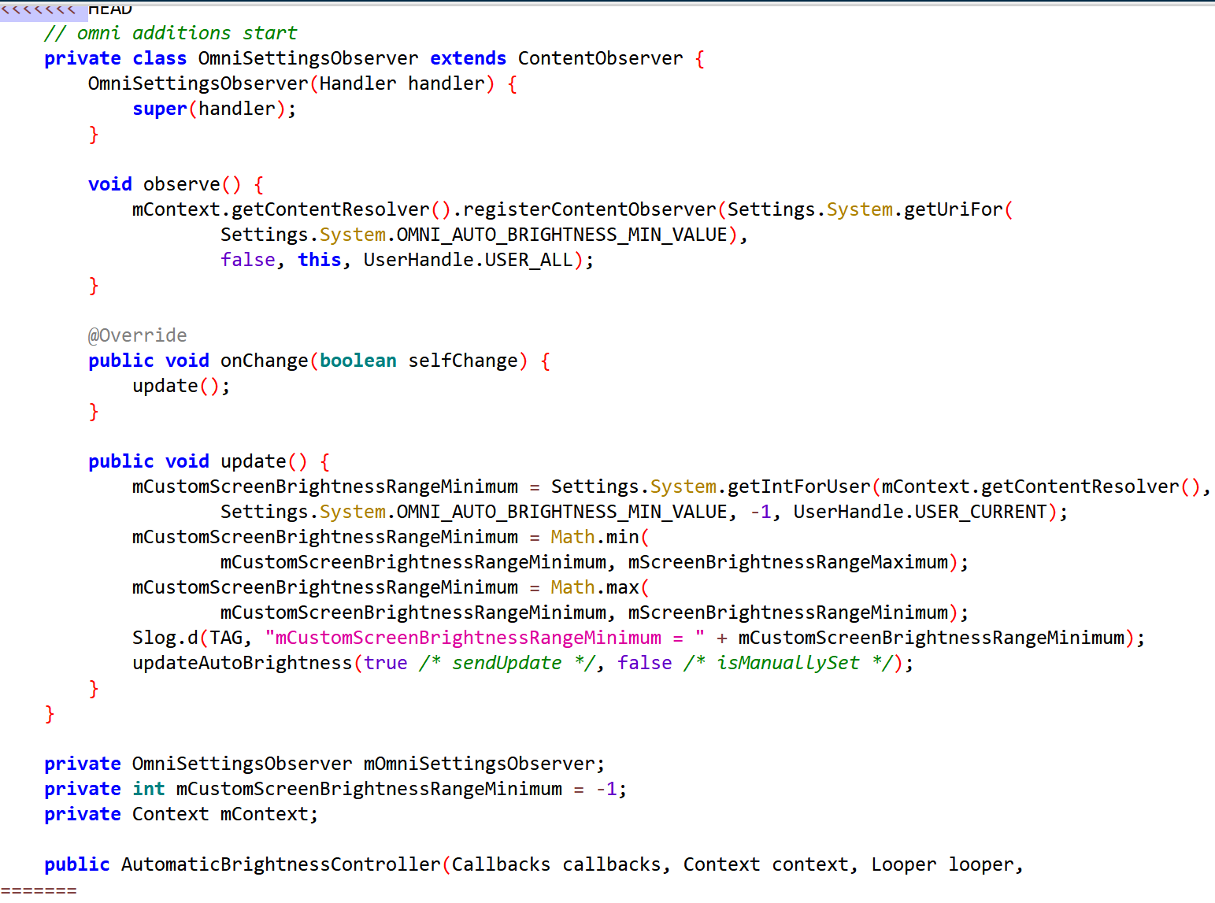

1. Downstream modifies method block

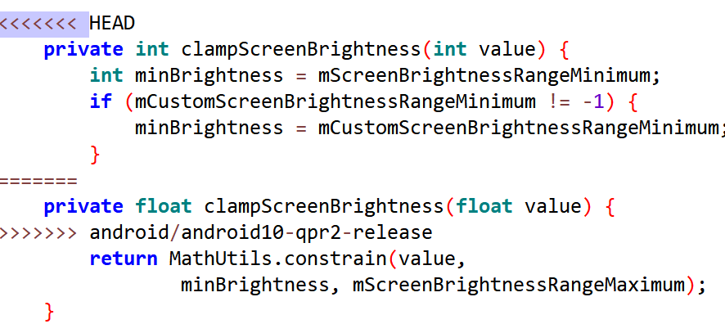

1. packages/SystemUI/src/com/android/systemui/statusbar/phone/StatusBar.java
2. Downstream modifies method block

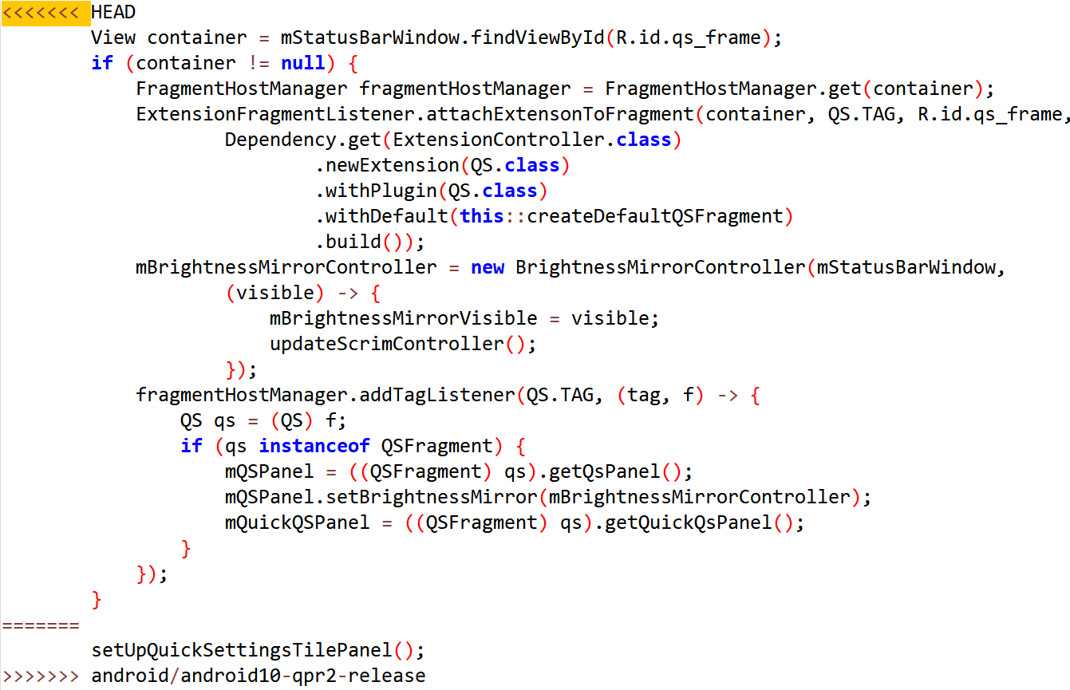

1. telephony/java/android/telephony/ServiceState.java
2. Downstream modifies method block

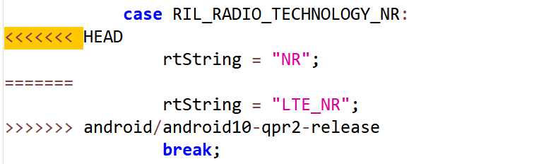

1. services/core/java/com/android/server/notification/NotificationManagerService.java
2. Downstream modifies method block

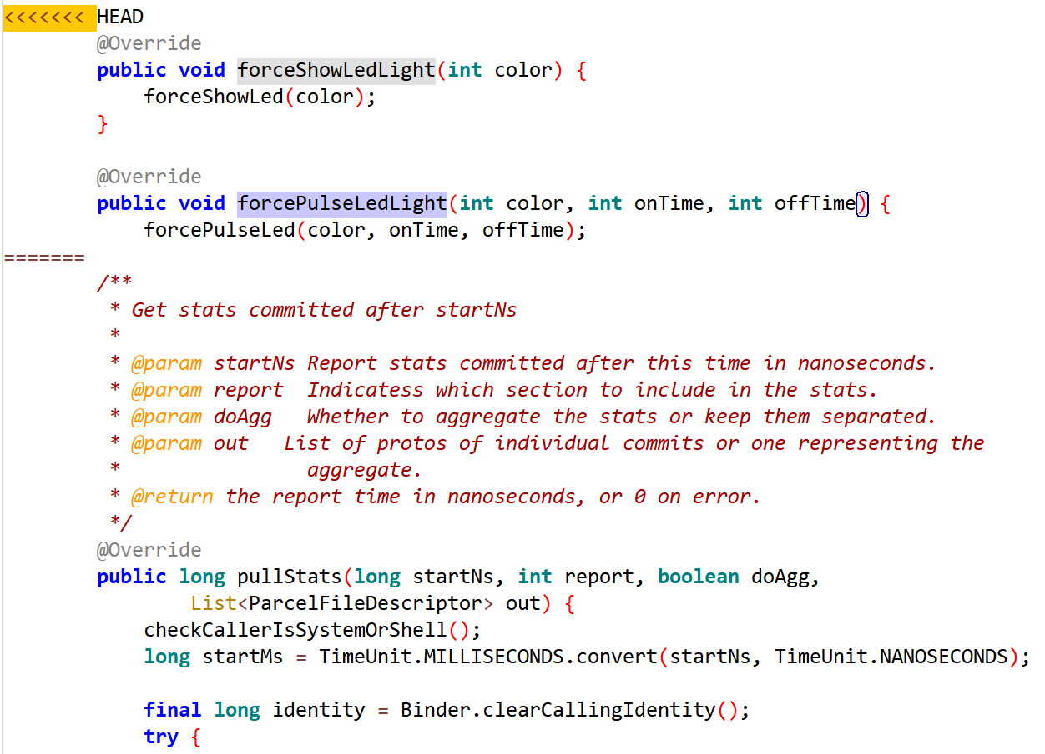

1. packages/SystemUI/src/com/android/systemui/statusbar/phone/ScrimController.java
2. Downstream modifies method block

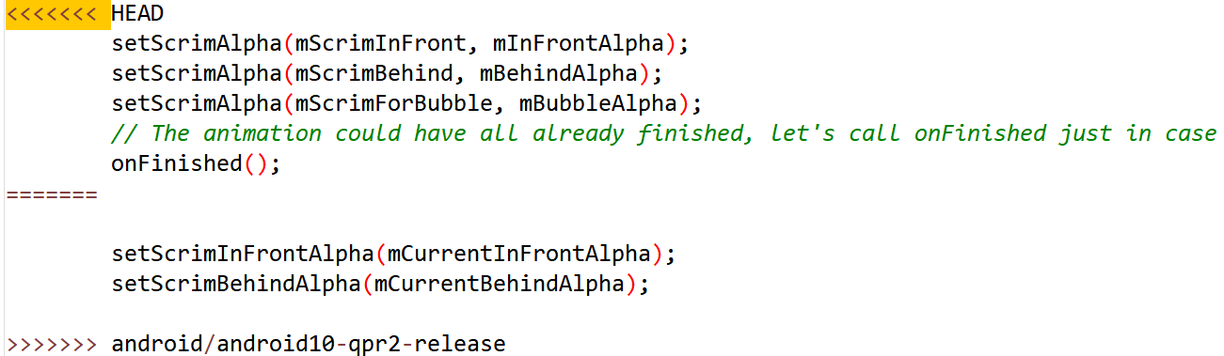

1. Downstream modifies method block

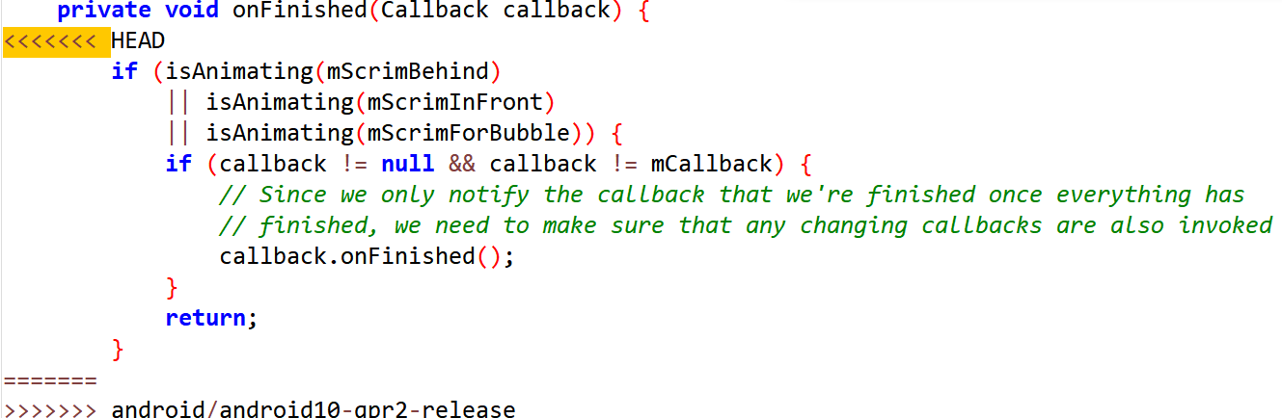

1. packages/SystemUI/src/com/android/systemui/statusbar/phone/PhoneStatusBarPolicy.java
2. Downstream modifies method block

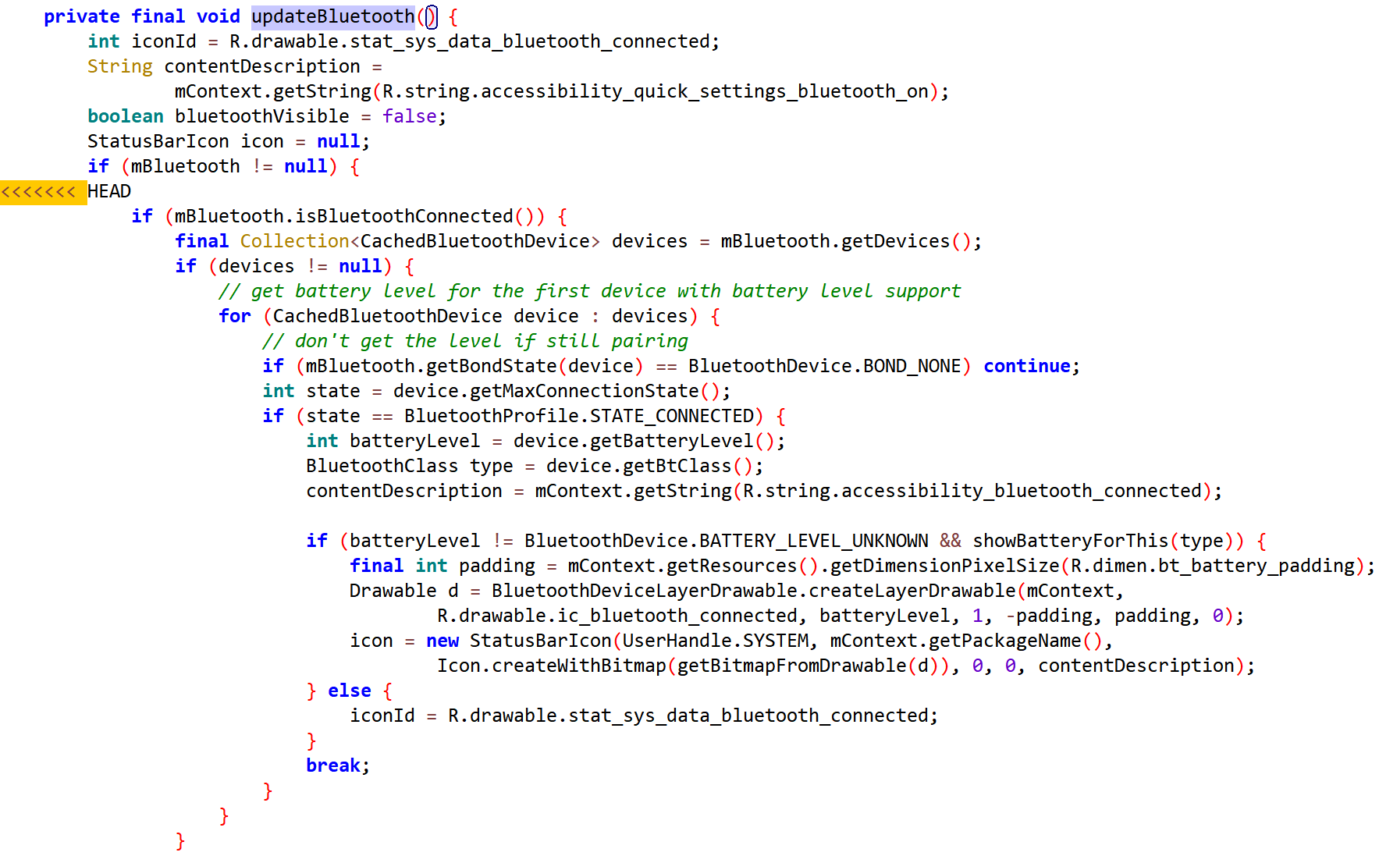

1. packages/SystemUI/src/com/android/systemui/statusbar/KeyguardIndicationController.java
2. Downstream modifies method block

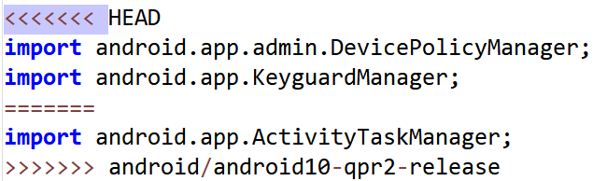

1. Downstream modifies method block

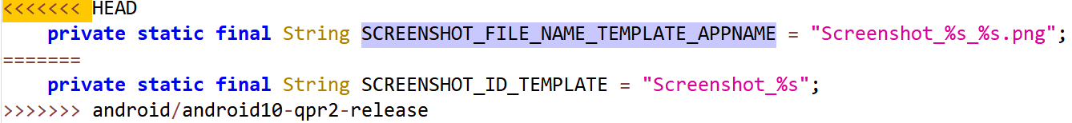

1. Downstream modifies method block

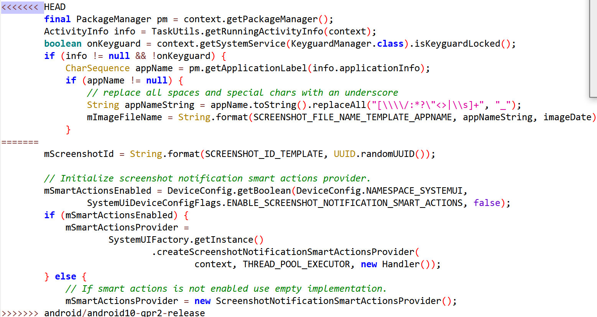

1. Downstream modifies method parameter

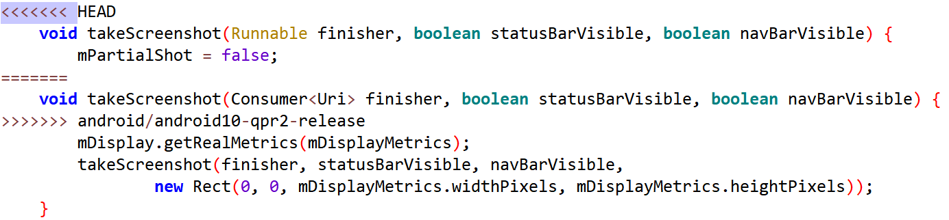

1. packages/SystemUI/src/com/android/systemui/globalactions/GlobalActionsDialog.java
2. Downstream modifies method block

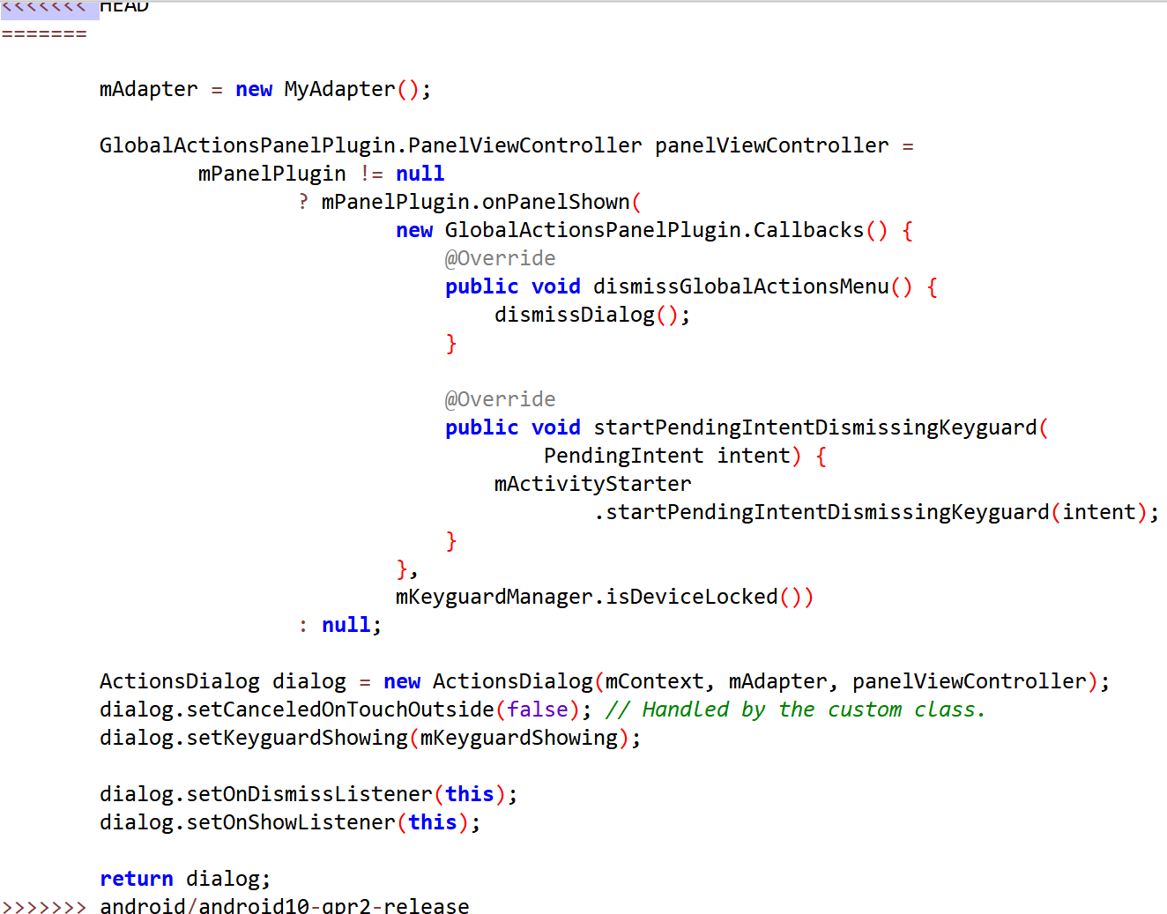

## OmniROM-9

### Merge: 7100a7fa7244d86adf9e33b9079ce2a355e2a525

1. packages/SystemUI/src/com/android/systemui/globalactions/GlobalActionsDialog.java
2. Downstream modifies method block

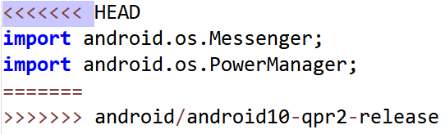

1. Downstream modifies method block

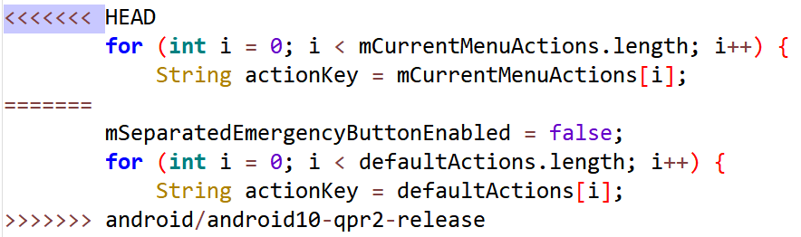

1. Downstream modifies method block

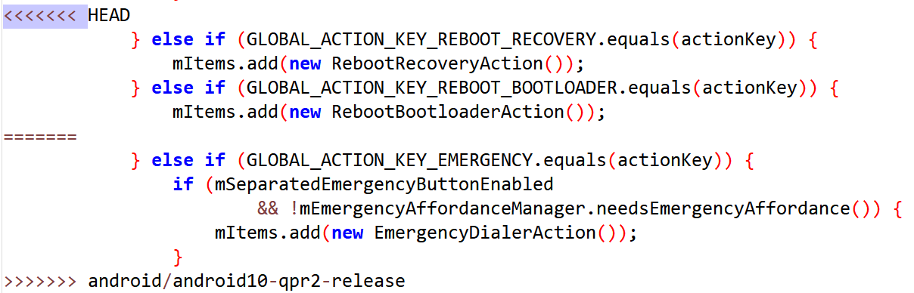

1. telephony/java/android/provider/Telephony.java
2. Downstream modifies method block

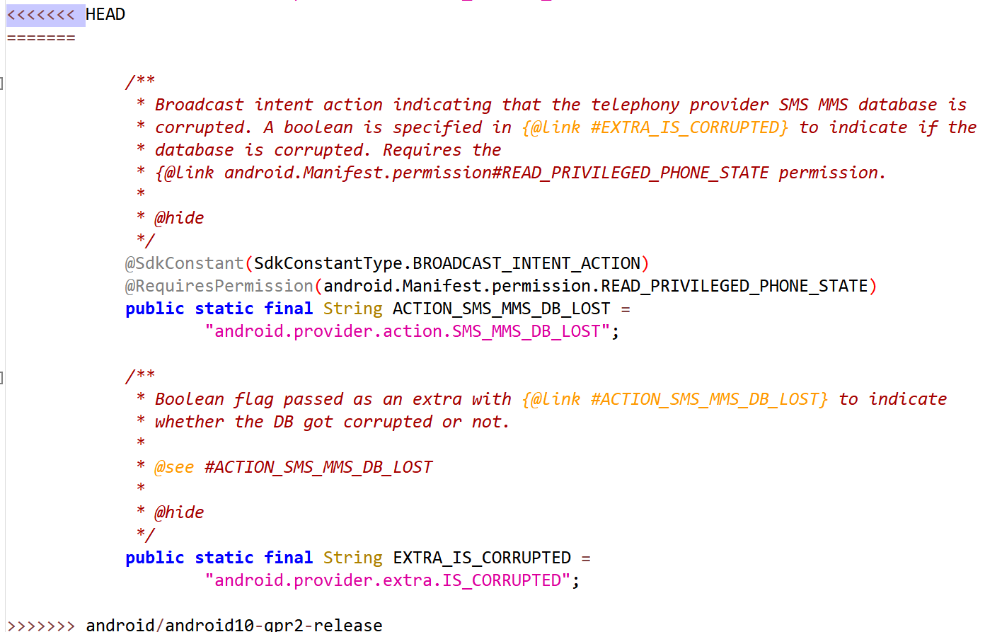

1. services/core/java/com/android/server/am/ActivityManagerService.java
2. Downstream modifies method block

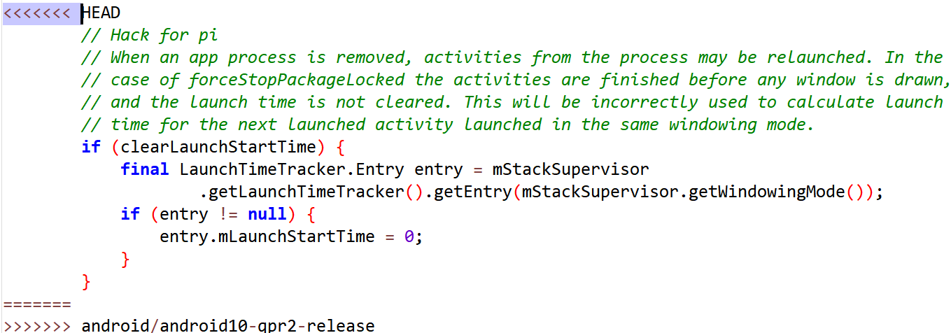

1. packages/SystemUI/src/com/android/systemui/qs/PagedTileLayout.java
2. Downstream modifies method block

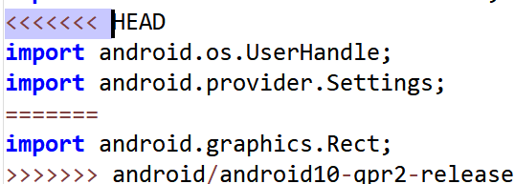

## Calyx-12

### Merge: 3f36a7788267a572e10d7839edaf49db9ddc9ab8

1. packages/SystemUI/tests/src/com/android/systemui/qs/QSTileHostTest.java
2. Downstream modifies method block

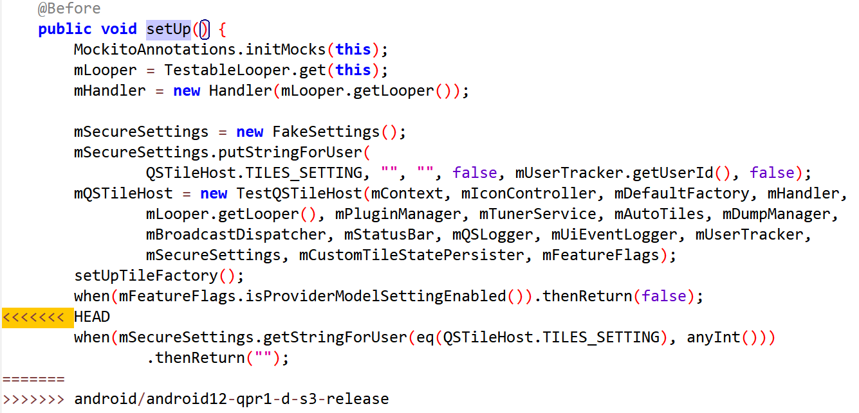

### Merge: 901b13b3f7c6f458366fbc62f9046226490965fc

1. services/core/java/com/android/server/BluetoothManagerService.java
2. Downstream modifies method block

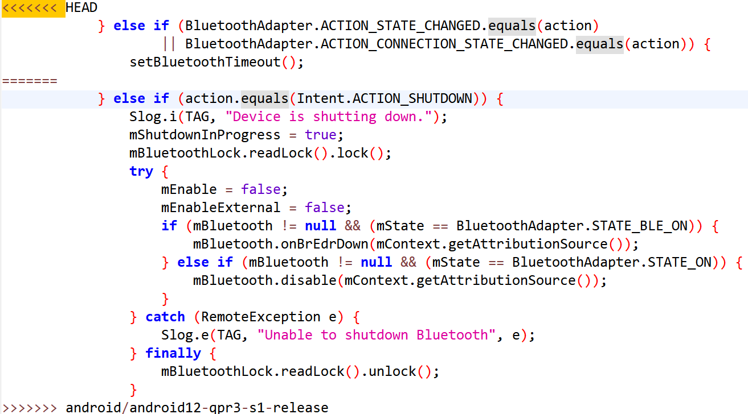

## AOSPA-sapphire

### Merge: ac442e0398fe7344f66cbbd4d2af15b1bfdbf46b

1. packages/SystemUI/src/com/android/systemui/statusbar/phone/StatusBar.java
2. Downstream modifies method block

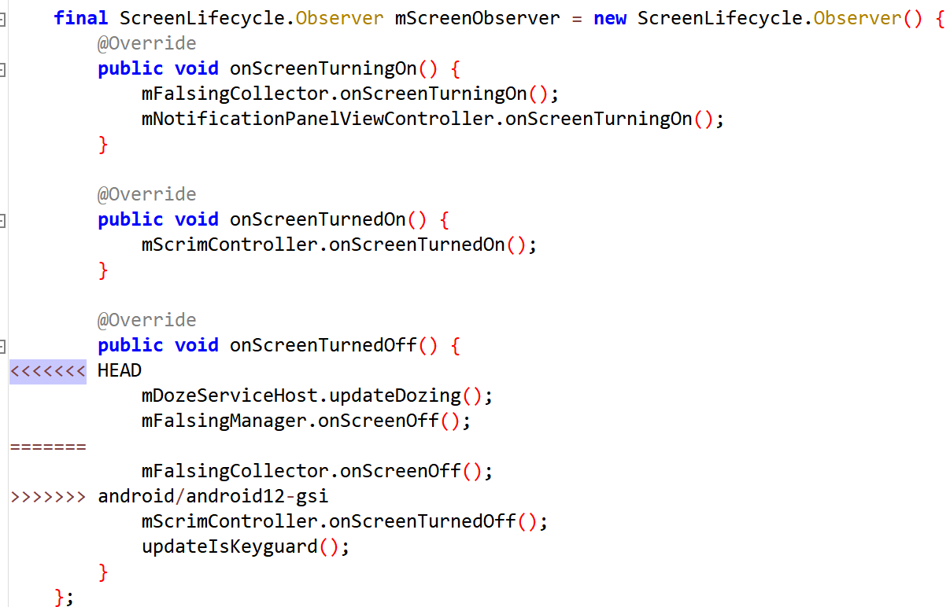

1. services/core/java/com/android/server/wm/ActivityTaskManagerService.java
2. Downstream modifies method block

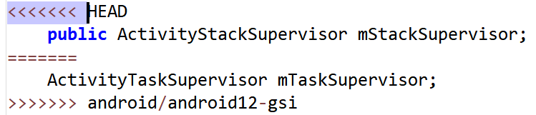

1. services/core/java/com/android/server/wm/ActivityRecord.java
2. Downstream modifies method block

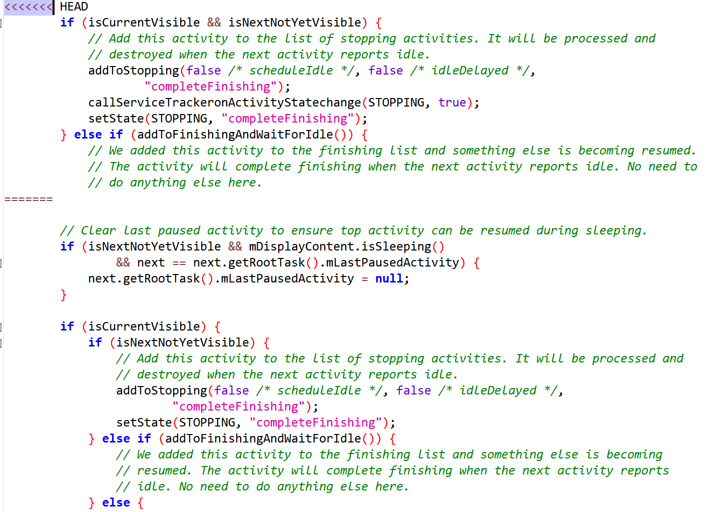

1. Downstream modifies method block

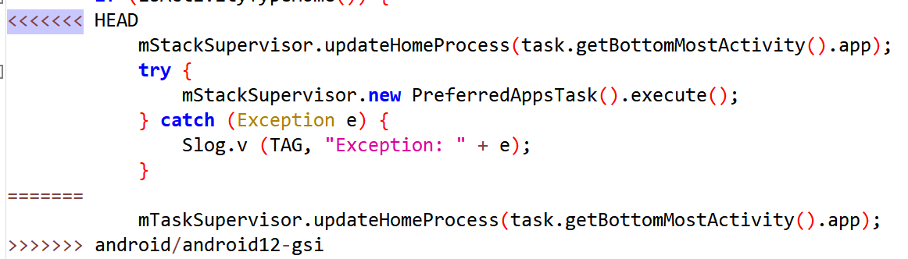

1. services/core/java/com/android/server/display/LogicalDisplayMapper.java
2. Downstream modifies method block

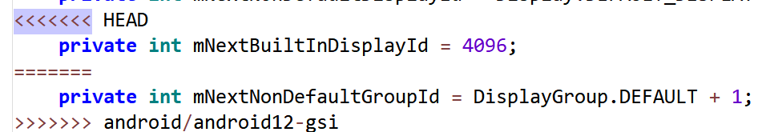

1. Downstream modifies method block

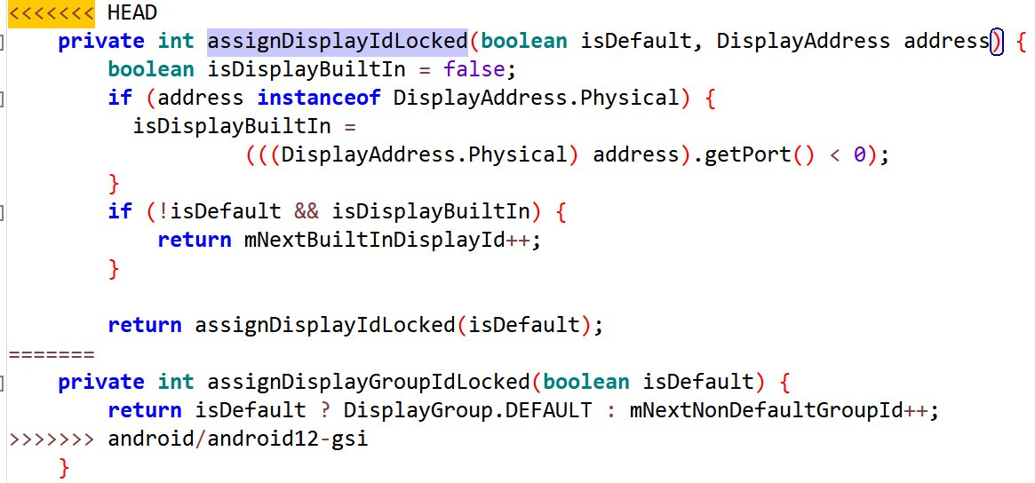

1. services/core/java/com/android/server/display/DisplayManagerService.java
2. Downstream modifies method block

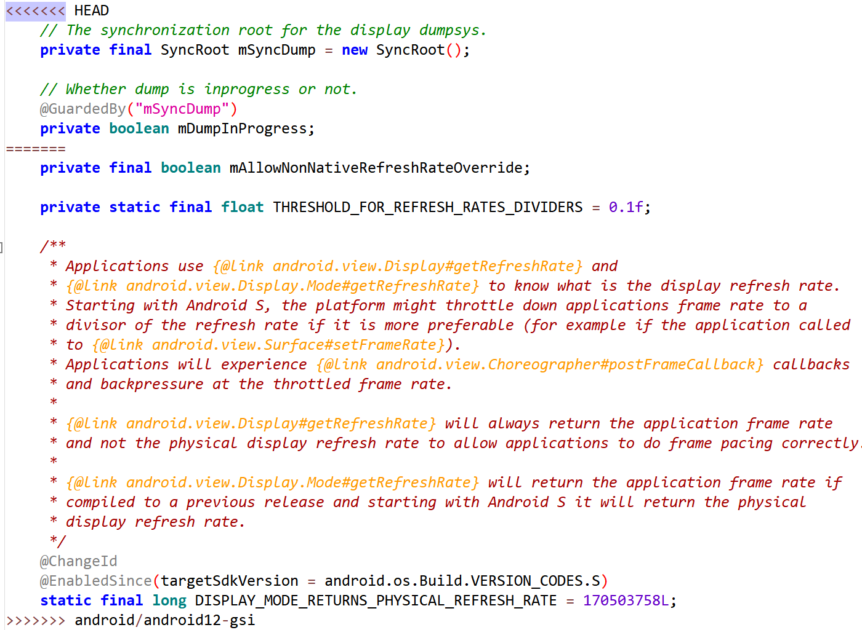

1. services/core/java/com/android/server/am/ActiveServices.java
2. Downstream modifies method block

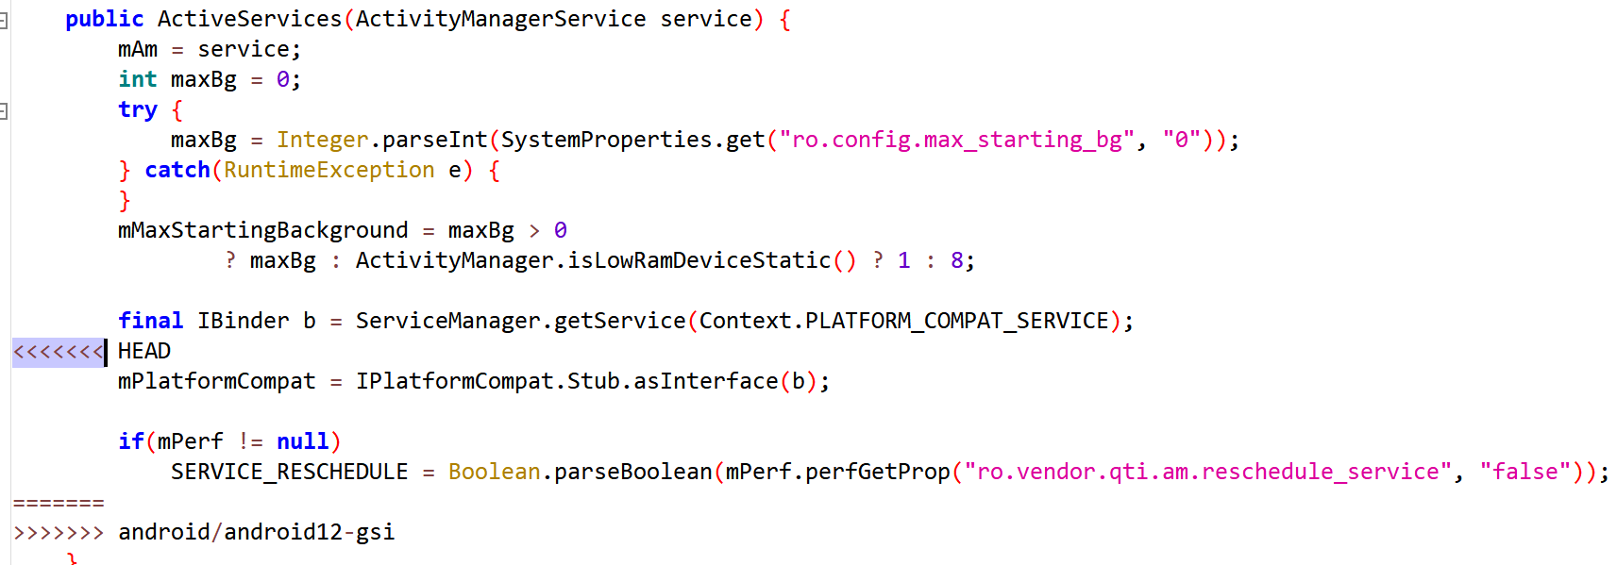

1. core/java/android/hardware/camera2/impl/CameraDeviceImpl.java
2. Downstream modifies method block

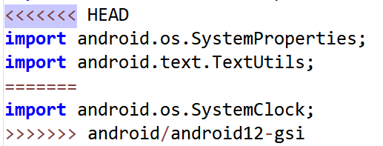

### Merge: 26017c68ee11d3f2d54ca731119c8dc4ddb842cf

1. services/core/java/com/android/server/wm/ActivityRecord.java
2. Downstream modifies method block

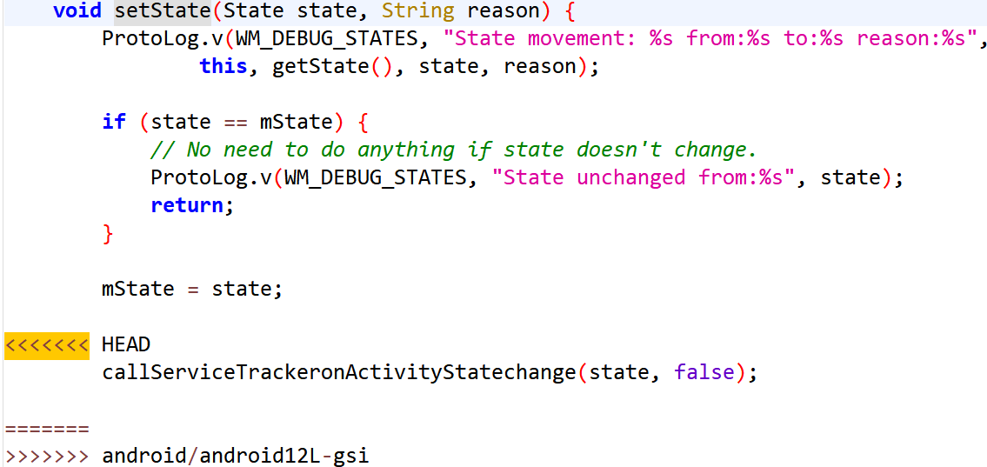

1. services/core/java/com/android/server/wm/ActivityRecord.java
2. Downstream modifies method block

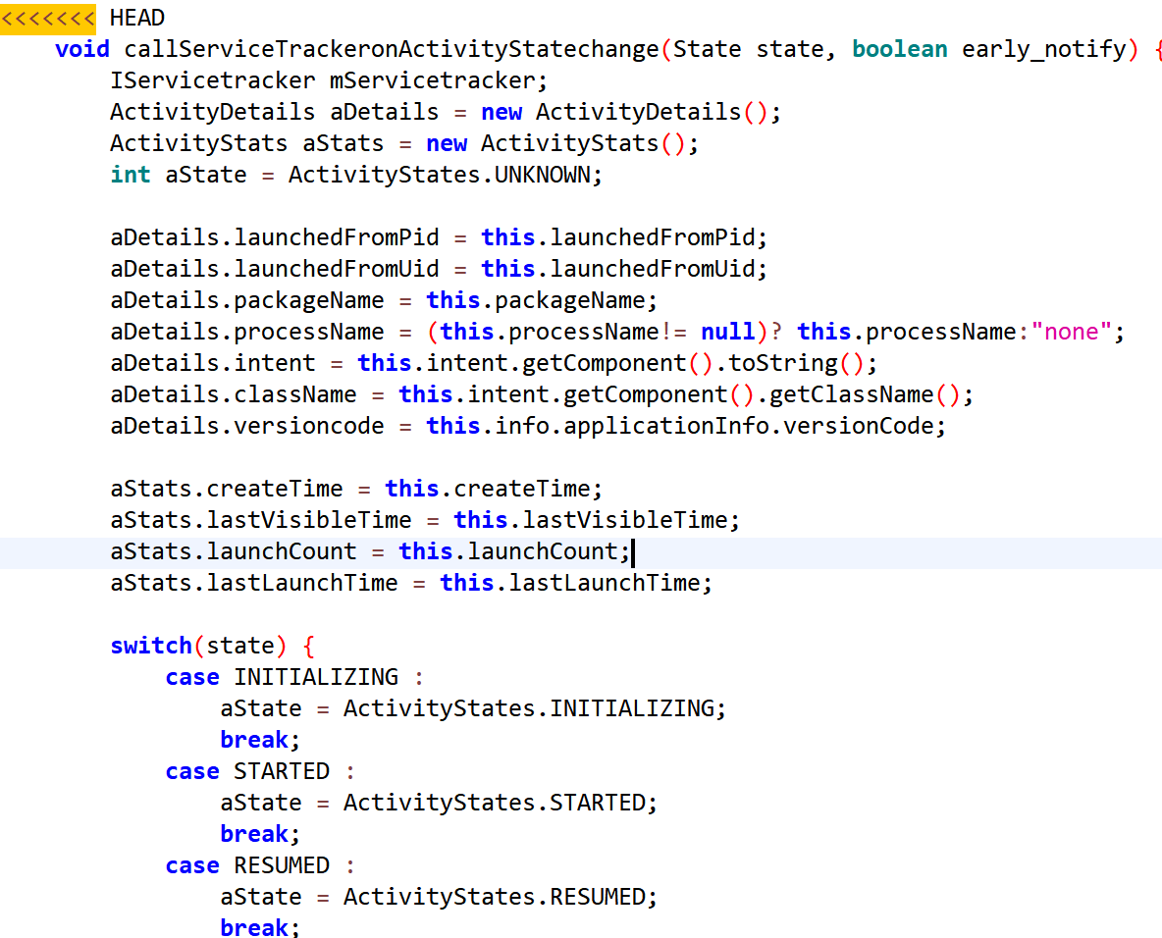

1. services/core/java/com/android/server/wm/WindowManagerService.java
2. Downstream modifies method block

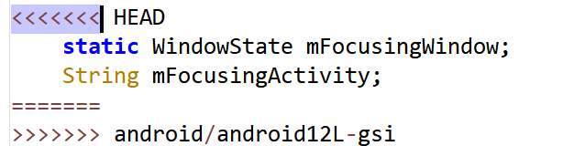

1. services/core/java/com/android/server/wm/Task.java
2. Downstream modifies method block

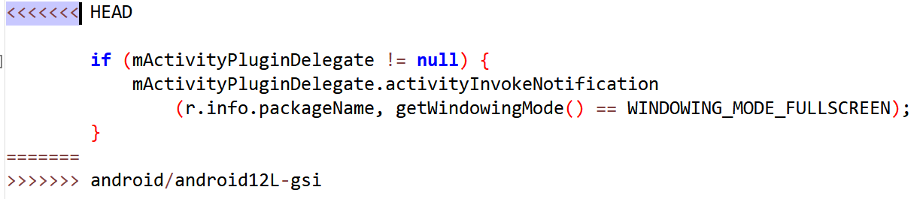

1. Downstream modifies method block

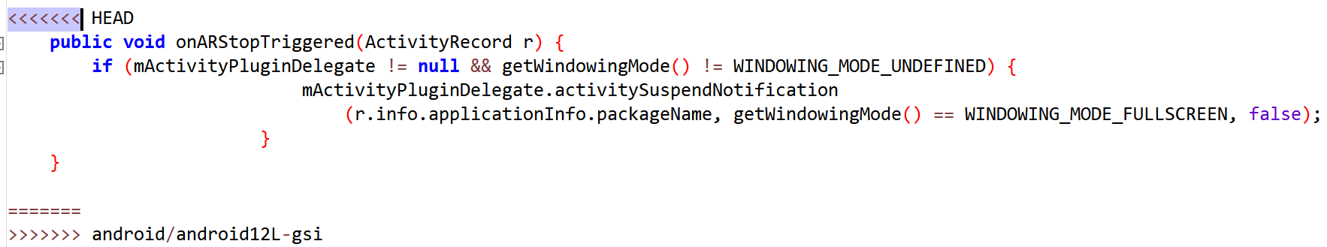

1. services/core/java/com/android/server/wm/ScreenRotationAnimation.java
2. Downstream modifies method block

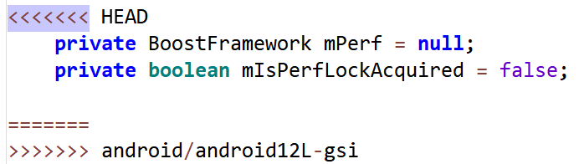

1. services/core/java/com/android/server/wm/RootWindowContainer.java
2. Downstream modifies method block

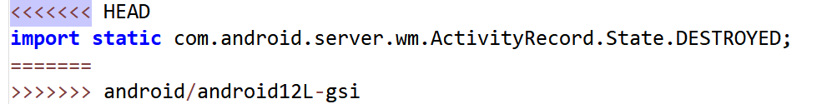

1. services/core/java/com/android/server/wm/DisplayPolicy.java
2. Downstream modifies method block

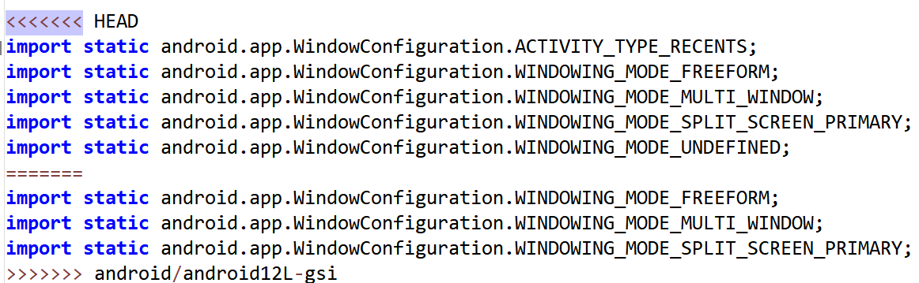

1. Downstream modifies method block

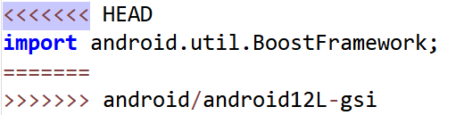

1. Downstream modifies method block

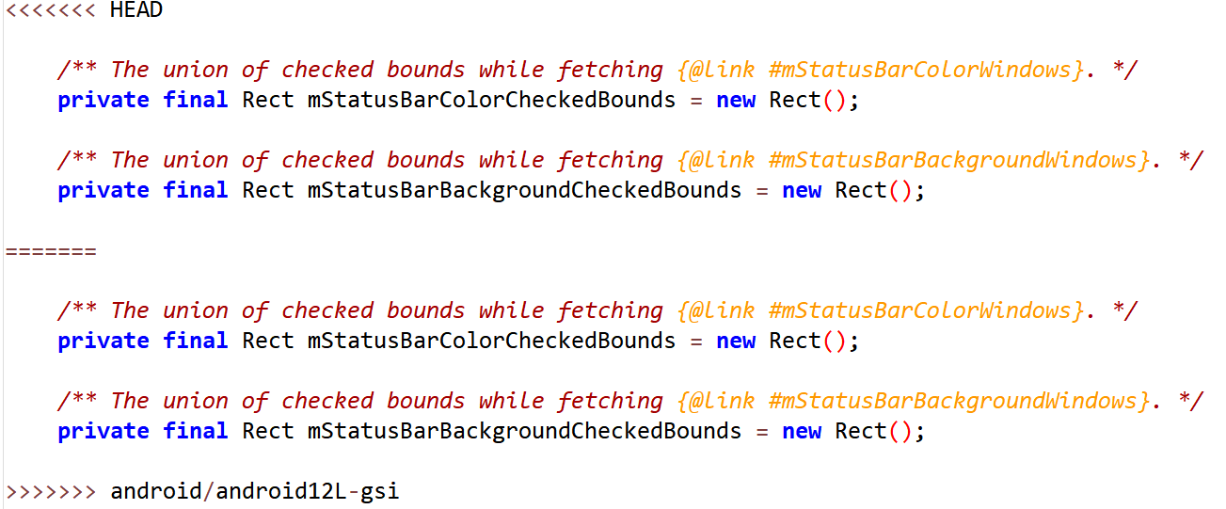

1. Downstream modifies method block

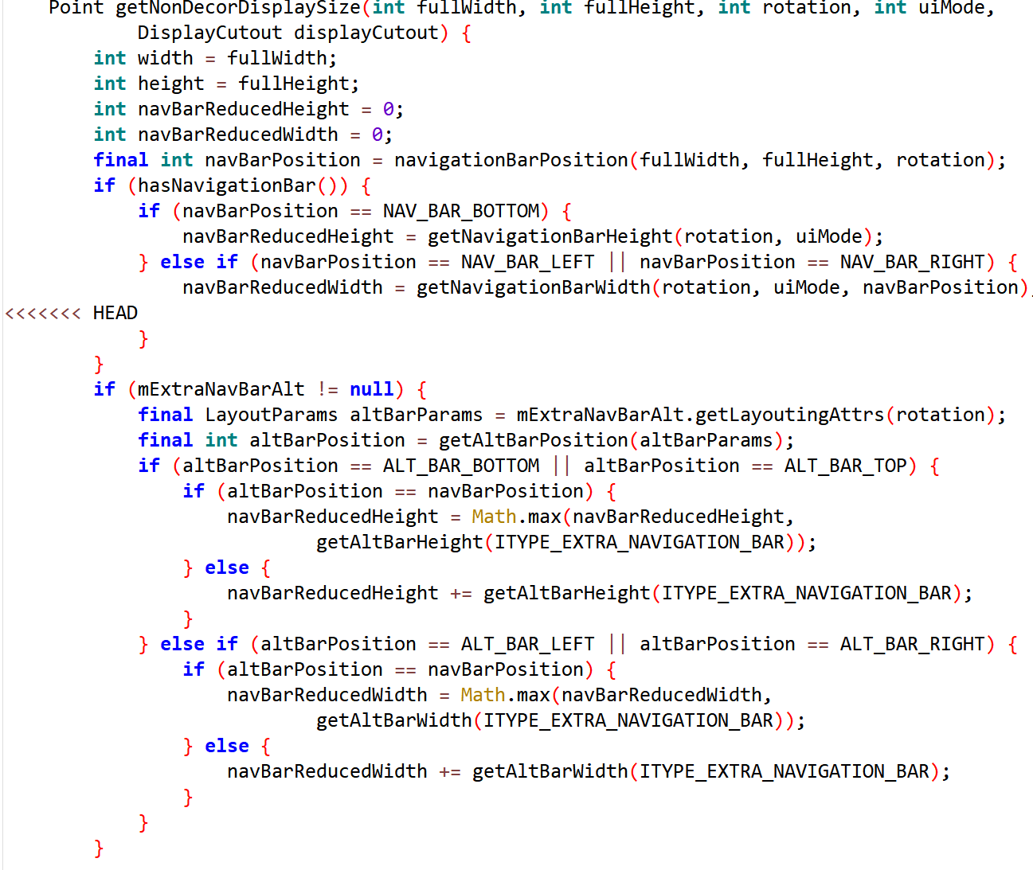

1. services/core/java/com/android/server/wm/ActivityTaskSupervisor.java
2. Downstream modifies method block

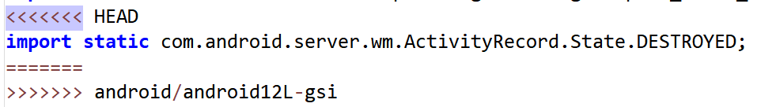

1. Downstream modifies method block

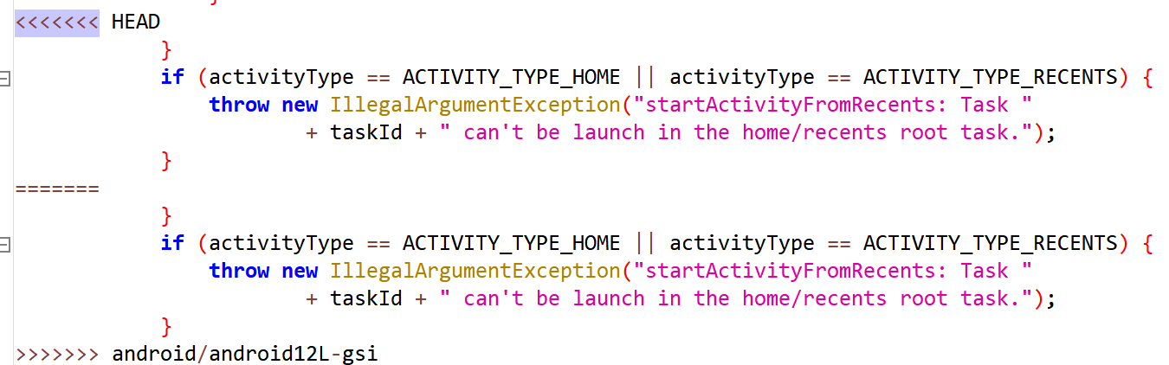

1. services/core/java/com/android/server/wm/ActivityStarter.java
2. Downstream modifies method block

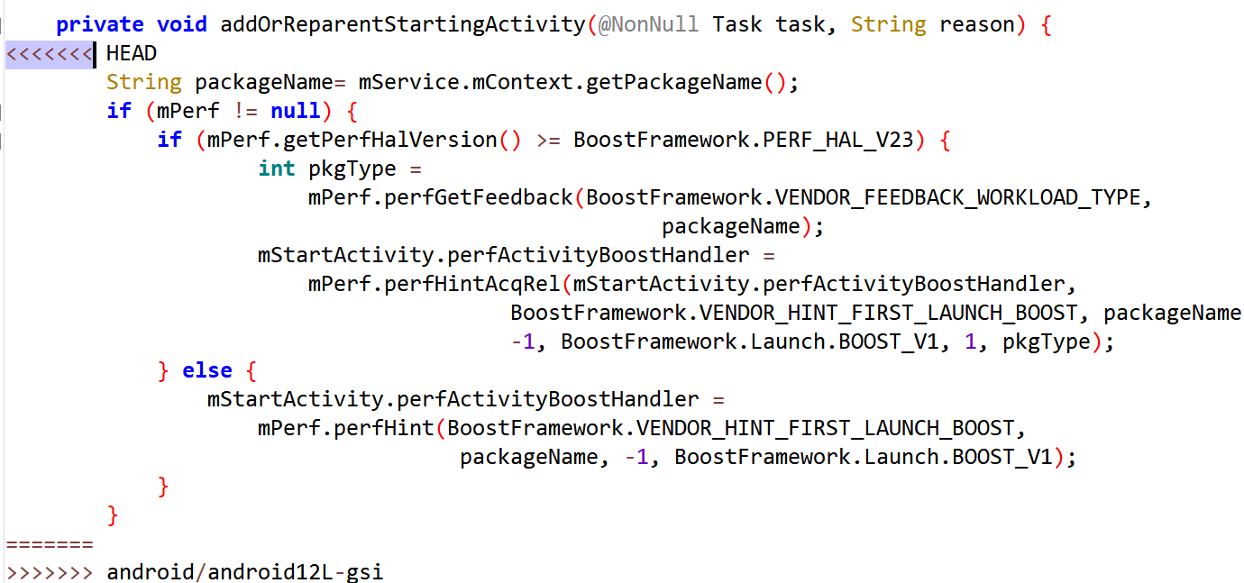

1. Downstream modifies method block

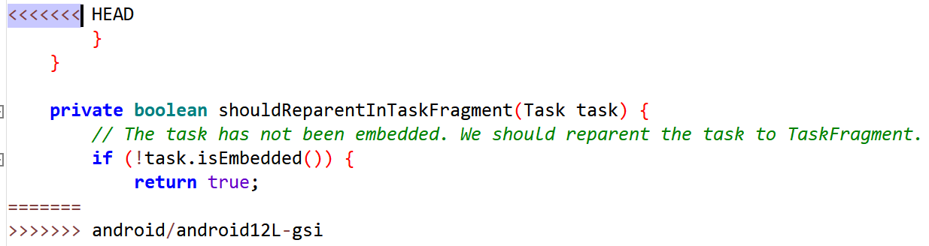

1. services/core/java/com/android/server/display/DisplayManagerService.java
2. Downstream modifies method block

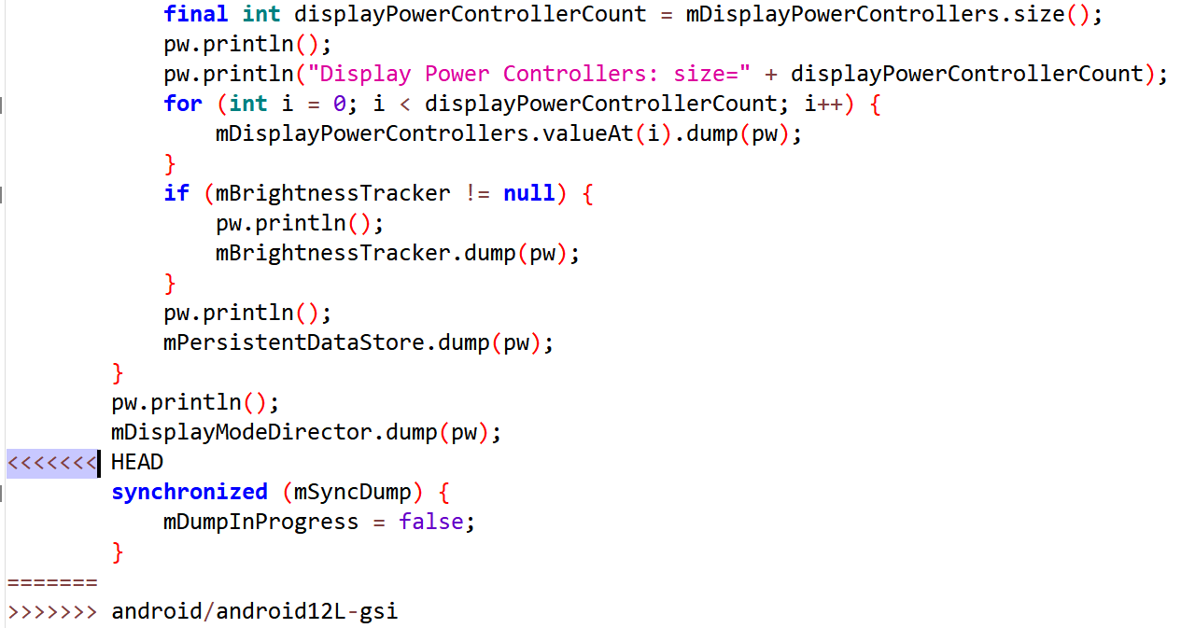

1. services/core/java/com/android/server/audio/AudioService.java
2. Downstream modifies method block

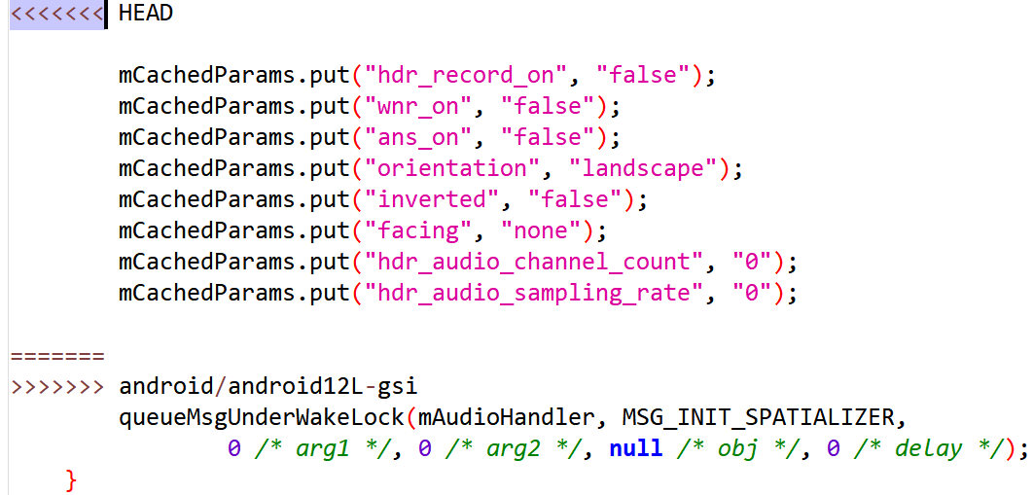

1. services/core/java/com/android/server/audio/AudioDeviceInventory.java
2. Downstream modifies method block

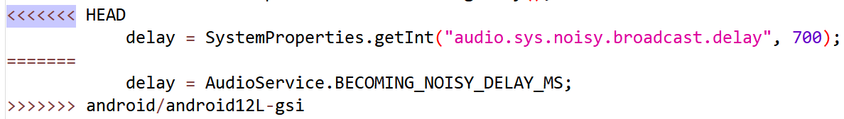

1. services/core/java/com/android/server/am/CachedAppOptimizer.java
2. Downstream modifies method block

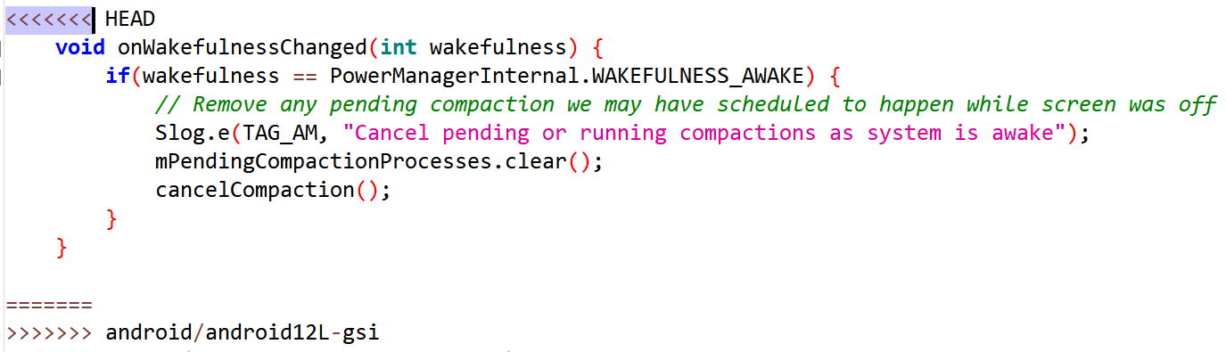

1. services/core/java/com/android/server/BluetoothManagerService.java
2. Downstream modifies method block

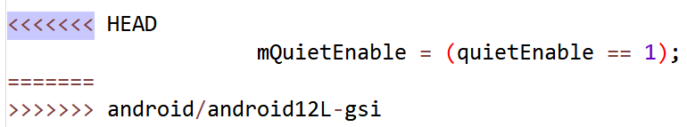

## AOSPA-ruby

### Merge: d28a4f6b38dbab44128b4319f665dd65c3e4ec2c

1. services/core/java/com/android/server/wm/ActivityStack.java
2. Downstream modifies method block

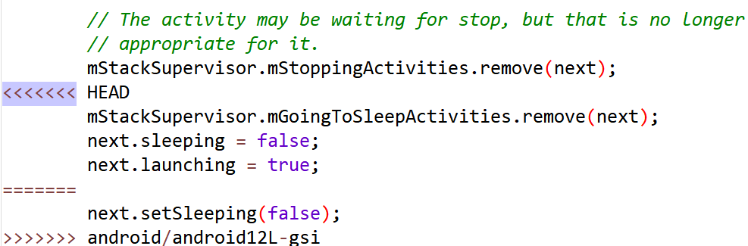

1. services/core/java/com/android/server/wm/ActivityRecord.java
2. Downstream modifies method block

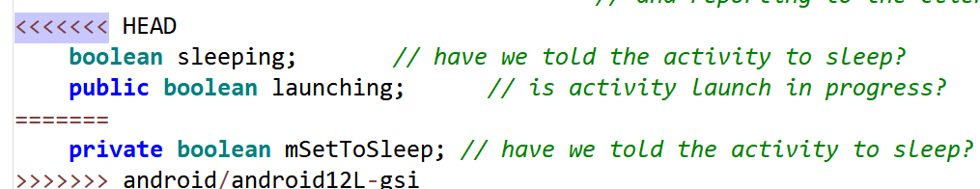

1. Downstream modifies method block

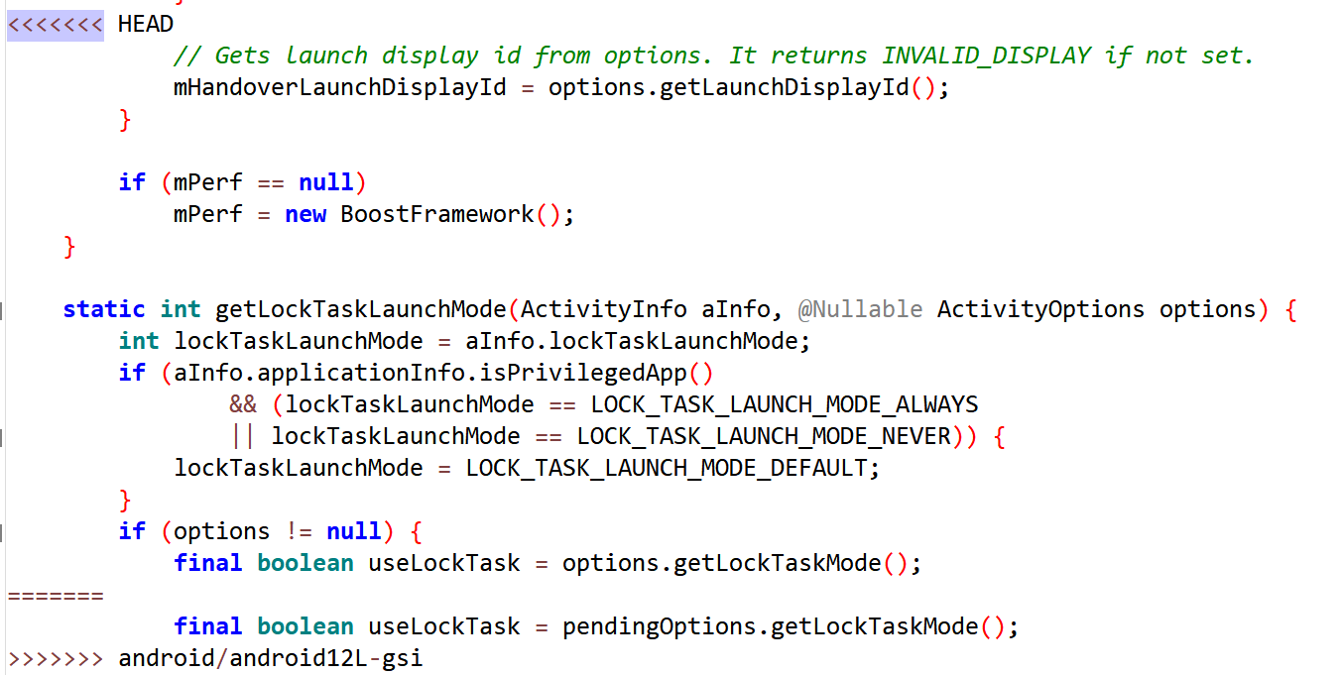

1. Downstream modifies method block

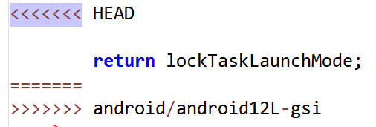

1. telephony/java/com/android/internal/telephony/TelephonyIntents.java
2. Downstream modifies method block

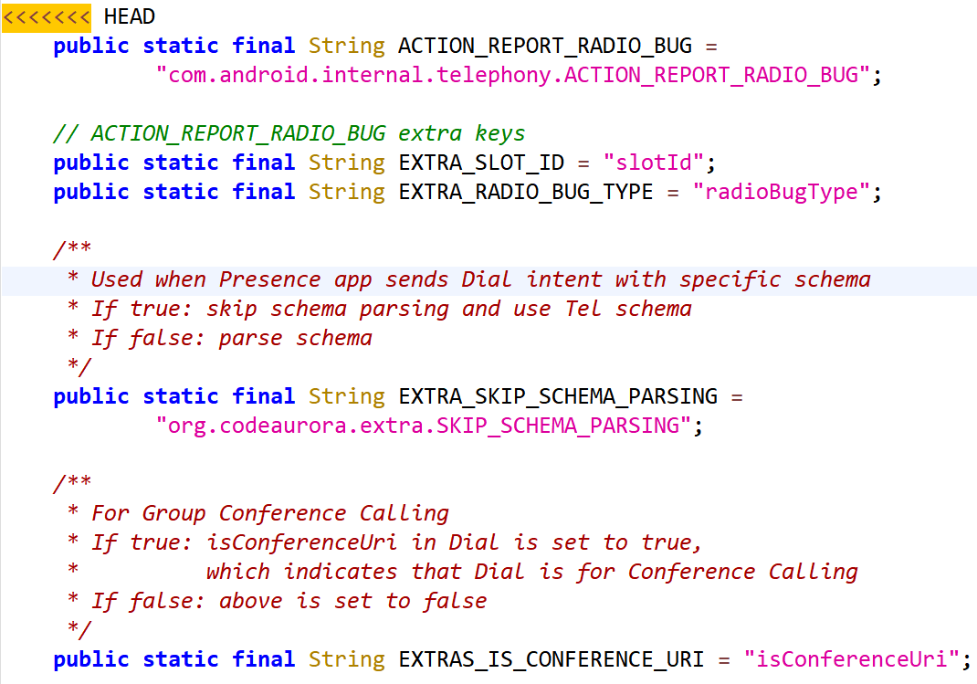

1. telecomm/java/android/telecom/ConnectionService.java
2. Downstream modifies method block

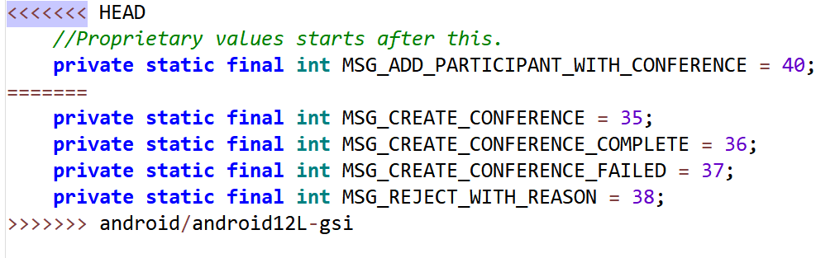

1. telecomm/java/android/telecom/Conference.java
2. Downstream modifies method block

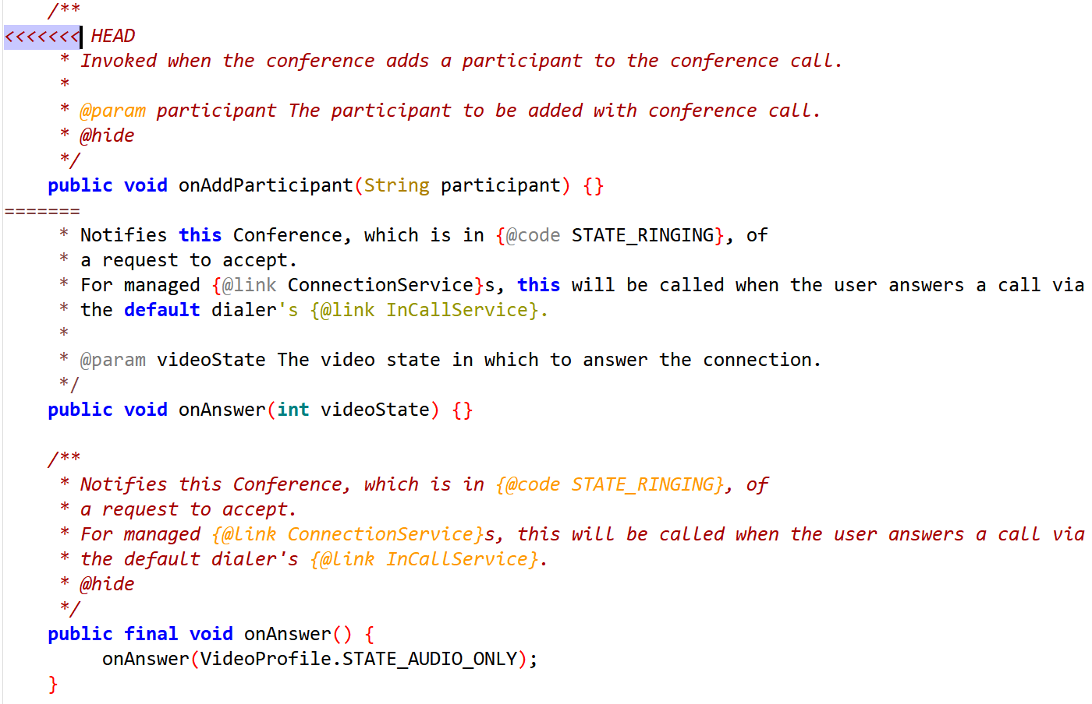

1. services/core/java/com/android/server/am/ProcessRecord.java
2. Downstream modifies method block

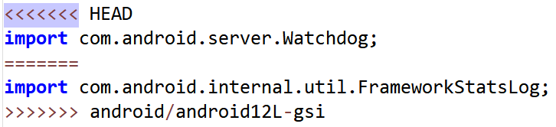

1. services/core/java/com/android/server/am/ProcessList.java
2. Downstream modifies method block

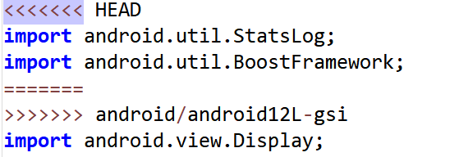

1. services/core/java/com/android/server/am/CachedAppOptimizer.java
2. Downstream modifies method block

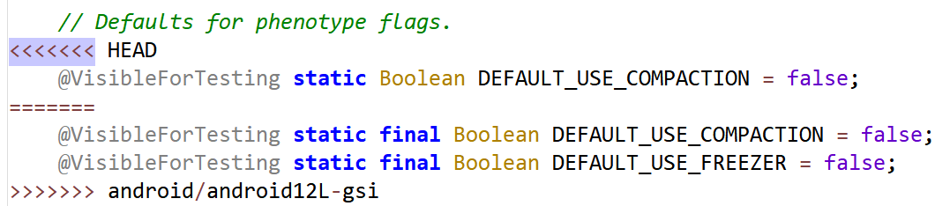

1. services/core/java/com/android/server/am/ActivityManagerService.java
2. Downstream modifies method block

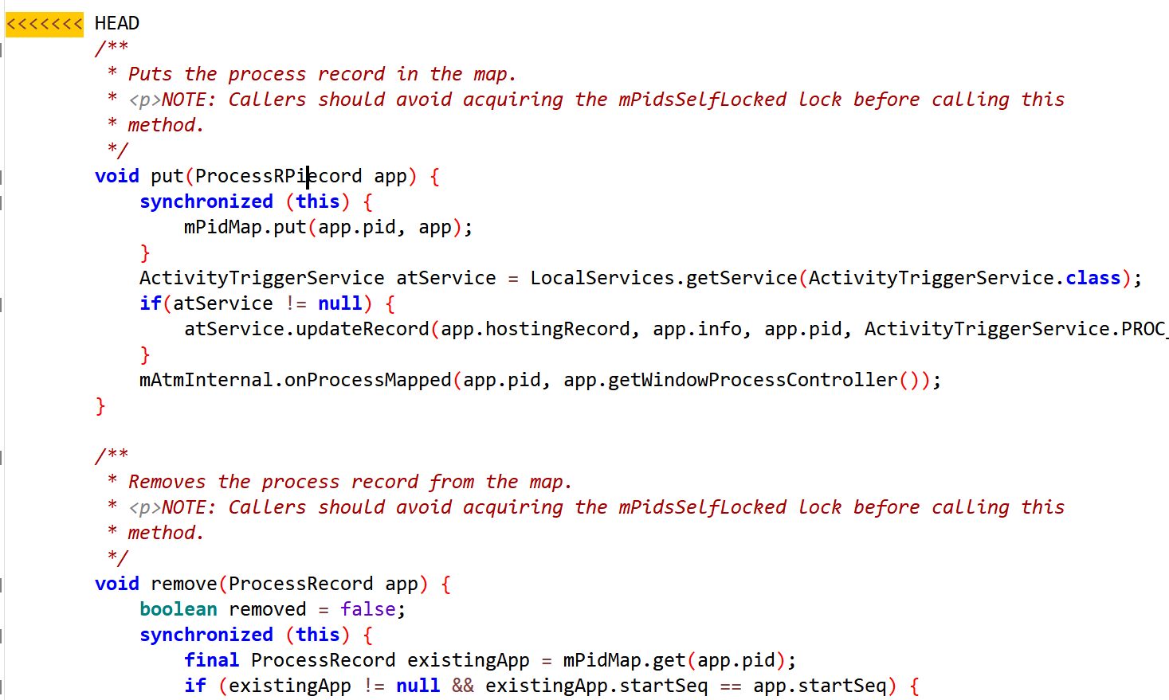

1. services/core/java/com/android/server/ConnectivityService.java
2. Downstream modifies method block

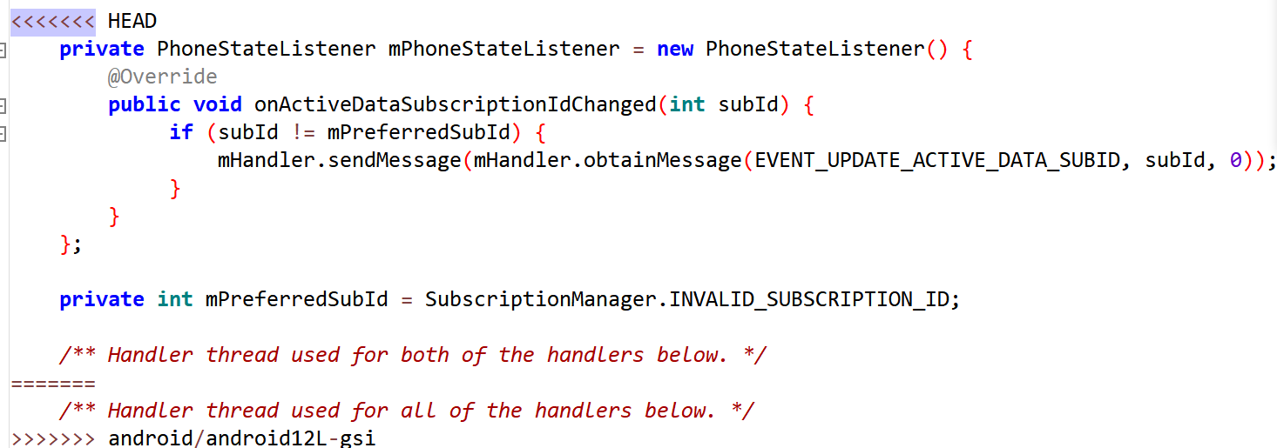

1. Downstream modifies method block

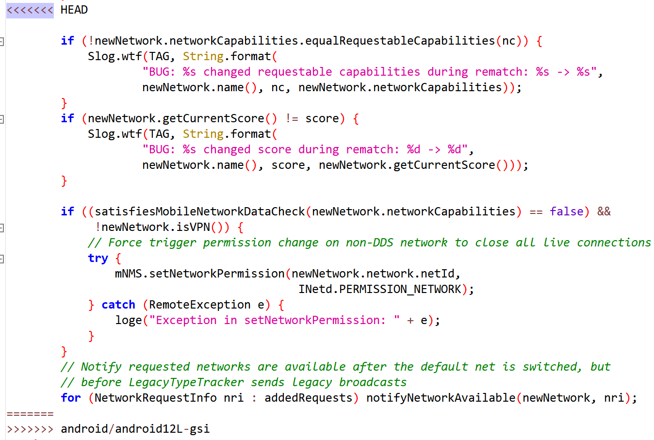

1. packages/Tethering/common/TetheringLib/src/android/net/TetheringManager.java
2. Downstream modifies method block

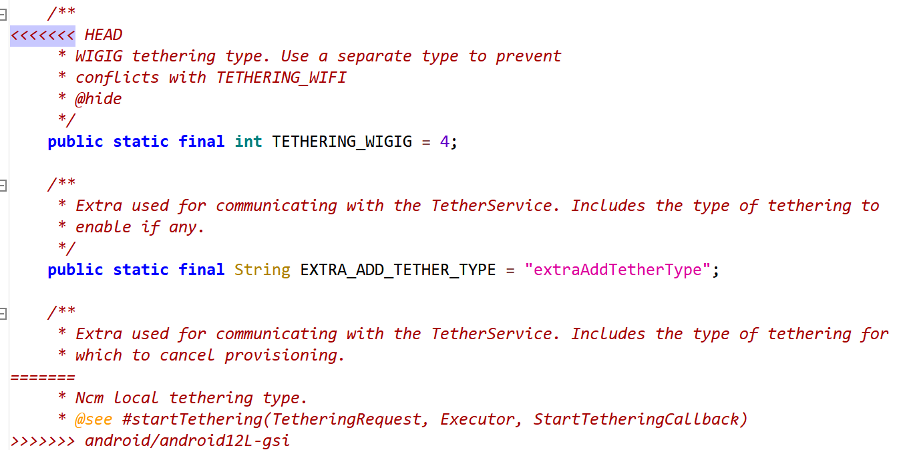

1. packages/SystemUI/src/com/android/systemui/statusbar/policy/MobileSignalController.java
2. Downstream modifies method block

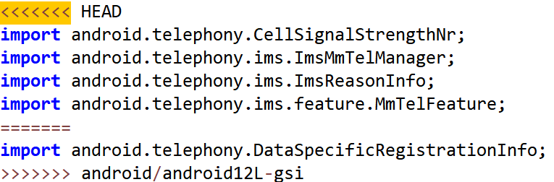

1. Downstream modifies method block

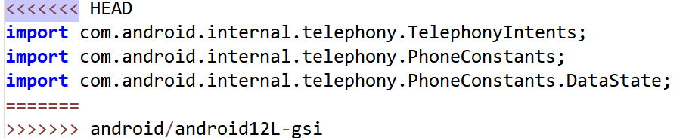

1. core/java/android/os/Process.java
2. Downstream modifies method block

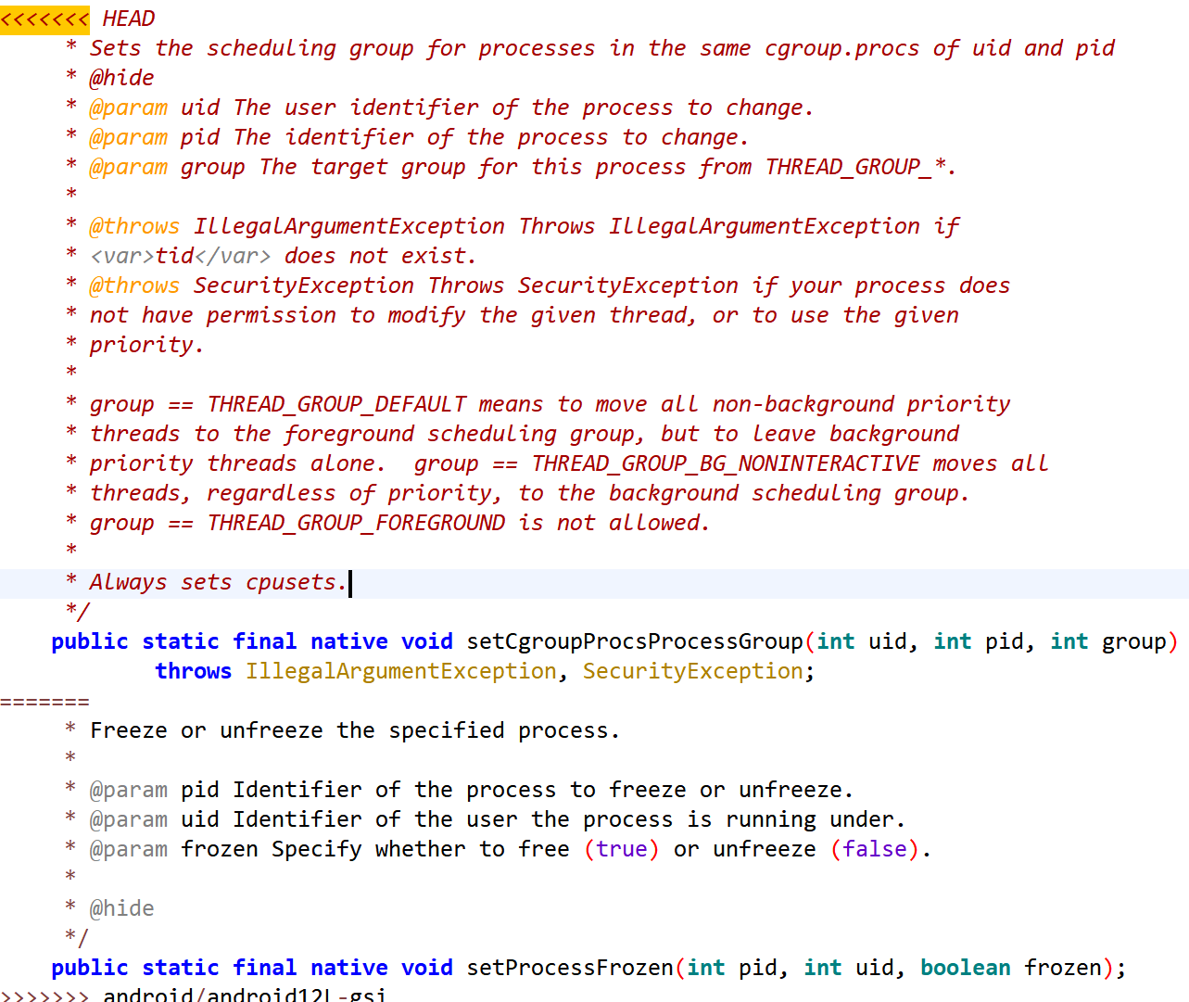

1. core/java/android/bluetooth/BluetoothAdapter.java
2. Downstream modifies method block

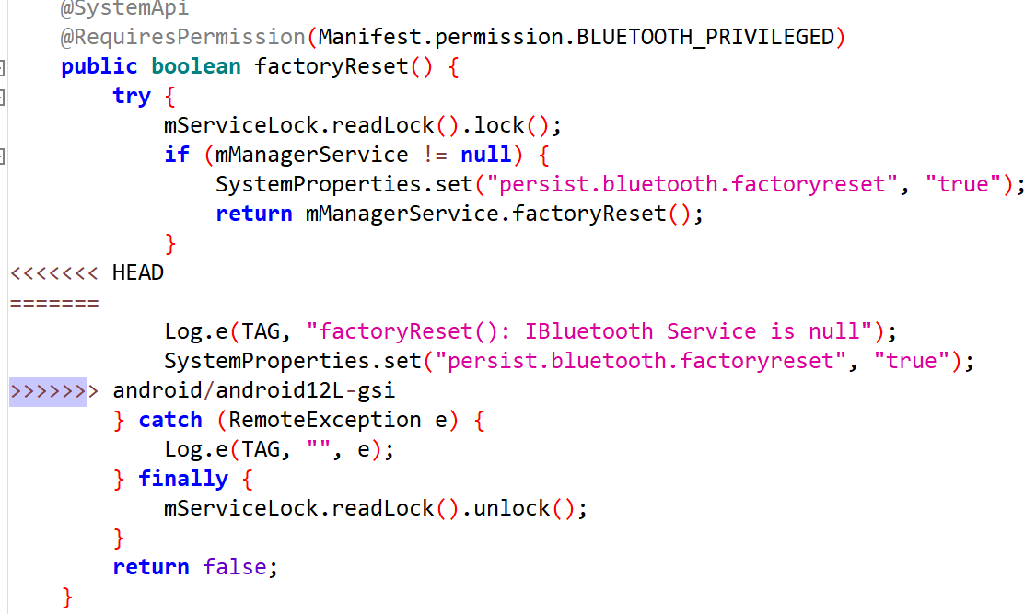

1. core/java/android/app/ActivityManagerInternal.java
2. Downstream modifies method block

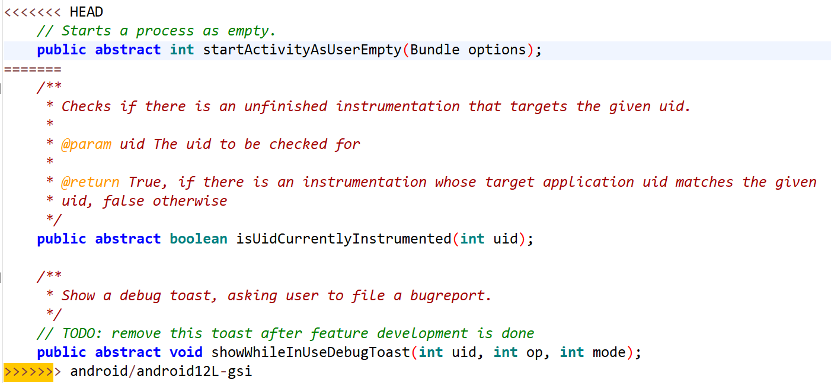

## AOSPA-quartz

### Merge: cf03be865b65f49562f1e442ee0e7510ee597aa8

1. telephony/java/com/android/internal/telephony/cdma/SmsMessage.java
2. Downstream modifies method block

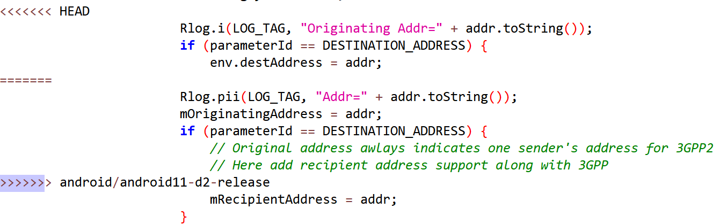

1. telephony/java/com/android/internal/telephony/cdma/BearerData.java
2. Downstream modifies method block

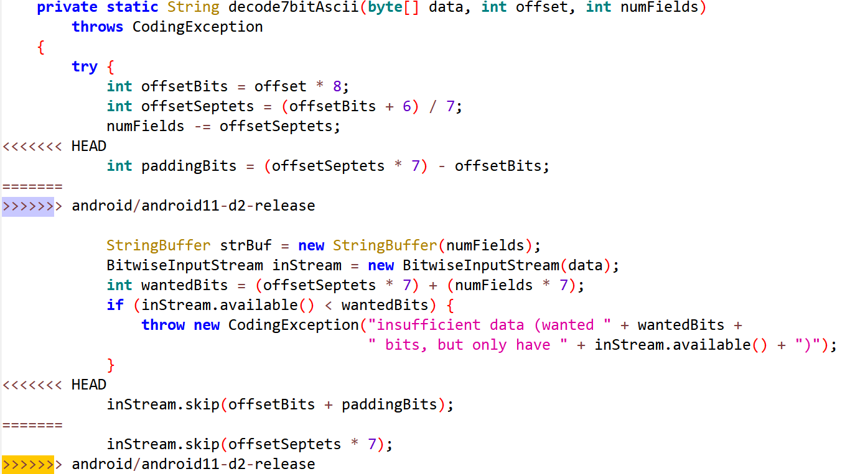

1. services/core/java/com/android/server/connectivity/tethering/TetheringConfiguration.java
2. Downstream modifies method block

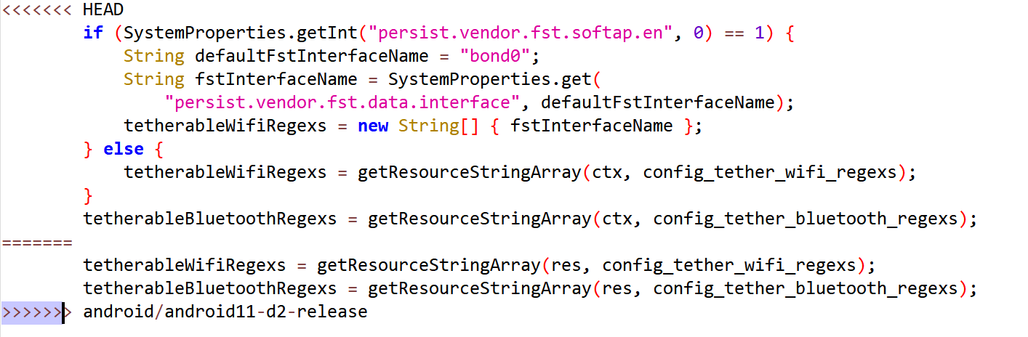

1. services/core/java/com/android/server/WiredAccessoryManager.java
2. Downstream modifies method block

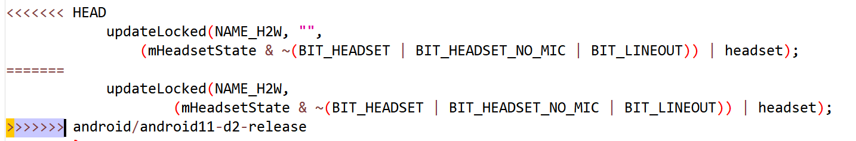

1. Downstream modifies method block

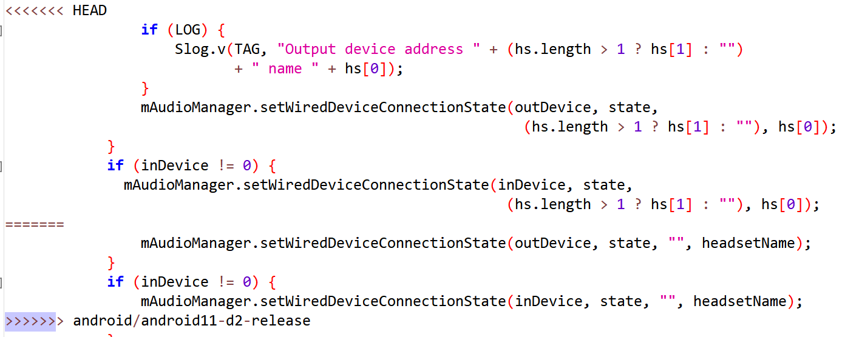

1. services/core/java/com/android/server/ConnectivityService.java
2. Downstream modifies method block

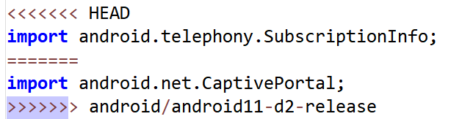

### Merge: 2edeff882ab756e76b3a028a1568d8774ddc0257

1. core/java/android/bluetooth/le/ScanFilter.java
2. Downstream modifies method block

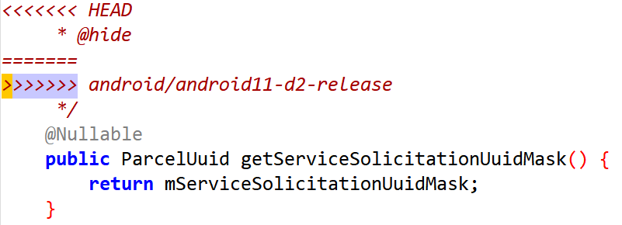

1. Downstream modifies method block

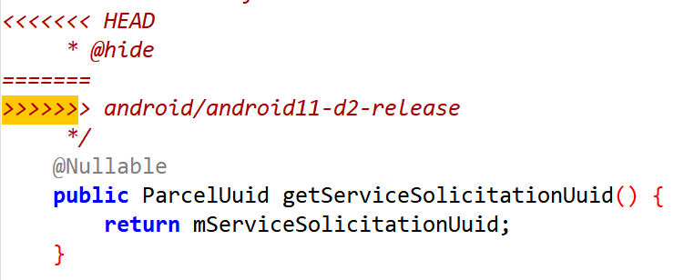

1. Downstream modifies method block

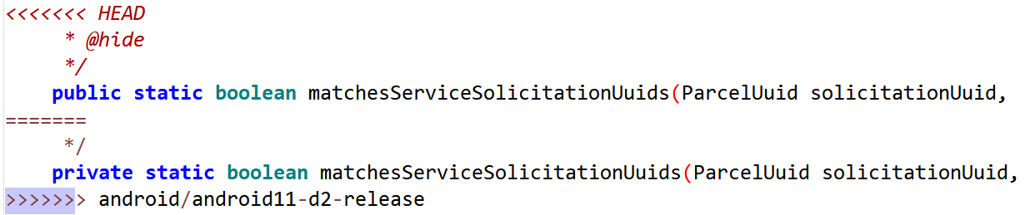

1. Downstream modifies method block

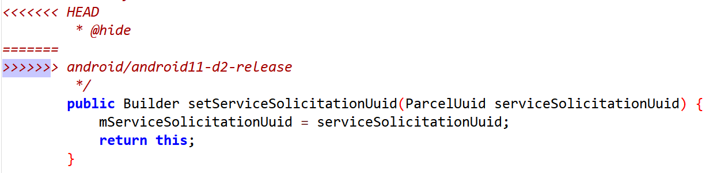

1. Downstream modifies method block

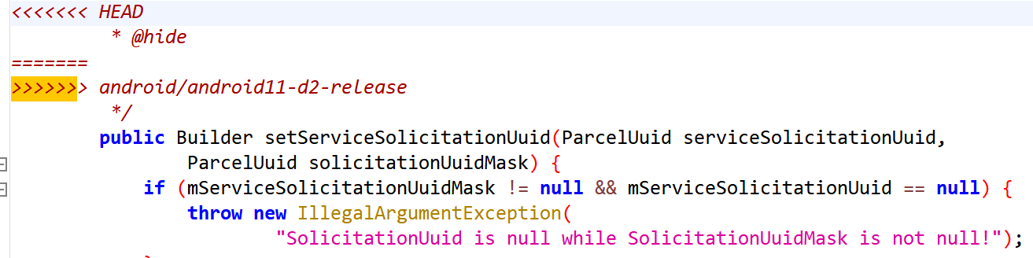

1. core/java/android/bluetooth/le/ScanRecord.java
2. Downstream modifies method block

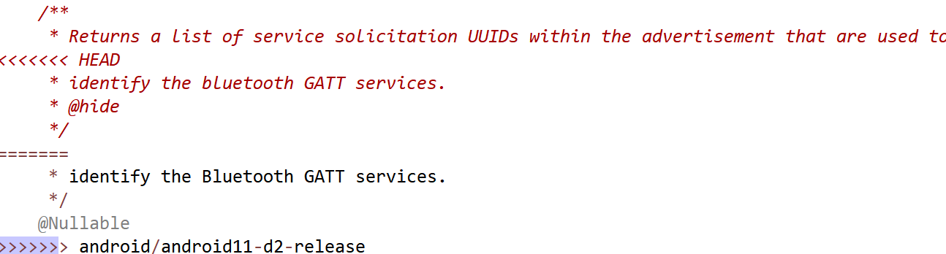

1. core/java/android/provider/Settings.java
2. Downstream modifies method block

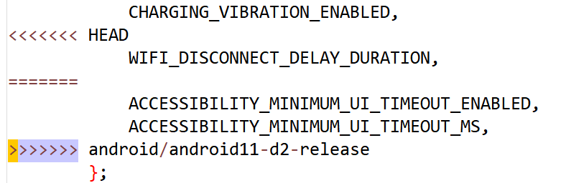

1. Downstream modifies method block

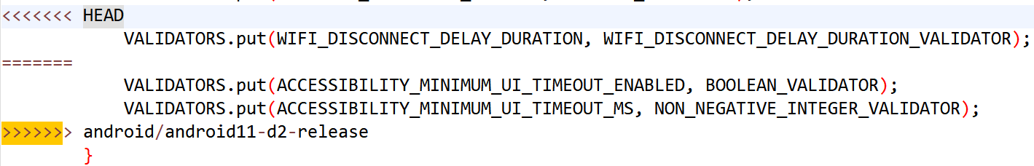

1. media/java/android/media/MediaFile.java
2. Downstream modifies method block

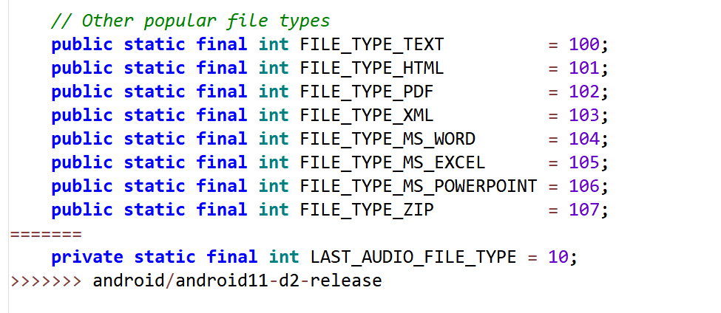

1. Downstream modifies method block

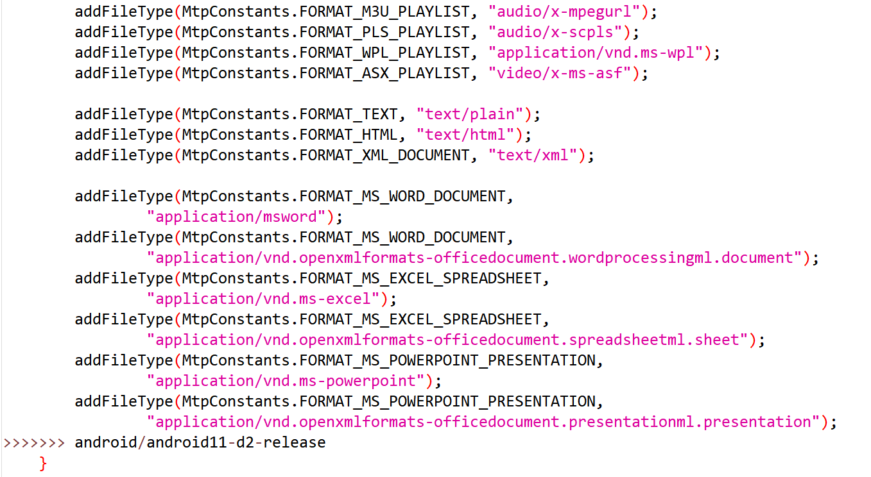

1. media/java/android/media/MediaFile.java
2. Downstream modifies method block

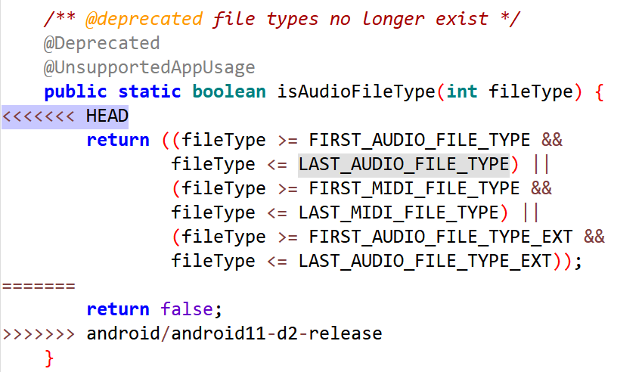

1. packages/SettingsLib/src/com/android/settingslib/bluetooth/BluetoothEventManager.java
2. Downstream modifies method block

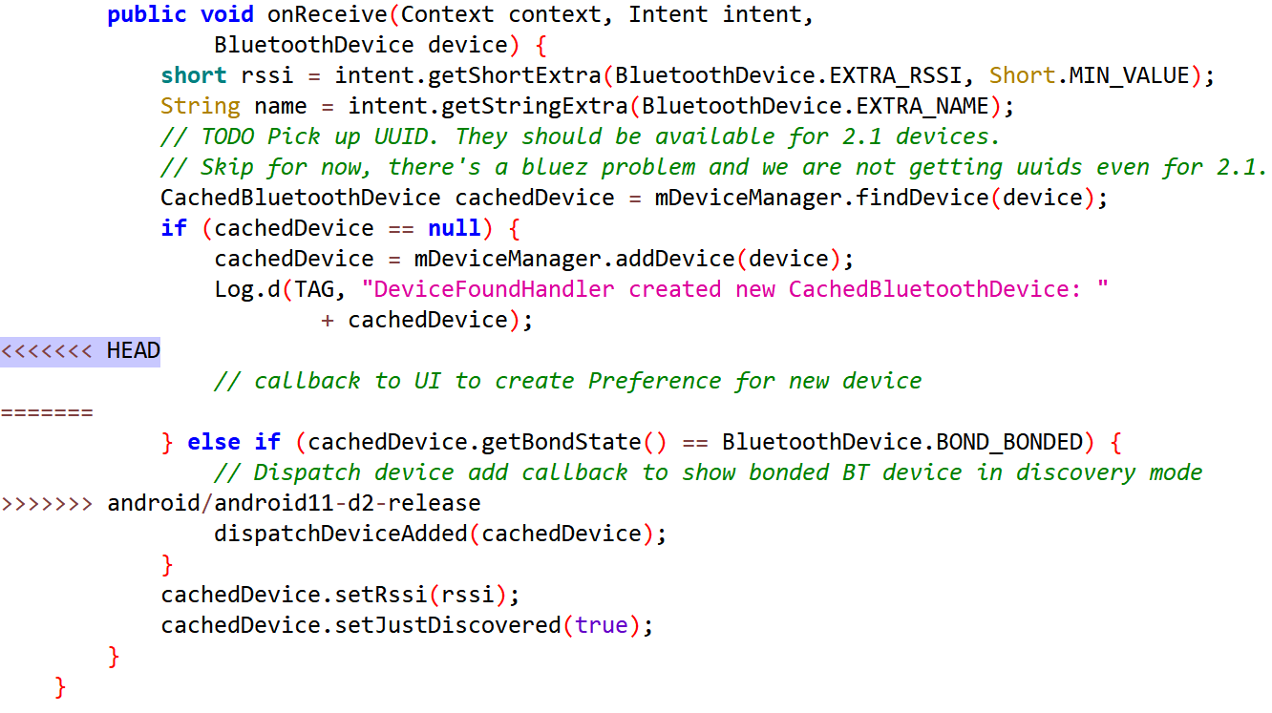

1. packages/SettingsLib/src/com/android/settingslib/bluetooth/CachedBluetoothDevice.java
2. Downstream modifies method block

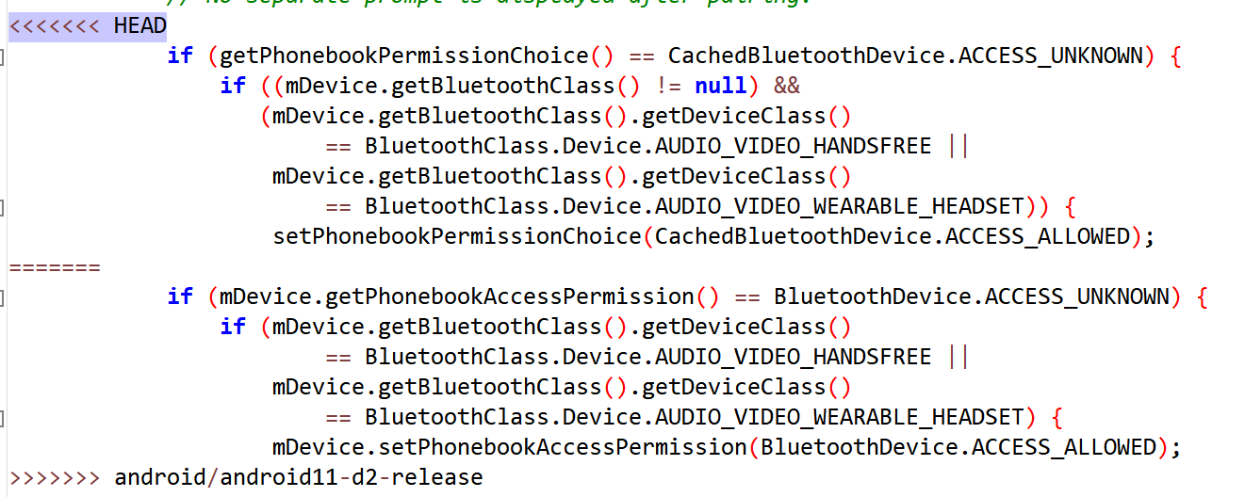

1. packages/SettingsLib/src/com/android/settingslib/bluetooth/LocalBluetoothProfileManager.java
2. Downstream modifies method block

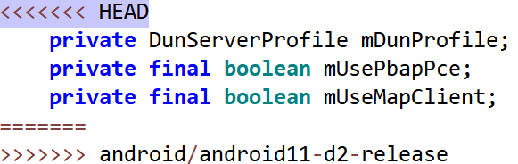

1. packages/SystemUI/src/com/android/systemui/statusbar/policy/MobileSignalController.java
2. Downstream modifies method block

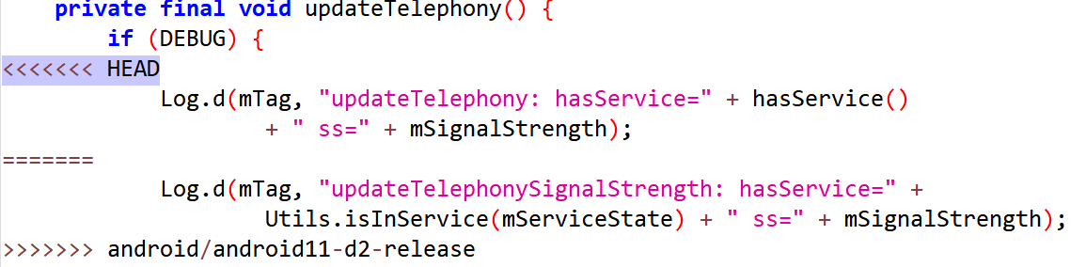

1. services/core/java/com/android/server/Watchdog.java
2. Downstream modifies method block

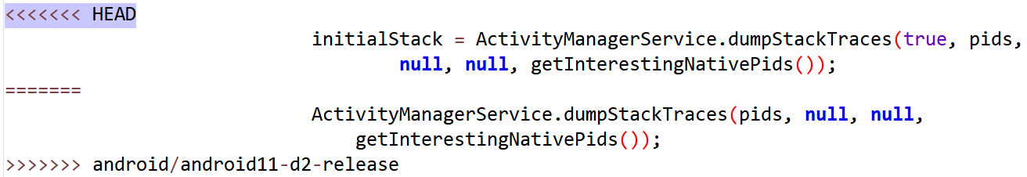

1. Downstream modifies method block

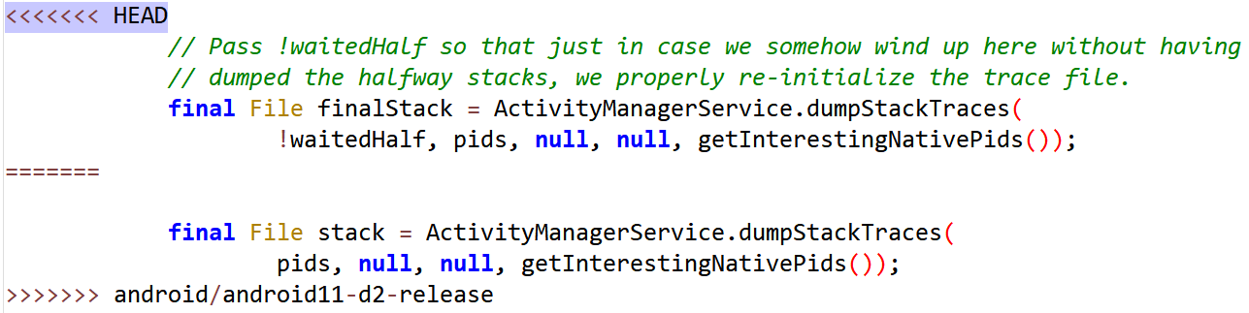

1. services/core/java/com/android/server/am/ActivityStackSupervisor.java
2. Downstream modifies method block

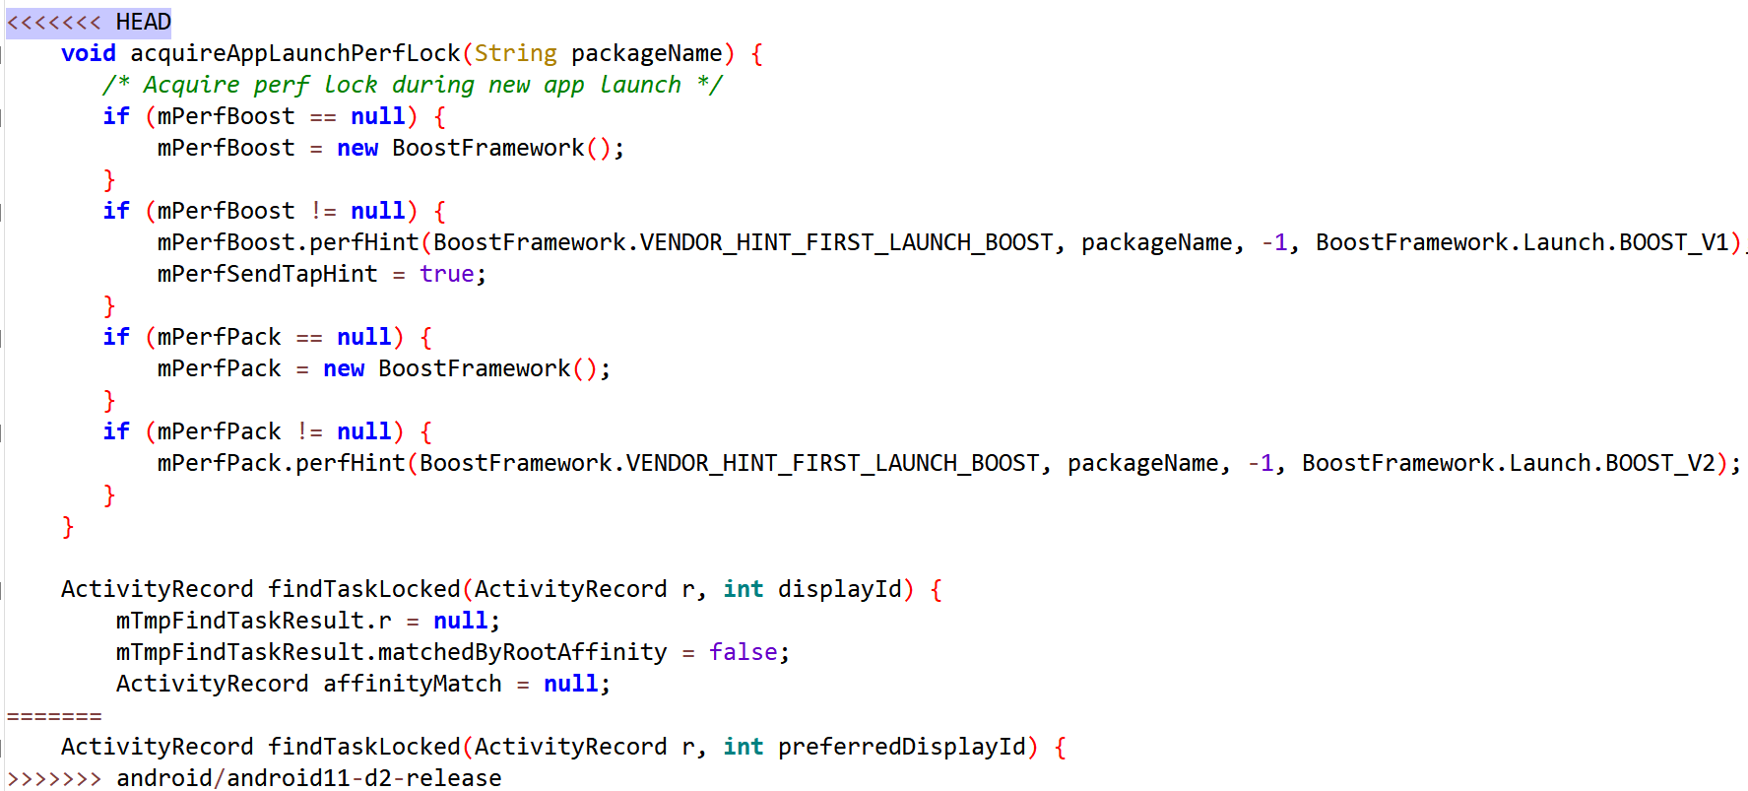

1. services/core/java/com/android/server/am/ActivityStackSupervisor.java
2. Downstream modifies method block

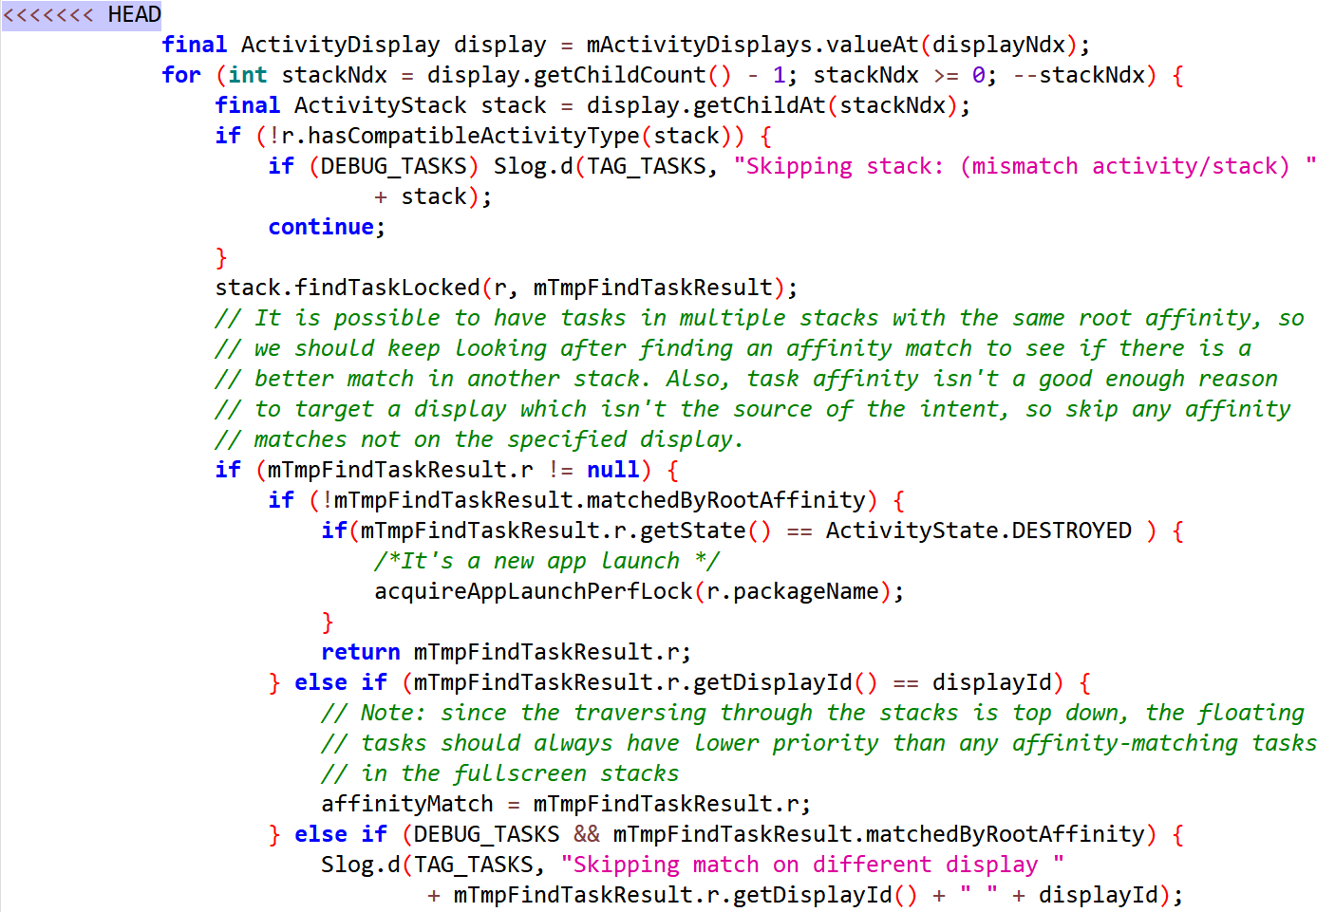

1. services/core/java/com/android/server/pm/PackageManagerService.java
2. Downstream modifies method block

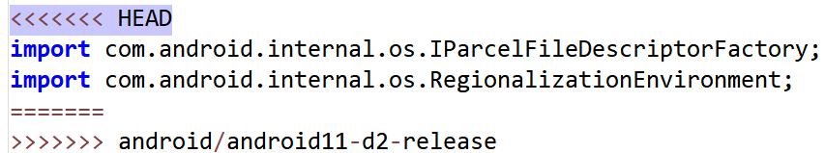

1. services/core/java/com/android/server/wm/ScreenRotationAnimation.java
2. Downstream modifies method block

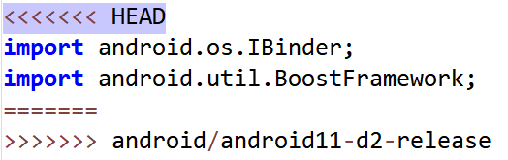

1. services/net/java/android/net/dhcp/DhcpPacket.java
2. Downstream modifies method block

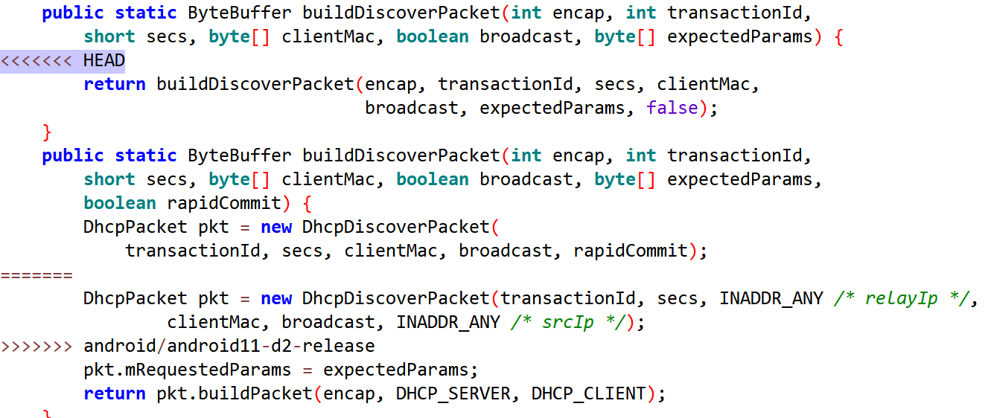

1. telephony/java/android/telephony/CarrierConfigManager.java
2. Downstream modifies method block

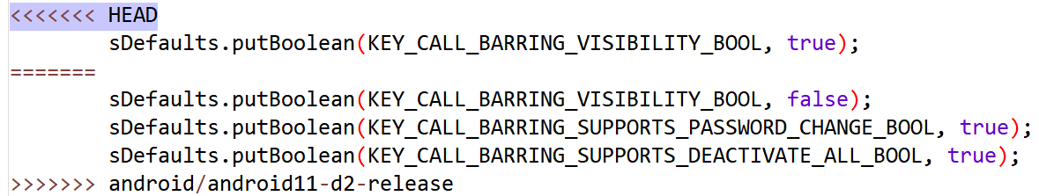

1. telephony/java/android/telephony/ims/ImsReasonInfo.java
2. Downstream modifies method block

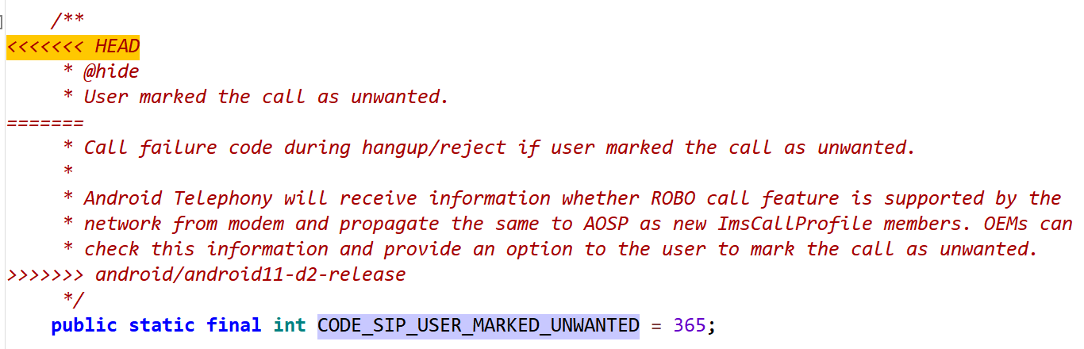

1. wifi/java/android/net/wifi/WifiManager.java
2. Downstream modifies method block

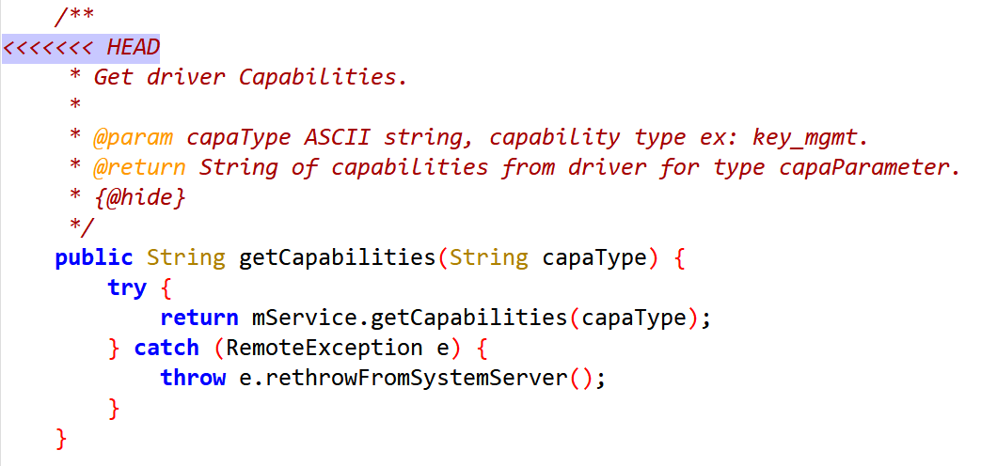

1. Downstream modifies method block

